UN-REDD Implementation:

Formative Review

Emerging insights
UN-REDD Executive Board Meeting
2 – 4th October, 2024, FAO-Rome

- Introduction
The Formative Review is part of the process that was envisaged to solicit inputs from stakeholders within and beyond UN-REDD to inform the development of the UN-REDD 2026 – 2030 Strategy. The Formative Review process began in April 2024 and is running concurrently with the strategy development. This document provides a summary of emerging insights from the formative review as of end of September 2024

- Objectives, purpose and approach
The formative review and lesson learning process is intended to focus on experiences to date, lessons learned, approach, process and contribution, rather than a summative, impact evaluation designed to assess overall performance against original workplan and targets. The review was conducted by an external, independent consultant.
The overall objective of this review is to:
- undertake a formative review of the UN-REDD programme to date and to make recommendations on how to maximise its future contributions and support over the period 2026 – 2030.

The scope of the review covers the whole period of UN-REDD operations, from 2009 to present. Three broad phases of support have been in effect over this period: i) 2009 – 2015; ii) between 2015 and 2020 and iii) Post 2020 (Annex 4)

Specifically, the review is intended to:
- assess the relevance, contribution and added value of UN-REDD support to climate mitigation processes at country, regional and global levels;
- review the overall theory of change of UN-REDD and its links to the wider national and international REDD+ process and the degree to which this theory of change has been validated;
- assess the effectiveness and efficiency of the support provided by UN-REDD, particularly from the country perspective, recognizing the joint responsibility for implementation, shared between UN-agencies and country counterparts;
- based on evidence collected, present key recommendations regarding how to enhance the future role and contribution of UN-REDD in the period 2026 – 2030, for inclusion within the UN-REDD Strategy development process

The review has three key stages as presented below:
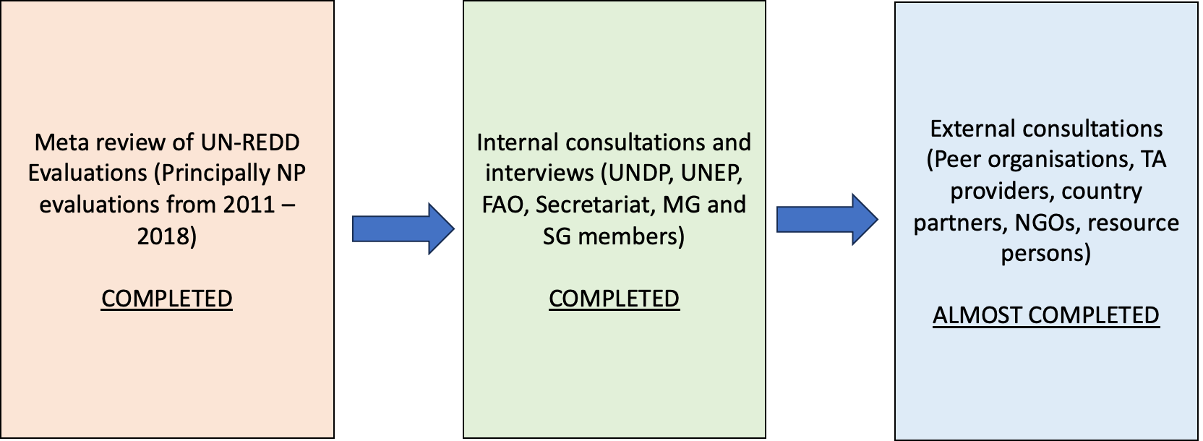

- Key findings
Relevance
Overall, the review found that UN-REDD has been and remains highly relevant to the needs of forest countries. Support in the 2010s was instrumental in supporting countries reach readiness and establishing the four pillars under the Warsaw Framework. UN-REDD was able to provide “foundational” support to countries, by raising awareness and understanding of REDD+ and then supporting them to build capacity, systems and structures for REDD+ readiness. The review found that there are high levels of coherence (and low duplication) between support provided by UN-REDD and other forms of bilateral or multi-lateral support. Given it’s sharp focus on supporting UNFCCC processes, UN-REDD is widely seen as “neutral” and not being associated with any particular institutional mechanism or process, beyond UNFCCC.
Over the past decade and a half, there have been significant changes in the external operating environment and countries are trying to navigate a path through these forms of support. UN-REDD has been instrumental in helping forest countries interpret, understand and navigate this complexity. However, it has been less agile in working with private sector approaches and technical assistance providers. In recent years, the drivers of deforestation in many countries has shifted from forest-related aspects to wider considerations of agriculture and land-use change. This is an area that UN-REDD will need to navigate in its next phase of support.
The review identified a few gaps relating to overall relevance. Firstly, although UN-REDD has been highly valued by forest agencies in many countries, it has been less successful in engaging non-forest government agencies that intersect with REDD+. This includes ministries of finance and planning, agriculture and rural development. Secondly, while support from UN-REDD has had a strong focus on the technical aspects of REDD+, it has been less successful in addressing the broader political economy aspects of REDD+ (such as barriers and enablers to real transformational change). Thirdly, the review identified the risks of UN-REDD moving towards supporting specific initiatives (such as LEAF) and the risk that this generates in terms of compromising the demand-driven nature of the programme and the “neutrality” of individual UN agencies
The theory of change
The UN-REDD programme was developed in the early 2010s to guide its overall development. Since this time, the external operating environment in which REDD+ operates has changed significantly Consequently, the initial assumptions made at the start of UN-REDD need to be revisited when re-drafting an updated ToC. Key considerations or assumptions that will need to be reviewed include:
- The time taken to achieve readiness was significantly longer and more complex than originally anticipated. Furthermore, individual countries have progressed at a significantly difference pace than others. Readiness is not (as originally thought), a descrete step that ends and moves into implementation, but an ongoing process that goes in parallel to implementation
- Capacity building at country level is a long and complex task and requires ongoing support to maintain relevance, given the fast-paced changes in the external operating environment and technology advances with regard to MRV and earth observation.
- It was assumed that once countries are ready for REDD+, results-based financing will be available in sufficient volumes. This has not proven to be correct. Results based finance are not sufficient to meet national demands. Furthermore, there has been a proliferation of different mechanisms, standards and approaches in results-based finance for REDD+, which was not foreseen.
UN-REDD strengths and weaknesses
Key strengths associated with UN-REDD include the strong and clear links to the Warsaw Framework for REDD+ and the wider UNFCCC process; the fact that UN-REDD works at global, regional as well as national levels; support to south-to-south, peer-based learning, exchange and knowledge management; the strong and broad-based technical support offer provided from three different UN agencies; the forging of links between forest countries and results-based finance mechanisms and the engagement of non-state actors during readiness support. A key strength identified by UN-REDD donors is the programme’s global reach – and its ability to create new relationships for donors outside existing bilateral relationships.
Weaknesses identified by the review include the apparent drop in engagement with non-state actors following completion of National Programmes (NPs); a perception from civil society of the “rush” towards RB finance and the risk of leaving non-state actors behind; weak engagement of private sector actors and limited engagement at a political level given UN-REDD’s primary focus on technical solutions.
Niche and added-value
The review identified UN-REDD’s unique niche and added value. This included its demand-driven, tailored support in line with Warsaw Framework and UNFCCC; the programme’s ability to connect to a wider network of support (peers, service providers, financing); its “invisibility” when supporting forest countries; trust exhibited by forest countries following the long relationships developed with UN agencies and its convening power.
Impacts
Unlike other international mechanisms supporting REDD+, UN-REDD does not deliver field-level impacts and REDD+ results (reduced emissions, reduced deforestation). Rather, it supports and enables countries to achieve these goals and facilitates linkages to those sources of finance and support that will enable these results to take place. UN-REDD works in support of existing processes rather than starting new ones. As such getting a clear assessment of UN-REDD impacts is very challenging given questions over attribution and contribution. Despite this, there are clear outcomes over which UN-REDD can claim clear contribution. These include:
- Building the capacity of forest countries, facilitating the establishment of REDD+ readiness building;
- Supporting the transfer of emerging knowledge and best practice from across the REDD+ community of practice
- Engagement of non-state actors in public decision-making and multi-stakeholder processes
- Raising ambition on NDCs
- Helping partner countries access results-based finance

Efficiency
On one hand, UN-REDD supports a broad range of complementary technical assistance needs from across the three UN agencies – encompassing both “hard” TA needs (MRV, FREL, NFMS) and “soft” needs (gender, safeguards, governance, finance). However, a clear signal was sent from forest countries that UN-REDD was not “delivering as one” in the context of National Programme support. UN-REDD placed high transaction costs on partner countries given that each UN agency had its own distinct systems, administrative and financial requirements and arrangements. This undermined efficiency. It is less of an issue with the Technical Assistance modality as funds are retained by the agencies to cover TA costs.
Governance
The former Policy Board was established at the start of the UN-REDD programme but was transitioned into the Executive Board in around 2017, following a decline in donor funding to UN-REDD. The Executive Board remains in place and remains the overall governance body for UN-REDD at international level. A number of members (particularly non-state actors) expressed some concern over the lack of clarity regarding the role, mandate and authority of the EB. Furthermore, some country-level and non-state actors expressed a concern that while the membership of the EB is quite balanced, donors have proportionately more decision-making power over the direction and operations of the programme. Members of the EB felt that there was a need for two clear functions or roles of a governance body at international level. Firstly, a decision-making function (including the review and approval of workplans, budgets and strategy) and secondly a dialogue and exchange between donors, forest countries, non-state actors. It is unlikely that these two functions can effectively be managed within one single body.

- Next steps
Feedback from the presentation of the formative review will be used to inform the findings. Outstanding inputs from other stakeholders will be solicited and then a final set of findings and conclusions prepared. A final report of the formative review will be prepared and circulated to Executive Board members.

