
UN-REDD Programme Online Workspace FAQs
(Last updated August 2013)

Français
Español

General
How do I change my password?
How do I modify contents?
How do I search for documents or people?

Documents
How can I quickly see the most recent Documents on the workspace without having to navigate the whole library (RSS feed)?
How do I upload a document?
I don’t like the way the Documents feature is organized. Can I rename or create a new folder under the Documents tab?
What is the use of the full access/restricted access button under Documents?
I was looking at the Documents tab, and now I cannot access the rest of the Workspace

Calendar
How do I link a calendar entry to associated documents?
How do I edit or remove an event?

Contacts
My contact information is wrong, how do I update it?
How do I add a contact?
How do I add a user?

Country pages
Who should edit country pages?

SharedDocs
The SharedDocs feature is awfully slow…
How do I send a link to a document in SharedDocs?

How can I quickly see the most recent Documents uploaded on the workspace without having to navigate the whole library?
You can see what documents has been added every day by subscribing to the Documents RSS feed:
1. Click on Documents
2. Click on the RSS feed icon (this orange icon: )
3. Subscribe using iGoogle, my yahoo or any other embedded RSS reader you may have on your computer
4. The RSS feed will recognize your user access level.
5. From your RSS reader you can click on the documents names to navigate back into the workspace and view and download documents. Please note that you’ll need to be logged in to see the restricted access documents.

Also note that the most recent documents appear on the home page in the right hand side column.
I have problems with the RSS feed
If you are using “Google Chrome” the problem is that the browser does not have native support for feeds so text may appear jumbled and illegible. In order to solve this problem, you simply need to install an extension by clicking on the following link:

1) https://chrome.google.com/extensions/detail/nlbjncdgjeocebhnmkbbbdekmmmcbfjd?hl=en-US
2) Click on the blue “Install” button and the problem should be immediately resolved.

How do I link a calendar entry to associated documents?
When you create a calendar entry, you may link it to one or several associated documents residing on the workspace (for example agenda, participant lists etc). To do so:
- Upload your document in the relevant section of Documents (Global programme, National Programmes, Partners etc)
- Mouse over the name of your document
- A link appears at the bottom of your screen :
http://www.unredd.net/index.php?option=com_docman&task=doc_download&gid=XXX%Itemid=53. Record the number highlighted in yellow.
- In your calendar entry, under Common/Activity
  - Enter the name of your document
  - Highlight it
  - Click on the link icon (4th row, second icon from the left, a chain with a green plus) - see schematic below
  - In the pop up box, paste the link to your document next to “url:
http://www.unredd.net/index.php?option=com_docman&task=doc_download&gid=XXX%Itemid=53
  - Click on insert
- Complete your calendar entry and save

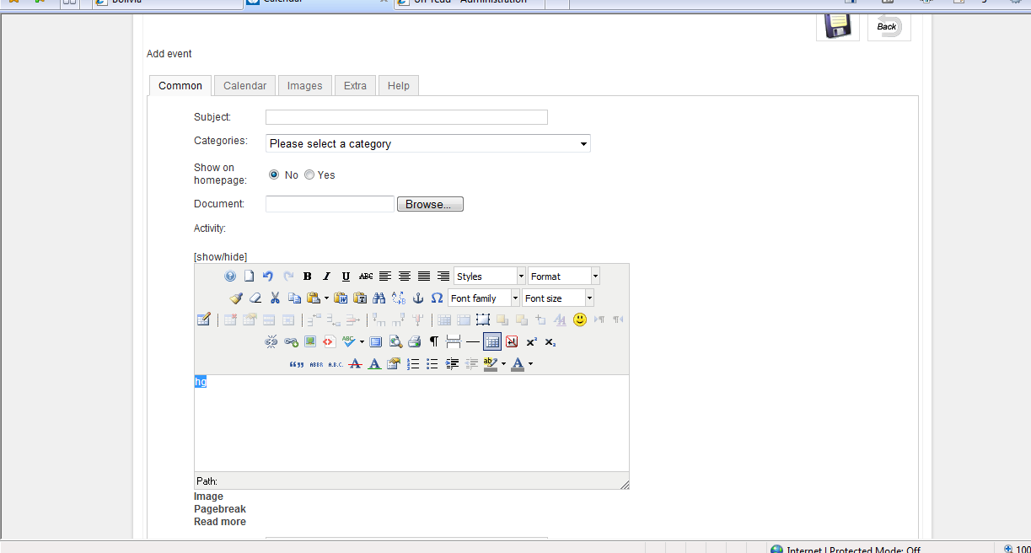

How do I change my password?
There is a link “Change your password” on the bottom right hand corner of the homepage. Click on it, change your password (recommended: alpha and non alpha numeric characters), and save.

How do I modify contents?
You can modify contents anytime you see the edit icon () by clicking on it, or anytime you see an “edit” tab.

How do I upload a document?
All documents are stored under the “Documents” tab. Click on “submit file” and follow the three easy steps. You will be prompted to select a file from your computer and have the possibility to rename it, choose the folder it will be stored in, and make it appear on the home page under “latest document”. The tags you will add when uploading a document can be separated by a comma, and will inform the search of documents in the workspace.

I don’t like the way the Documents feature is organized. Can I rename or create a new folder under the Documents tab?
You cannot, but please send your suggestion to admin@unredd.net

What is the use of the full access/restricted access button in Documents?
Certain users have the ability to show or hide documents they upload. When a document is hidden, it appears on a pink background to those who are authorized to see it.

I was looking at the Documents tab, and now I cannot access the rest of the Workspace
You have been logged out. Click on the UN-REDD Online Collaborative Workspace header and you will be brought back to the login if you have been inactive for 30 minutes.

How do I search for documents or people?
Type any search word on the home page. This button will search into documents, contents and contacts database.
You can also use the search function under the Documents tab, which will be limited to documents under “Documents”.

My contact information is wrong, how do I update it?
Click on the edit iconnext to the name you wish to edit, make your changes and save.

How do I add a contact?
Click on “Contacts” in the upper right bar of the home page
Then click on the “Add contact” button, add contact information, scroll to the bottom of the page and save.

The SharedDocs feature is awfully slow…
This may be related to your internet provider and speed, but we are working to improve it.

How do I add a user?
You cannot add a user to the Workspace yourself, but you may send your suggestion to admin@unredd.org, specifying: first name; last name; position; organization; and email address

Je comprends mal l’anglais, ce site est-il accessible en français?
Le “Workspace” (site de travail) n’est disponible qu’en anglais, mais un bouton automatique permet de traduire (approximativement) son contenu. Vous pouvez poser toutes vos questions en français à admin@unredd.net

No entiendo el inglés, es el sitio disponible en español ?
El “Workspace” (sitio de trabajo) sólo existe en inglés, pero estamos pensando en añadir un botón que traducirá (aproximativamente) su contenido. Puede preguntar cualquier cosa en español a admin@unredd.net

Who should edit country pages?
We encourage all workspace members active in a country to edit country pages.

How do I send a link to a document in SharedDocs?
You have created a document in SharedDocs. To send a link to it, do not copy the url – instead :
- go to your list of documents under a specific folder
- right click and select “copy link location”
- paste it into the email you are sending.

How do I edit or remove an event in the calendar?
1. Click on the event
2. Click on the edit button (orange pencil icon)
3. Change the text, date, time, description etc as appropriate
4. To remove the event, select "no" next to "Published" or the delete button
5. Save (by clicking on this button: 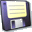)
6. Notify the original event creator of the changes you've made by using the "Send an email via Outlook" link.

