UN-REDD Programme Online Workspace
Quick Facts—Modifying contacts on a country page
Updated May 2012

Why?
Maintain your colleagues and partners updated on who’s who in REDD pilot and partner countries.
- How to change who appears as a contact on a country page?
- How to change information about a specific person?
Who edits what?
The UN-REDD Secretariat edits the section under “Government”.
Regional and country teams edit all other sections.
A bit of background…
A number of the same people appear on a number of different country pages on the workspace. Instead of having this information entered manually in each page, the workspace uses an ID system for each contact (person). When you update the information for a specific person, the information is simultaneously updated on all pages.
How to change who appears as a contact on a country page?
- Check if the contact you seek to add is already under “Contacts” (upper right corner of the home page, or here) or on the country page you seek to update
- If it is, proceed to step 4
- If it is not :
  - Click on the Add contact button
  - Add all the information you have
  - Scroll down and click on save
- This contact has its unique ID number. To find it,
  - Click on the orange pencil icon next to the name
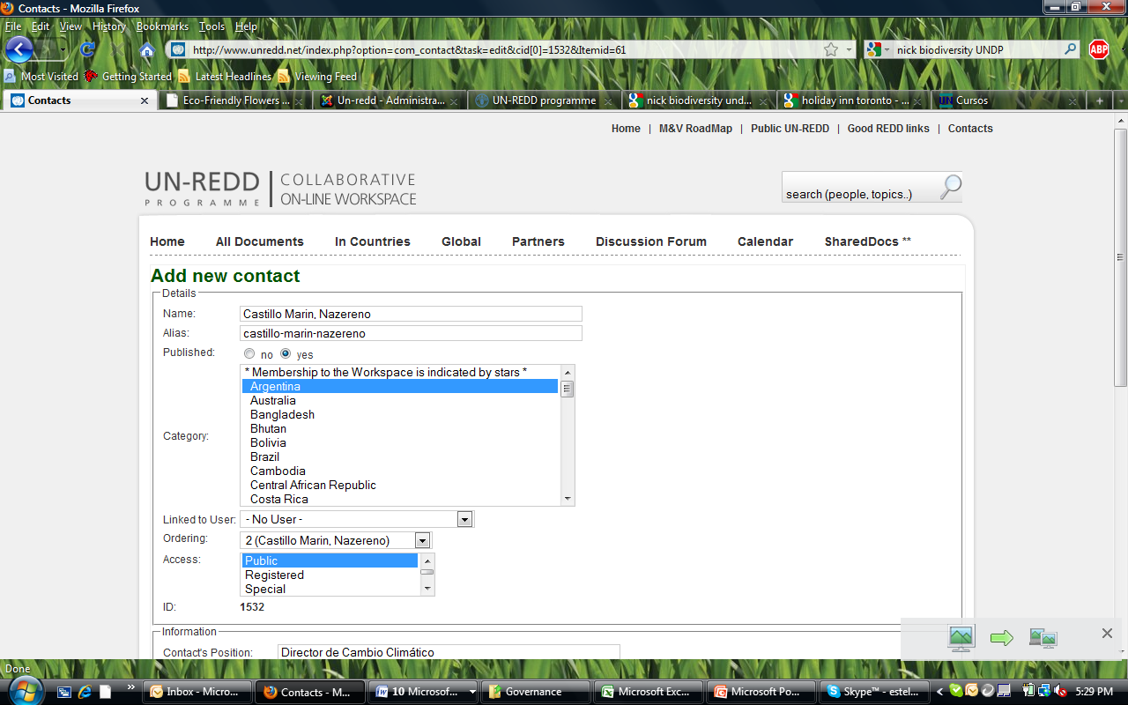
  - Locate the ID number. In this example it is 1532

- In your country page :
  - Click on the edit icon at the top of the Contact page (top right-hand side)
  - You will see different sub sections headers that categorize contacts in Country Offices, Global Programme, In-Country, etc. Under each sub section some code will appear, it looks like this:

{dgcontactinfo}id IN (number, number){/dgcontactinfo}

Find the sub section that you are going to add the contact under and find the code located under the header. Plug in the ID number you have located in step 4b in this code. For example: {dgcontactinfo}id IN (number,number,1532){/dgcontactinfo}

  - Click on save

- To remove a contact from a country page, simply delete his/her ID number from the code. For example, you want to delete user 1532:

Find 1532 in the code: {dgcontactinfo}id IN (number,number,1532){/dgcontactinfo}

Be careful to delete only the code of the person you wish to remove so you don’t delete other contacts in the code. When you are finished deleting user 1532 your code should appear as so: {dgcontactinfo}id IN (number,number){/dgcontactinfo}

- And voila! You’ve successfully edited the contacts in a country page.

How to change the information about a specific person?
1. Click on the edit icon next to their name
2. Enter information
3. Click on save

