UN-REDD Programme Online Workspace
Quick Facts—Creating a link to a document or a folder
Updated June 2013
Why?
Create hyperlinks to documents you have uploaded or folders under All Documents to:
- An announcement
- A country page
- A calendar event
- Other public websites, documents, announcements, newsletters, etc.
How?
- Upload a document in the appropriate folder in “All Documents” (if you need to create a new folder please see : Quick Guide series # 6 how to create a folder)

- Choose the access level for your document : full access (to all workspace users, appears on a white background) or restricted access (to UN personnel only, appears on a pink background)

- Identify the direct link to your document OR the url of the folder
a. direct link : Click on “details” button below your document after you upload, and copy the “direct link to this document” that you’ll find in the last row of the table below 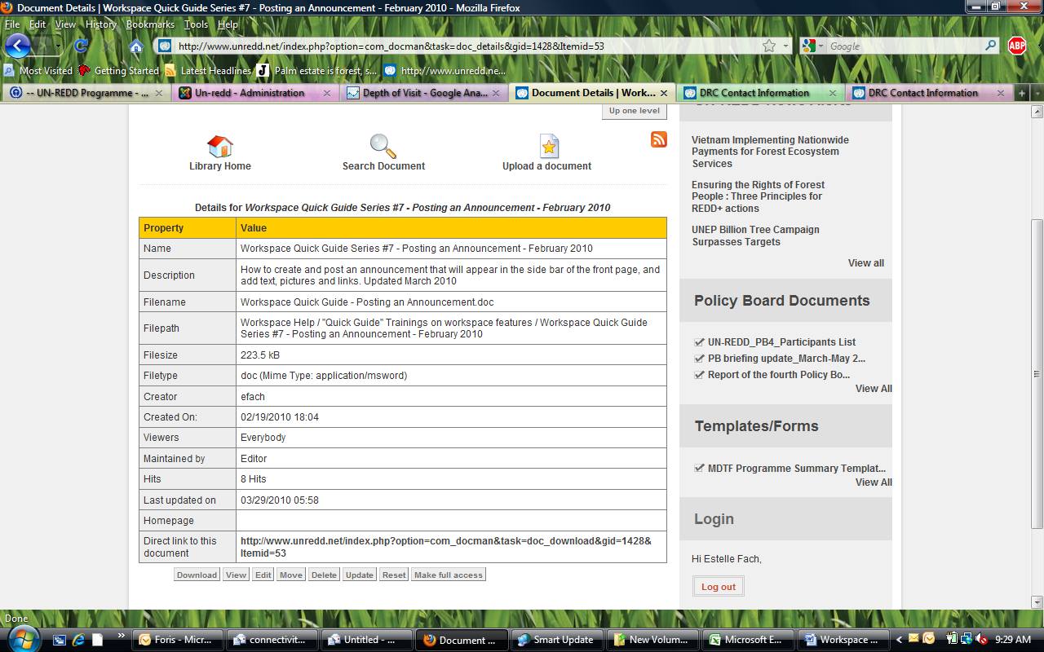

Also, you could right click on the title of the document and “copy link” location to obtain the URL

b : link to a folder: enter the folder and copy its URL

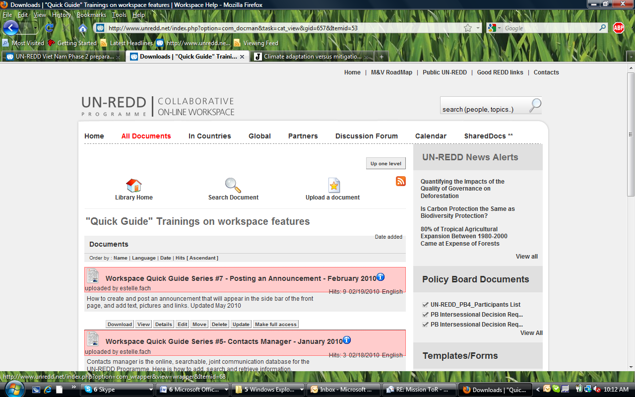

- In the editor of your country page, calendar entry or announcement:
  - Enter some text (in the example below we’ve typed ”More details”)
  - Select this text so that it is highlighted in blue
  - Click on the chain icon (chain with a green plus sign, see arrow)
  - A new box will pop up :
    - paste the link from step 3
    - click on “insert”

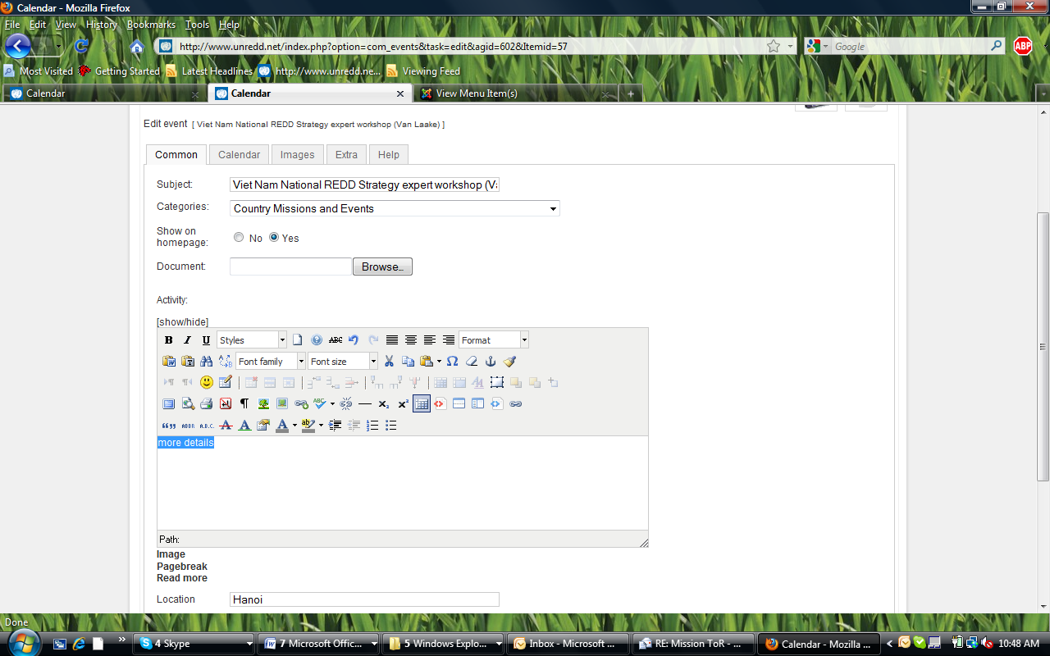

- Save your calendar entry, country page or announcement

