UN-REDD Programme Online Workspace
Quick Facts-- Posting an Announcement
Updated June 2013

Why?
Share your work, achievements an updates by posting announcements on the home page of the workspace. Posting announcements is an excellent way to publicize events, updates, publications, etc. Each week, announcements from the homepage are compiled and sent out in the workspace’s “Mini Roundup” newsletter, reaching an audience of over 1,100 REDD+ practitioners.
Important note: in order to maintain connectivity between the website and the workspace, any announcement posted on the workspace is sent automatically to Communication colleagues in the Secretariat, who will decide whether and how this can be featured on the website (www.un-redd.org) as well.
What ?
Consider posting an announcement for:
- Vacancy announcements
- Alerting to an upcoming workshop or side event and/or reporting on a concluded workshop/side event
- Alerting to a new publication under the UN-REDD Programme or an external publication you have found particularly relevant
- Publicizing a particular milestone in a REDD+ country (such as creation of a new institution, completion of an activity under a national programme etc)
- or anything else you wish to share with the UN-REDD community of practice
How?
- On the home page, click on “Post an announcement” under ”What’s Happening” (side bar, bottom)

- Enter a title : for consistency it should start with “--Your title here“

- Enter text in first text field : No more than 1000 characters for what will appear on the side bar.

- If your announcement is longer than 1000 characters, you will enter the introduction in the first text box and the remainder text in the “read more text” box. The read more hyperlink should automatically appear once you saved your announcement.
- Choose the page: under “Category”, leave as is “Front page” if you would like the announcement to appear on the homepage side bar of the workspace under “what’s happening”. You may also select a country page from the menu. If your announcement is relevant to more than one page (ie. both front page and a country page), cross post the announcement by selecting the second page under the menu “Cross Post”.
- If your announcement is very important, select the “ Important announcement for homepage” option as YES. By default this is marked NO. By marking YES, your announcement will have its own page on the homepage and when users log in they will see this announcement page instead of the text that is currently on the homepage. Please use your discretion with this function.

6) Optional:
You can now, if you need to :

  - Make a link to a document on the workspace

- Upload a document in the appropriate folder in “All Documents”

- Make your document full access (appears on a white background, not pink)

- Identify the direct link : Click on “details”, and copy the “direct link to this document” located in the last row of the “Details” table, or place mouse over the document title and right click to select “copy link location”
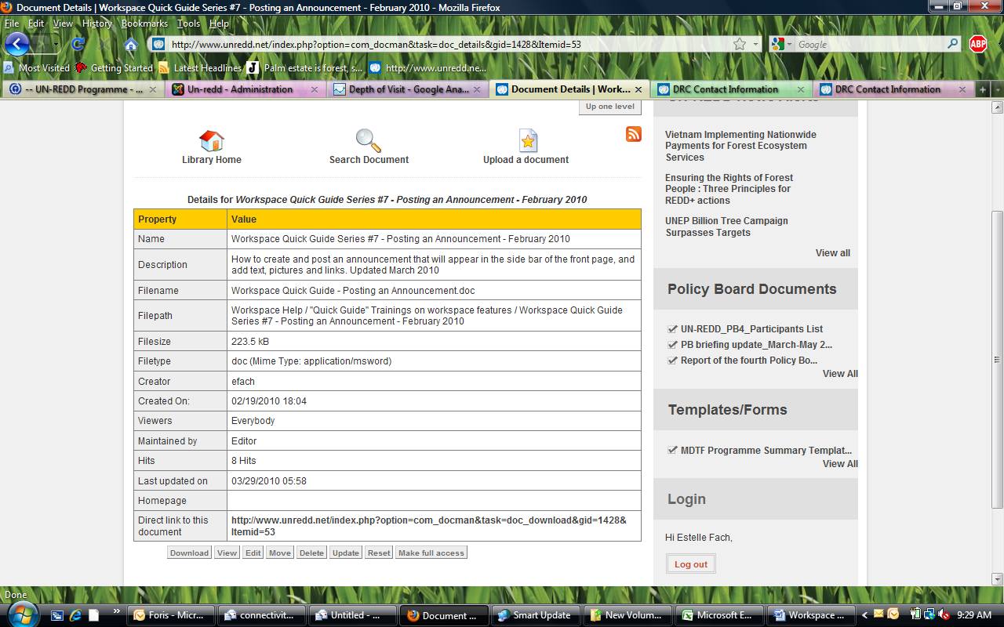

- In your announcement, highlight the text you want to become a link, click on the chain icon (chain with a green plus sign : ), and paste the link you copied in step b) iii.

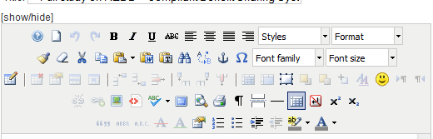
  - Add a picture (underneath “read more text”): click on the picture icon and follow the steps to upload a picture from your computer

- Scroll down and click on Save.

- Refresh your screen ! Depending on your cache computer setting it may take a few minutes for the announcement to appear.

