UN-REDD Programme Online Workspace
Quick Guide- Creating Folders in All Documents
June 2013

- Log into http://www.unredd.net/administrator/?unreddSecure with your regular login

- Go to Components>> DocMan >> Categories ( Categories are what we call folders)

- Click on the “ADD” Button on the upper right

- Enter the information:
  - Under Category title, enter the name of the folder
  - Under category name, enter the same name
  - Under Parent item, select the folder under which you want your new folder to reside
  - Ignore “select image”
  - Ignore “image position”
  - Ignore ordering for now – you will have an opportunity to order your folders after you’ve created it.
  - Ignore Access level if you would like your folder to be public (this is very common)
  - Under Folder access level, select the groups you want to grant access to, using your Control key to select many. If you would like to restrict your folder to a minimum level, ie Only UN members, then you must select the minimum group who can access and all the users groups above that category. If you only select one group, only that one group will see the folder.

*Do not select any group if you want this folder to be accessible to all, including outsiders who do not have a login and password.

As a reminder
    - Technical advisors are 2 stars (ie UN colleagues, not directly UN-REDD)
    - National counterparts are 1 star (governments)
    - Partners are 1 star (NGOs, donors, etc)
    - ALWAYS Select super administrator 4 stars (workspace managers)
    - UN-REDD coordination group are 3 stars
    - Technical secretariat are 3 stars
    - You can ignore the other categories
So for example:
-if you want UN people (2 stars and more) to see the folder, use the CTRL and SHIFT keys to select super administrator , technical advisers, UN-REDD coordination group and Technical Secretariat
-If you want the highest level (3 stars) UN-REDD team to see the folder, select coordination group and technical secretariat, and of course, super administrator
-If you want everyone, including non workspace members, to see the folder and its contents, do not select anything.
  - Ignore “Can publish documents” unless you would like to restrict who can upload documents to the folder
  - Published: select yes
  - Description: enter a brief description (optional). This is where you can add bullet points and hyperlink certain key files from the folder. Also, you can upload photos here.
- Scroll back up and press save

- You are now back in the list of categories. Find your newly created folder in this list– you may have to hit “display” and select “all” at the bottom of the page.

- Folders should be ordered alphabetically but you may have other needs in terms of folder and subfolder order. To reorder folders, use the green up and down arrows under the “order” column. The left arrow pointing up will move your folder one notch up; the downward- pointing arrow will move it one notch down. Alternatively, there are number boxes where you can reorder your folders. If you use the number boxes, remember to scroll up to the top and select the floppy disk “save” icon in the “order” column

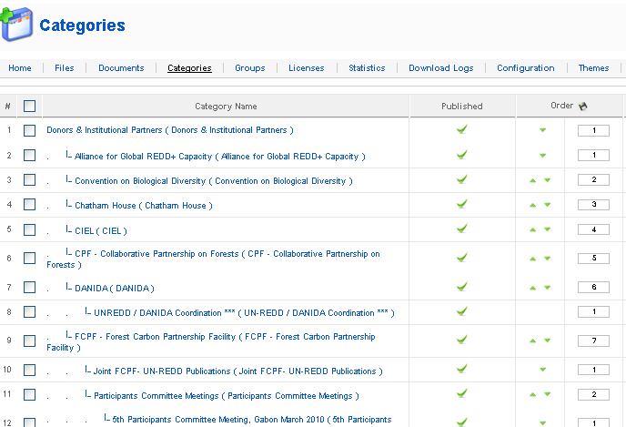

- Go back into the workspace, refresh your screen and see the folder you’ve just created !
- If you need to edit the title of your folder, go back to the : Components>> DocMan >> Categories page, find your folder and click on it. From here, you can edit the title and any other details. Save your changes when finished!

