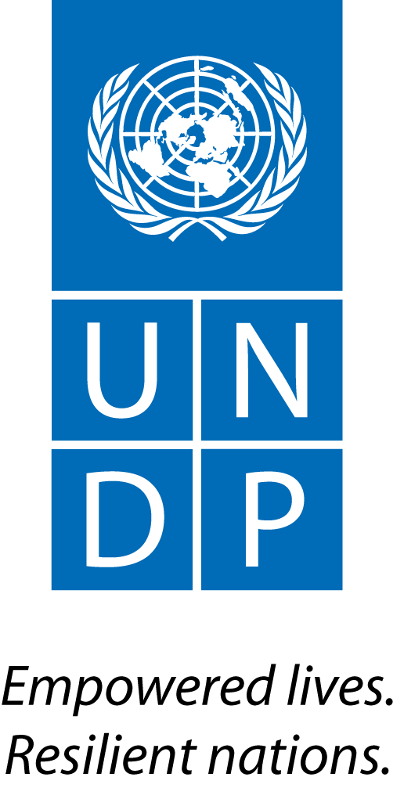 | Back to Office Report  Submitted by Wahida Shah  Title – Technical Specialist – Multiple Benefits and Safeguards  Date submitted – 26 July 2016
1. Practice area : Sustainable Development
2. Mission period (incl. of travel days)
From : 4-8 July
3. Type of mission: Support to Republic of Congo | 4. Clients  Coordination Nationale REDD+, Republic of Congo  J340V OCH Moungali 3 (vers L’ENAM)  Brazzaville, Republic of Congo
5. Purpose of mission:  - Finalisation and validation of National Strategy  - Discussions with UNDP with regards to the final activities for the Naitonal Programme | 6. Documents, materials, resources  Republic of Congo National Strategy (Working draft 3)
7. Mission members  Wahida Shah  Roy Hagen (consultant) | 8. Costs  Republic of Congo National Programme (through the UNDP Country Office)
9. Brief summary of the mission
- Worked on the draft National Strategy closely with Roy Hagen, consultant hired by UNDP CO;
- Worked with the members of the Coordination Nationale to integrate comments from national and international partners including UN-REDD, to enable a final draft of the National REDD+ Strategy, to be ready for a validation workshop which took place on the 15/16 of July. FCPF also participated in the meetings;
- Discussion with the UNDP CO on the elements within the annual work plan and progress towards finalisation of the Republic of Congo’s National Programme; and
- Discussions with FCPF on their involvement in Congo and on the National Investment Plan.

9.a Findings
- As per the annual work plan agreed to by the Coordination Nationale and UNDP Country Office, the following activities have been or are in the process of being completed by the end of Ju;ly 2016;
- Management of the REDD+ Programme through the Coordination Nationale
- Setting up of Departmental heads for REDD+ (CODEPA)
- Participatory evaluation of the civil society platform (CACO-REDD) undertaken in June. Activities emanating from the recommendations to be funded by FCPF. Changes in the governance of CACO-REDD will be expected and until conflicts are resolved, the platform cannot become effective
- REDD+ Registry – is not complete, the consultant’s work was found not to be acceptable. Discussions being held with the consultant to improve the product.
- Afforestation work with Pronar is almost complete
- Consultant hired to finalise the national strategy, work ongoing since June 2016 together with government counterparts
- Strategy process is now more or less complete. A final draft is available. There is increased ownership of the National Strategy by the Coordination Nationale/Government, and willingness to produce a strong dcoument which will also act as a basis of the forthcoming national investment plan (NIF). It is envisaged that the NIF will contain components to be funded by the FIP, African Development Bank and proposals from AFD (these already being developed for 2/3 years) as well as FAO which will also contribute with funds. CAFI preparatory funds for this purpose will soon be available. Pending - ascertain issue of inclusion of peatlands in the Strategy. It is not currently in the Strategy.

- The Programme will come to a close on July 31 2016. UNDP CO has funds for the audit requirements. FAO will be leading the final evaluation process.
- Implementation, governance, cross sectoral issues and actions on the ground now will shape the manner in which Congo will be able to transform and benefit from improved management of forests as well as carry out REDD+ actions. The issues include support to smallholders, agriculture and income generating opportunities that do result in DD and realisation of multiple benefits, infrastructure expansion into previously isolated areas, manner in which agricultural, forest and mining concessions are allocated and managed, lack of capacity to regulate and enforce policies and laws, absence of land use planning, cross sectoral planning and gaps in policy coordination.

9.b Results achieved (key outputs)

- Incorporation of changes in the National Strategy
- Finalisation and presentation of Draft National Strategy for the Validation workshop
- Collaboration with FCPF including cost sharing for the Validation workshop and CACO-REDD participatory evaluation
- Presentation and discusisons with CODEPA to discuss and validate the National Strategy.

9.c Expected outcomes and impacts
Satisfatory closure of the UN-REDD supported National Programme
Participation of UNDP CO in the process to develop the National Investment Plan.
Ascertain extent to which UNDP CO will be able to support Congo to develop a GCF proposal

10. Key counterparts
- Mohamed Abchir (Operations Director) and Jean Felix Issang (Programme Officer) - UNDP Country Office.
- Roy Hagen – Consultant hired by UNDP.
- Georges Claver Boundzanga, Coordonnateur National; Arnaud Kiesse Kibinza, Chef de la Cellule juridique; Henriette Tsoh-Ikounga, Chef de la Cellule Evaluation; Dollorèce Okoutowa, Assistante de la Cellule Action; Hugues Koudimbila, Chef de la Cellule Information, Education et Communication; Dabeny Matoko, MRV, GIS.
- Patrick Ampali – FAO
- Aurelie Rossignol – FCPF
11. Follow up action matrix
Action to be taken |  | By whom | Expected completion date
Continue to engage with UNDP CO to follow up with expected outcomes above. Finalise Evaluation terms of reference and launch audit. |  | UNDP CO, Wahida | August 30
12. Distribution list
Elsie Attafuah, Anne Martinussen, Tim Clairs, Josep Gari

The main areas integrated into the Strategy were - Les liens entre les causes de la déforestation/dégradation et les options stratégique ont été présentés d’une façon explicite au début de chaque option stratégique en Chapitre 3 ; - Les mesures pour minimiser l’impact sur la forêt de l’amélioration de l’agriculture des petits producteurs (l’intensification agricole augmente la rentabilité de l’agriculture et les pressions sur la forêt) ; - L’addition d’une sous-option sur l’agriculteur industrielle avec des mesures pour minimiser son impact sur la forêt ; - On a mis un accent sur l’augmentation de la rentabilité de la gestion forestière vis-à-vis les autres utilisations des terres, au niveau nationale et au niveau communautaire, comme stratégie de conservation des forêts ; - L’intégration du développement de la gestion communautaire forestière dans la stratégie et son développement dans les zones de surexploitation pour le bois énergie et pour le bois d’œuvre artisanal; - La stratégie reconnaisse le potentiel de la mise sous gestion des forêts fortement dégradées comme moyen de fixation de quantités importantes de carbone ; - La cogestion des aires proteges (AP) avec les peuples autochtones and des communautés locales est identifiée comme une option pour créer de partenariat avec les populations locales et pour diminuer les coûts de gestion des AP.

