Applying Free Prior and Informed Consent in Viet Nam
April 2010

As the first country programme to proceed with formal preparations for field-based REDD-plus activities, the Viet Nam UN-REDD Programme is pioneering a process to seek Free Prior and Informed Consent (FPIC) in two pilot districts. The pilot process raises a number of questions: What is the unit of consent? Who is empowered to give consent? How will consent, or lack of, be recorded? How will results be interpreted?

What is FPIC?
Free, Prior and Informed Consent is a rights-based principle representing a particular expression of the right to self-determination, related rights to lands, territories and natural resources, the right to culture, and the right to be free from racial discrimination. FPIC applies to key decision points for actions that have the potential to impact the lands, territories, and resources upon which rights holders depend for their cultural, spiritual and physical sustenance, well-being and survival. The UN-REDD- Programme’s approach to FPIC is consistent with international human rights instruments such as the UN Declaration on the Rights of Indigenous Peoples and reflects the draft UNFCCC CoP-15 AWG-LCA text, which recognizes the need for full and effective engagement of indigenous peoples and local communities in REDD-plus.
Among the guiding principles for the UN‐REDD Programme is the principle that FPIC for indigenous peoples and other forest-dependent communities must be adhered to, and is essential to ensuring the full and effective participation in policy‐making and decision-making processes within UN‐REDD Programme activities. The UN-REDD Programme Operational Guidance details what lies beneath the terms “free”, “prior”, “informed” and “consent”, based on the Report of the International Workshop on Methodologies Regarding Free Prior and Informed Consent endorsed by the UN Permanent Forum on Indigenous Issues during its Fourth Session in 2005.

FPIC in Viet Nam
As the first country programme to proceed with formal preparations for field-based REDD-plus activities, the Viet Nam UN-REDD Programme is pioneering a process to seek FPIC in two pilot districts, namely the Lam Ha and Di Linh districts. Vietnam has 53 toc nguoi (= “ethnic minority groups”) belonging to eight language groups and representing about 16 million people. Most of these groups live in mountainous, highly forested areas. Approximately 30 ethnic minorities live in the two pilot districts in Lam Dong province, where the Viet Nam UN-REDD Programme plans to carry out programme activities, but of these, only 6 minorities are actually native to the area, the others having migrated from other parts of the country in the last few decades.
Four simple principles are guiding the pilot FPIC process :
- FPIC should be sought for all forest communities and communities living at the margin of forests
- FPIC activities must proactively reach out to communities, and not wait for them to come forward
- Homogeneity between communities cannot be assumed
- Rights holders offer primary guidance for customized consent procedures

Seeking FPIC in Viet Nam: An Eight Step Process
While formulating these activities, the Viet Nam UN-REDD Programme had to reflect on a number of issues. For example, what is the unit of consent? What representation is appropriate? How will the process unfold in practice? How will consent (or lack of) be recorded? How will results be interpreted? The eight step process designed by the Viet Nam UN-REDD Programme attempts to address some of these questions.

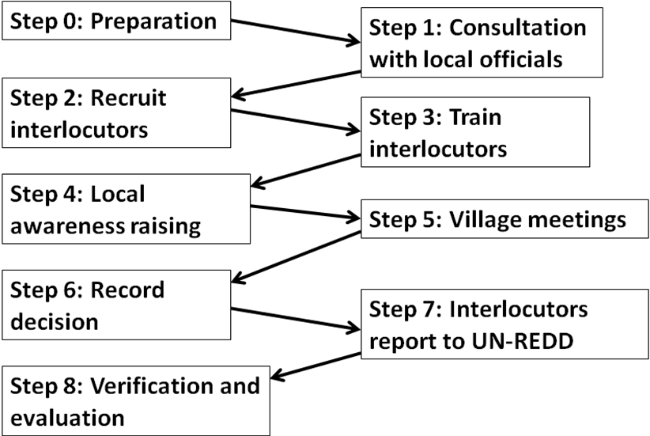
Figure 1: Eight Step Process

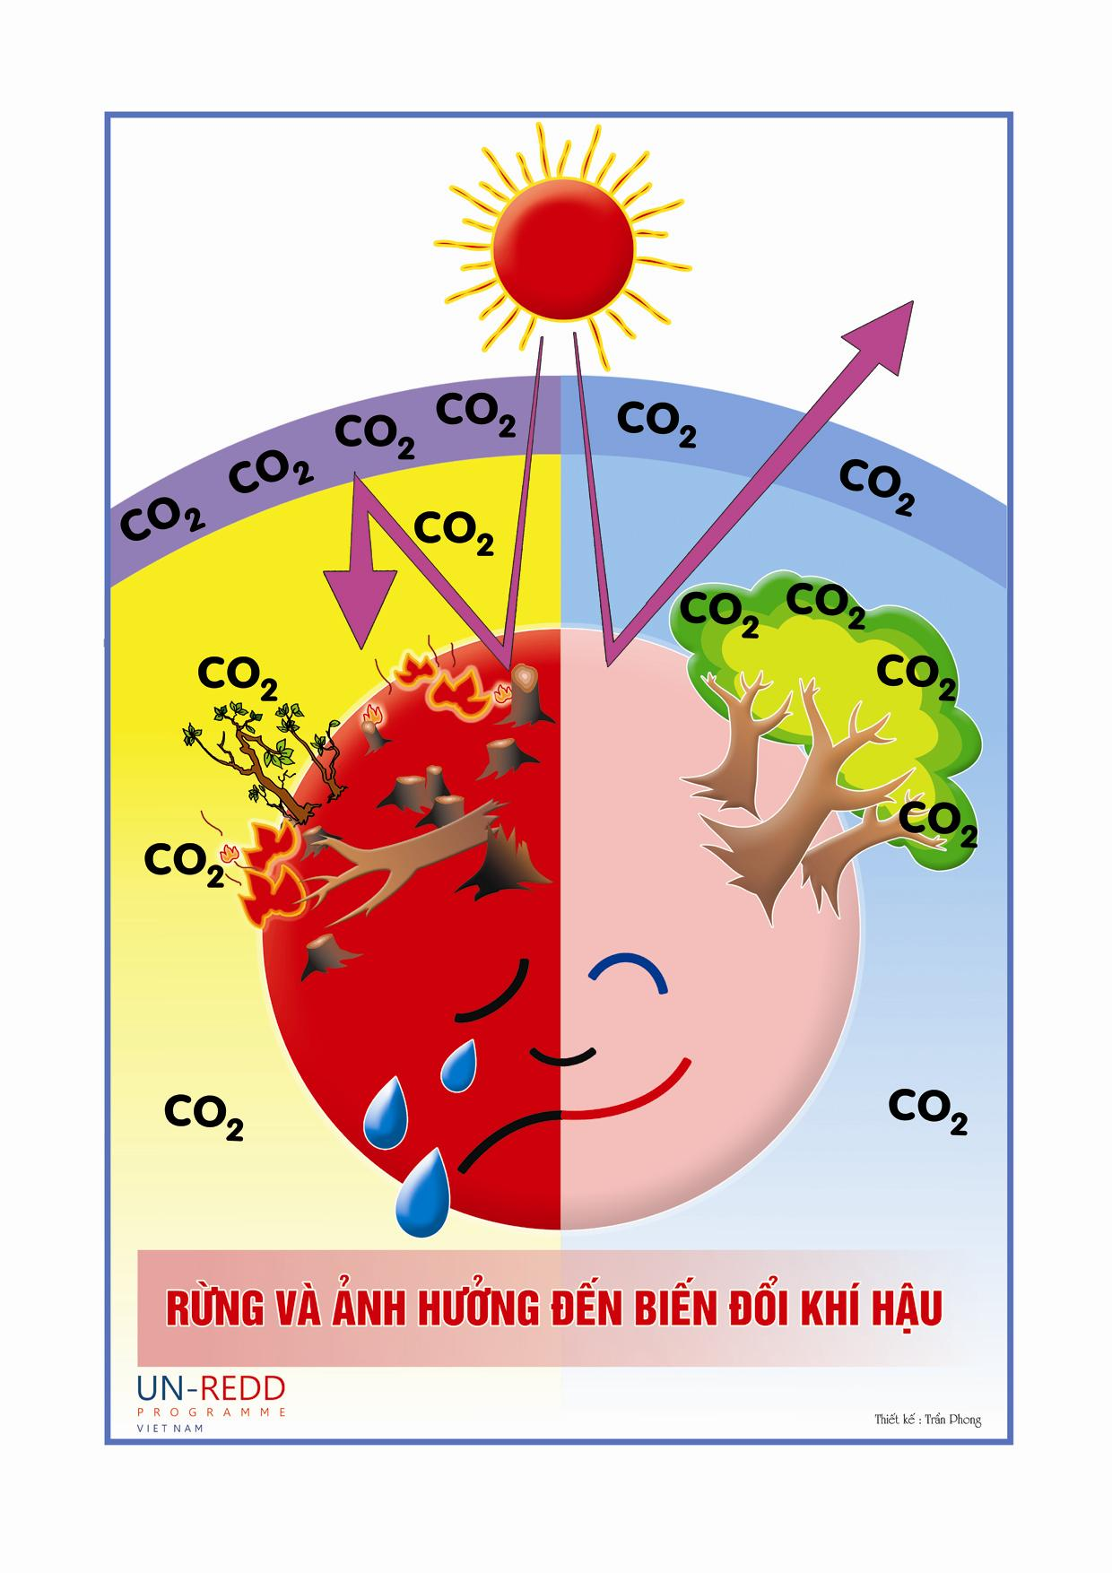
Activities have already been initiated, with consultations with local authorities, preparation of communication materials (see an example of a poster in Figure 2) and awareness raising events, and are expected to be completed by mid-2010 (see Figure 3).
Figure 2: Poster developed for awareness raising activities in villages

Step 0 – Preparation
A summary of the legal basis for local community engagement/FPIC in Viet Nam is prepared; communications materials, including posters (see Figure 2), a brochure, videos, and other materials explaining climate change, the concept of REDD-plus and proposed activities of the UN-REDD Programme are prepared; advance consultation with provincial and district authorities on the proposed process are conducted.
Step 1- Consultation with local officials
The Viet Nam UN-REDD Programme will organize numerous awareness-raising events for provincial, district and commune leaders, for village heads, and for Women’s and Youth Unions, to ensure that the principles guiding the Programme and district-level activities are understood. District and commune leaders and village heads will come only from pilot Districts. The posters, brochures and other materials will be distributed as part of the awareness raising event. The provincial, district and commune leaders will also review the proposals for steps 2 to 7. Local TV and radio stations will be mobilized to broadcast items on climate change and REDD-plus, in both Vietnamese and local languages.
Step 2 – Recruitment of interlocutors
The UN-REDD Programme will recruit sufficient interlocutors to guide the consultation process in each ethnic minority village in Lam Ha and Di Linh districts. The interlocutors will not be government officials, and each interlocutor will be fluent in at least one of the languages of the ethnic minorities in Lam Ha and Di Linh districts, such that all ethnic minority languages are represented.
Step 3 – Training of interlocutors
The UN-REDD Programme will organize a training event for interlocutors to ensure that they are fully familiar with the anticipated results and activities of the UN-REDD Programme and the principles guiding the consultations, and arrange for the information materials to be translated into ethnic minority languages, where those languages have a written form.

Step 4 – Local awareness raising
Each interlocutor will be assigned and responsible for about 10 villages of ethnic minorities in whose language they are fluent (villages with more than one ethnic minority may require more than one interlocutor). Interlocutors will contact village head to organize an awareness-raising event - at a location and time that are mutually acceptable to all village heads -, during which interlocutors will explain the meaning of REDD-plus and proposed activities of the UN-REDD Programme, using the translated materials. They will also agree to the form and timing of events to engage the villagers in each village (e.g. a single village meeting or multi-stage process).
The need for broad representation of all stakeholder groups (male/female, young/old, etc.) at the village meetings/events will be emphasized, and arrangements made for the meeting/event to be announced over several days through the village loud speaker systems.
Step 5 – Village meetings
Interlocutors will attend the village meeting(s) at the time(s) established in Step 4. At each meeting, they will explain the meaning of REDD-plus and the proposed activities of the UN-REDD Programme, using the translated brief document if the villagers are literate. The interlocutor(s) will answer questions and then retire to allow the villagers to discuss whether they are prepared to provide their consent, or return at an agreed later date for this purpose. At the initial meeting, an anonymous “Comments Box” will be provided, and collected at a later date.
Step 6 – Recording decisions
Having reached consensus, the villagers will convey their decision, either in writing using a template prepared by the UN-REDD Programme or, if preferred, orally. If a document is prepared, it will be signed by the village head and will indicate that the decision was reached by consensus. The names, sex, ages, ethnic group, and occupation of each participant in the village meeting will be recorded in an annex to the document.
Step 7 – Interlocutors report to the Viet Nam UN-REDD Programme
The record of consent or non-consent of each village will be provided to the UN-REDD Programme by each interlocutor, who will also prepare and submit a report summarizing the consultations, highlighting any concerns as to whether there was evidence of coercion or pressure having been brought to bear on the villagers.
Step 8 – Verification and evaluation
Independent verification of the FPIC process will be undertaken by RECOFTC, an international organization with specialization in the area of forest-community interactions. RECOFTC will be provided with all records on the process, and will be invited to interview interlocutors, local and central government officials, and local stakeholders to:
1. Assess whether the process has met the principles of FPIC
2. If not, generate recommendations for improvements that need to be made in order to secure FPIC; and
3. Assess the cost-effectiveness of the process and advise as to opportunities to reduce costs and/or time while retaining effectiveness of the process.
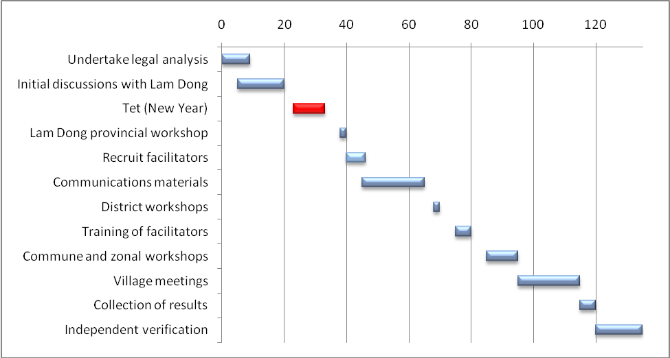
16 Jan 30 Jan 14 Feb 28 Feb 14 Mar 28 Mar 11 Apr 25 Apr 9 May 23 May 6 Jun
Figure 3: Timing of activities

Consent is Granted- or Not: What Happens Next?
Three cases are anticipated:
- For activities that do not involve engagement with individual villages (e.g., training of local government officials) any negative comments will be noted; if such comments are rare and/or minor, the activities will proceed as planned; if they are serious and consistent, the basis for the activities will be reconsidered
- For activities that do involve engagement with individual villages, and for which collective commitment from villages is not required, (e.g., training, awareness raising), activities will proceed only in those villages from which consent was secured
- For activities that involve engagement with individual villages, but for which a collective commitment is required (e.g., capacity building for mainstreaming REDD-plus into planning; or systematic sampling for carbon density estimation), the basis for withholding of FPIC will be analyzed; the proposed activities will be re-designed, if possible, in light of the withholding of consent, and the process of securing FPIC re-initiated.

Partners
The UN-REDD Programme is benefiting from the expertise and support of a number of partners, including:
  - The Center for International and Environmental Law (CIEL) has developed recommendations based on legal and practical considerations for FPIC, which are summarized here
  - The Global Canopy Programme and the Woods Hole Research Center have shared educational videos to inform and educate village stakeholders about REDD-plus.
  - RECOFTC, the Centre for People and Forests will develop a comprehensive toolkit to undertake an independent verification and evaluation of the FPIC process in Viet Nam.
  - The Forests Dialogue is undertaking an initiative on Free, Prior and Informed Consent and will conduct series of scoping dialogues, studies, and workshops in order to address the questions associated with implementing FPIC.
  - The UN Permanent Forum on Indigenous Issues and regional and national Indigenous Peoples networks that are providing important leadership in defining FPIC for indigenous communities.
Looking ahead, the UN-REDD Programme will to continue to work with these important partners to provide guidance and develop a common understanding on how to implement FPIC for REDD-plus, using the expertise acquired and lessons learned through testing its FPIC process on the ground. These pioneer activities in Viet Nam will also inform FPIC process in other UN-REDD countries, starting with Indonesia. They will, finally, be explored in regional consultations on FPIC to that will be initiated by the UN-REDD Programme in the Asia Pacific region this summer, and whose conclusions will be annexed to the Programme’s Operational Guidance on engagement of Indigenous Peoples and other Forest-dependent Communities.

