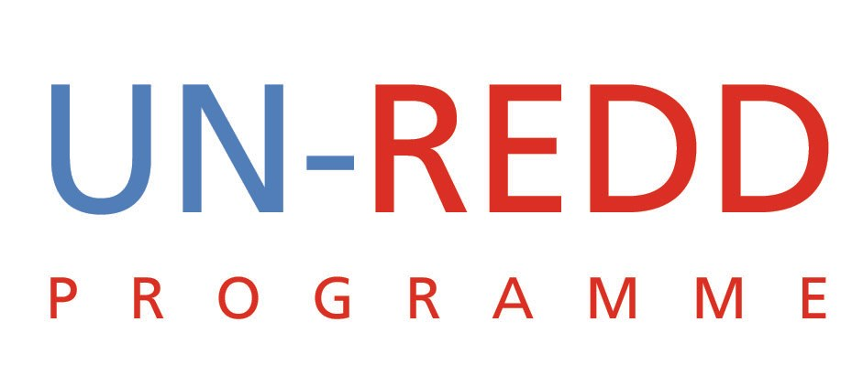

Update prepared for
Brazil-DRC-Indonesia Technical Workshop on REDD+

UN-REDD PROGRAMME

Introduction
The UN-REDD Programme was established in June 2008 and became operational with its first contribution from the Government of Norway in August 2008. The UN-REDD Programme Policy Board was established in March 2009, and since then, has met three times to decide on fund allocations, and to review and endorse UN-REDD activities and guidance. A Secretariat has also been established. The UN-REDD Programme played a catalytic role in raising awareness, knowledge and consensus in preparation for the Conference of Parties of the United Nations Framework Convention on Climate Change in Copenhagen in December 2009.

Strategic Framework
The Programme has two components: (i) assisting developing countries prepare and implement national REDD+ strategies and mechanisms (national programmes); (ii) supporting the development of normative solutions and standardized approaches based on sound science for a REDD+ instrument linked with the United Nations Framework Convention on Climate Change (UNFCCC) (global programme). The nine pilot countries are: Bolivia, the Democratic Republic of Congo (DRC), Indonesia, Papua New Guinea, Panama, Paraguay, Tanzania, Viet Nam and Zambia. The REDD+ mechanism was significantly advanced in the Conference of the Parties in Copenhagen in December 2009.

As defined in the UN-REDD Programme Framework Document, a primary objective of national actions is to facilitate and broker the challenging national process in which REDD+ actions are defined and agreed. National actions are identified and led by the host government and supported by the UN Country team. As “honest brokers” to support country-led development programmes and to facilitate the informed involvement of national stakeholders, particularly forest-dependent local communities, UNDP, UNEP and FAO aim to provide critical assurances necessary to help establish a national REDD+ institutional framework. The application of UNDP, UNEP and FAO rights-based and participatory approaches helps to ensure the rights of indigenous and forest-dwelling people are protected and the active involvement of local communities and relevant institutions in the design and implementation of REDD+ plans.

Using their convening power, FAO, UNDP and UNEP bring together experts and scientists to develop the global monitoring, assessment, verification and financial components. The UN-REDD Programme works closely with other REDD+ actors including the World Bank, bilateral donors, research institutions, NGOs and potential investors.

Governance Arrangements
Overall leadership of the UN-REDD Programme Fund is provided by its Policy Board. The Terms of Reference and Rules of Procedure, which were approved at the first meeting of the Policy Board set out the process for fund allocation.

UN-REDD Programme Policy Board is made up of representatives from pilot countries, donors to the multi-donor trust fund, Civil Society, Indigenous Peoples and UN organizations. In addition, the Policy Board includes observers from indigenous people and civil society organizations from the each of the regions, the Global Environment Facility, the World Bank’s Forest Carbon Partnership Facility hosted by the World Bank, and the Secretariat of the United Nations Framework Convention on Climate Change. Other observers have participated in the Policy Board meetings. By the end of 2009, in addition to the nine pilot countries, five additional countries, Argentina, Cambodia, Ecuador, Nepal and Sri Lanka were granted observer status. The Policy Board met three times in 2009.

Countries
The initial nine pilot countries are: Bolivia, the Democratic Republic of Congo (DRC), Indonesia, Papua New Guinea, Panama, Tanzania, Viet Nam and Zambia. All countries have initiated work on their joint programmes, and six have received approvals for their joint programmes. Of these, three—DRC, Vietnam and Indonesia--had submitted complete documentation required for fund transfer by the end of December, 2009. Below is a status of approvals and transfers.
Country | Joint Programme Title | Participating UN Organization |  |  | Total Approved Budget US Dollars | Date of Transfer(s)
Country | Joint Programme Title | FAO | UNDP | UNEP | Total Approved Budget US Dollars | Date of Transfer(s)
Democratic Republic of Congo | UN-REDD DR Congo Quick Start Programme - Year 1 | 583,150 | 925,550 | 374,500 | 1,883,200 | 24 June 2009
Indonesia | UN-REDD Indonesia | 1,498,000 | 2,996,000 | 1,150,250 | 5,644,250 | pending
Panama | UN-REDD Panama programme | 2,189,000 | 2,067,350 | 1,043,650 | 5,300,000 | N/A
Papua New Guinea* | UN-REDD Programme - PNG Quick Start Initiative | 1,016,500 | 1,568,534 | - | 6,388,884 | N/A
Tanzania | UN-REDD Programme - Tanzania Quick Start Initiative | 1,498,000 | 2,568,000 | 214,000 | 4,280,000 | N/A
Vietnam | UN-REDD Viet Nam Programme | 1,690,814 | 2,501,128 | 192,814 | 4,384,756 | 6 Oct. 2009
International | UN-REDD Programme - International Support Functions | 2,738,899 | 2,812,809 | 4,010,297 | 9,562,005 | 2 Feb. 2009  11 Sept 2009
Total Approved |  | 11,214,363 | 15,439,371 | 6,985,511 | 37,443,095

*The Policy Board approved an 'earmark' of 3,803,850 for the PNG joint programme. UN agency distribution to be provided.
UN-REDD Secretariat
The UN-REDD Secretariat was established in Geneva in 2009. It comprises of a head of the office, and professional staff to coordinate, implement and oversee the UN-REDD Programme, including serving as the Secretariat to the UN-REDD Policy Board.

The United Nations Development Programme’s Multi-Donor Trust Fund Office (MDTF Office) has been designated as the Administrative Agent for the MDG-F. Its responsibilities as Administrative Agent include the receipt, administration, and management of contributions from the Donor; disbursement of funds to the Participating Organizations in accordance with instructions from the UN-REDD Programme Policy Board; and consolidation of narrative and financial reports produced by each of the joint programmes and Participating Organizations.

The MDTF Office performs the full range of Administrative Agent functions in accordance with the UNDG-approved “Protocol on the Administrative Agent for Multi-Donor Trust Funds and Joint Programmes, and One UN Funds.”

Approval Process
Joint Programmes from the pilot countries are developed locally and are subject to a multi-stakeholder in-country validation process. They are then reviewed by an independent technical reviewer, and once any review comments have been addressed, submitted to the UN-REDD Programme Secretariat for further processing. The Secretariat reviews the submissions and provides inputs to the Policy Board for approval.

Financial Performance
In 2009, deposits to the fund increased from US$35 million to US$54 million. US$37 million were allocated to seven joint programmes—US$24 million (+ earmarking of 3.8) for six countries, and US$ 9.6 million for the international support functions. Of the allocated amount, nearly US$ 16 million were transferred to the Participating UN Organizations in three joint programmes. Informal updates show that of the amounts received, US$6.3 million were disbursed.

Joint Programme Approval and Fund Transfer

Chart 1: UN-REDD National Programme Development Process:

In October 2009, five new countries were welcomed to the Programme and given observer status to the UN-REDD Policy Board: Argentina, Cambodia, Ecuador, Nepal and Sri Lanka. Current UN-REDD funding is programmed for its nine pilot countries, but observer countries can take advantage of many other benefits of the UN-REDD Programme, such as networking, knowledge sharing and creation, facilitated by the UN-REDD Programme’s online community of practice through its dedicated workspace. Observer countries can also participate in global and regional workshops and have official observer status at UN-REDD Policy Board meetings.

National Programmes
Of the nine initial pilot countries, UN-REDD Programmes in Bolivia, Paraguay and Zambia continue to work on preparing their joint programme proposals, while all others have had their joint programme proposals approved by the UN-REDD Policy Board. By February 2010, Tanzania, Viet Nam and the Democratic Republic of Congo (see spotlight box below) had reached or gone beyond their inception phases; Panama, Indonesia (see following spotlight box) and Papua New Guinea were in their elaboration phase; and the remaining countries were finalizing the formulation of their proposals.

Spotlight on the Democratic Republic of Congo
The initial DRC UN-REDD programme aims at putting in place the enabling conditions for a REDD strategy in the Democratic Republic of Congo. It was elaborated through a qualitative dialogue with governmental and non-governmental stakeholders, both national and international. The National Coordination ("Coordination Nationale"), established by the Government pilots the REDD process and the implementation of UN-REDD and FCPF programmes. It comprises the National Coordinator (nominated by the Government) and a International technical Assistant (funded by AFD/WWF), a UN-REDD lead technical Advisor (Conseiller Technique Principal), an IEC specialist; a administrative responsible and an accountant.
Engagement of stakeholders at all levels is an overarching component of REDD readiness activities in the DRC. This includes:
1. Strong engagement of Indigenous Peoples and Civil Society with:
- The development of Information, Education and Communication (IEC) materials
- The creation of a civil society REDD working group, with whom planning exercices are undertaken as part of the Initial Workplan
- Representation of civil society on the REDD National Committee, as stated in te REDD Decree signed on 23 November
- Four members of civil society have been financed to be part of the DRC's delegation during the forthcoming negotiations at the UNFCCC COP-15
2. Cooperation with COMIFAC - This will be crucial to identify and manage REDD leakage points, i.e deforestation trends simply shifting from one country onto another in response to different policies and levels of enforcement.
3. Close and integrated collaboration between the UN-REDD programme and the Forest Carbon Partnership Facility
Ongoing REDD readiness activities include:
- Coordination and consultation, including awareness raising workshops and the development of an Information, Education and Communication plan
- REDD strategy: terms of reference are under development; several studies underway; a division is being created within the MECNT
- Reference scenario: terms of reference are being developed
- MRV system: planning for a national forest carbon inventory is underway; a training project for carbon measurement is with the University of Kisangani is being considered.
Selected highlights
In March 2010 the R-PP jointly developed by UN-REDD Programme and the World Bank’s FCPF will be presented to the UN-REDD’s Policy Board and subsequently to the FCPF Participant Committee for approval. This is the first time that such a coordinated approach had borne concrete results and is seen as a pioneering feat enabled because of the presence of the Coordination Nationale. The Decree establishing the REDD institutional framework in the DRC and the participation of civil society was signed 23 November 2009. The DRC Civil Society Working Group on Climate and REDD organized a mobilisation of young people and women in support of REDD in Kinshasa on 3 December. A number of other technical, institutional and organizational innovations are currently underway. An example is the development of the REDD reference scenario which will be based on national circumstances. This will feature modeling of the future evolution of forest cover. This work is underway through the study on the causes of deforestation.

Spotlight on Indonesia
Indonesia has moved progressively on REDD (Reducing Emissions from Deforestation and forest Degradation). In mid 2007, under the guidance of the Ministry of Forestry, a multi-stakeholder forum named the Indonesian Forest and Carbon Alliance was established. IFCA contributed significantly towards REDD readiness in the country. The UN-REDD joint program aims to facilitate the Indonesian government to develop a REDD architecture that will allow a fair, equitable and transparent REDD implementation significantly contributing to a sustainable reduction of forestry related greenhouse gas emissions. The Joint Programme will be guided by the National REDD strategy. Three Outcomes will be pursued:
Outcome 1: Strengthened multi-stakeholder participation and consensus at national level
Outcome 2: Successful demonstration of establishing a reference emission level, MRV and fair payment systems based on the national REDD architecture
Outcome 3: Capacity established to implement REDD at decentralized levels
Multi-stakeholder participation in REDD is of critical importance to REDD readiness. Recognizing this, the government worked through IFCA on communication/coordination/consultation of stakeholders working on forest and climate changes in Indonesia; for example, IFCA organized and streamlined stakeholder input, and published a "consolidation report". This describes the initial outline of a REDD supply chain, options to set up the reference emission level, carbon monitoring and payment distribution systems, among others.
Selected highlights
Indonesia is the first REDD country to have passed a legislation governing revenue sharing for carbon market payments in the preservation of its forests. Under the rules, up to 50 per cent of all carbon credit revenues envisaged would go to various levels of government and between 20 and 70 per cent given to forest communities, distributed by a trust fund.
On 23 November the Indonesia UN-REDD Programme document was formally signed by and the Ministry of Forestry, UNDP and FAO. The signing was witnessed by Norwegian Minister of the Environment and International Development, Mr. Erik Solheim, State Minister for Forestry, Mr. Zulkifli Hasan, Chairman of National Council of Climate Change (DNPI), Mr. Rachmat Witoelar, State Minister for Environment, Mr. Gusti Muhammad Hatta, and DNPI. On 30 October the Indonesia UN-REDD Programme Document was approved by the Ministry of Forestry having previously been formally endorsed by Bappenas (the National Development Planning Agency).
An two-part Earth report documentary was filmed by Television for the Environment (TVE) for the BBC and was first broadcast during the 3rd week of October.
Preparatory work to establish the Programme Management Unit Office is ongoing. This work includes: 1) appointment of NPD, 2) recruitment of key programme staff, 3) Programme Office installation and 4) registration of the JPD for implementation through the Ministry of Finance. The target date for the completion of these efforts is March, 2010.

Further information on all nine UN-REDD national programmes in partner countries can be found at: http://www.un-redd.org/UNREDDProgramme/CountryActions/tabid/584/language/en-US/Default.aspx

UN-REDD Global Programme
The UN-REDD Global Programme provides support to country actions on REDD+ readiness through international support functions, such as expert consultations, operational and practical guidelines, technical reviews, analyses, development of knowledge and sharing of experience. It also aims to increase international confidence and understanding about the potential REDD+ mechanism under the UNFCC. The outcomes of the global programme are: 1) improved guidance on Measurement, Reporting and Verification approaches; 2) increased engagement of stakeholders in the REDD+ agenda; 3) improved analytical and technical framework of multiple benefits for REDD+ decision makers; 4) increased knowledge management, coordination and communication.

The Global Programme has made progress in all the outcomes. In the area of MRV (see section below ‘spotlight on MRV’), a breakthrough was made in remote sensing by making available ready-to-use remote sensing data on a website free of charge. This facilitates sound and objective estimates of global forest and land cover change. Progress has also been made in monitoring multiple benefits of forests, for example, through spatial analysis of which illustrates areas that are high in carbon are also high on other benefits such as biodiversity. In addition, the UN-REDD Programme has also started elaborating its governance activities and has promoted independent forest monitoring through collaboration with CSO partners.

Spotlight on MRV and multiple benefits
A cost-effective, robust and compatible system for measurement, reporting and verification (MRV) of greenhouse gas emissions is an essential component in the implementation of REDD+. MRV is one of the UN-REDD Programme’s main work areas, and considerable progress was made on this front in 2009.

Achievements
As member countries began the implementation of their National Programmes, the UN-REDD Programme worked with them to develop MRV methodologies tailored to their specific REDD+ initiatives. In Democratic Republic of Congo and Tanzania, for example, they are now able to generate and incorporate estimates for forest-related emission factors into their national Green House Gases inventories. And this progress is having a ripple effect-- the DRC’s National Forest Inventory will, in turn, be a template for the definition of a possible regional approach in the Congo Basin.

The UN-REDD Programme also worked diligently throughout 2009 to develop a “framework proposal” for a fully-operational national MRV system that will support the integration of REDD+ mechanisms into other mechanisms under the United Nations Framework Convention on Climate Change (UNFCCC). To this end, FAO signed a Memorandum of Understanding with Brazil’s Space Agency (INPE) in December, to jointly develop a land monitoring systems using remote sensing data that will help individual countries establish MRV systems.

Some of the most noteworthy developments for MRV came out of a number of important events that the UN-REDD Programme co-sponsored throughout the year, including: the National Forest Inventory workshop in India in April; the GHGs Inventory workshop in Bonn in August; the Forest Degradation Expert meeting in early September at FAO in Rome; and the Capacity Building Workshop in Barcelona in November.

In September, the Programme convened an MRV meeting with representatives from UN-REDD countries, FAO, UNEP, UNDP and a few other institutions, during which an MRV framework and toolkit were presented and discussed with participants from various UN-REDD countries. Members presented the current status of their MRV developments and gave valuable inputs on the MRV strategy and tools being developed by the UN-REDD Programme. Countries were able to learn from the experiences of other UN-REDD projects, establish priorities for capacity building activities, and gained technical advice on MRV systems.

COP-15 in December was also an important milestone for MRV, as world leaders recognized the importance of MRV as an essential component in REDD+ implementation.

In addition to their carbon storage role, forests provide many other ecosystem services to society. The nature of these services varies from place to place, and includes water regulation, soil protection, non-timber forest products including food and fibre, climate regulation and biodiversity. As most tropical forests deliver a wide range of these essential services, there are many ways in which REDD+ can provide ‘multiple benefits’ to countries and forest communities.

A dedicated two-week spatial analysis workshop on co-benefits was held in Cambridge, with UN-REDD Programme staff at UNEP’s World Conservation Monitoring Centre (WCMC) and staff from Tanzania’s Ministry of Natural Resources and Tourism. The group undertook national-scale analyses of co-benefits and other factors, including population density, honey/beeswax/gum production, and mammal and amphibian species richness. In addition, the workshop produced a new combined soil and biomass carbon map for Tanzania, which was launched at Forest Day 3 in December.

To explore the relationship between carbon storage in forests and ecosystem services at a global scale, a revised map of carbon storage in biomass and soils in various countries was also produced at UNEP-WCMC, in collaboration with Stanford University (USA) and the EC’s Joint Research Centre and with additional support from the German government, for use in the UN-REDD Programme and elsewhere.
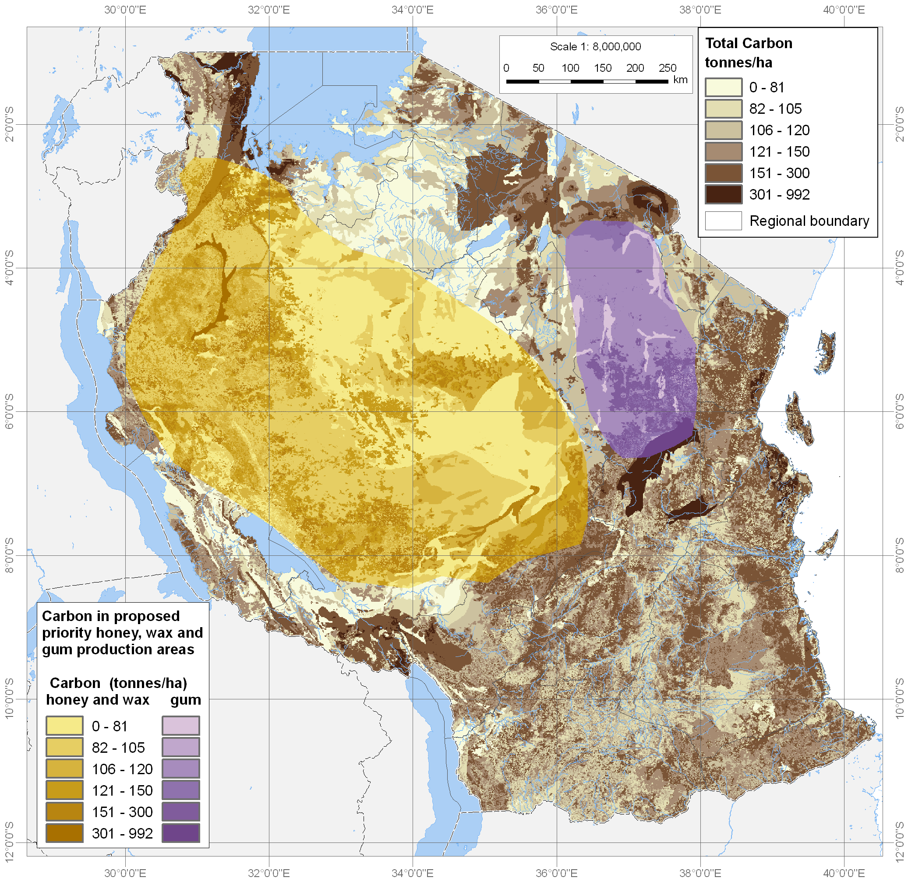
The UN-REDD Programme worked with Tanzania in 2009 to produce this initial combined soil and biomass carbon map for Tanzania, which was launched at Forest Day 3 in December. Here it is shown together with priority areas for selected non-timber forest products (Tanzania National Land Use Planning Commission 2006).

Regarding the engagement and participation of indigenous peoples and civil society organizations, the UN-REDD Programme supported activities at both global and national levels. The Programme drafted and built consensus for the UN-REDD Operational Guidance on the Engagement of Indigenous Peoples and other Forest Dependent Communities, and supported national UN-REDD programmes to fully engage stakeholders. The Programme has also made progress towards harmonizing the UN-REDD approach to engagement with the FCPF approach. The good practice of engaging stakeholders in the DRC was documented and widely distributed, and the programme has developed recommendations on Free Prior and Informed Consent and recourse mechanisms.

Outreach on REDD+, particularly in preparation to the COP15, included a High Level Event presided by the United Nations Secretary-General, and attended by the World Bank President, 15 heads of state and government, and over 100 countries and 150 dignitaries and leaders from international and non-governmental organizations, academia, think tanks and the private sector. In addition, two 30 minute documentaries have been broadcast on BBC World and 3,500 media briefing packs were distributed at the COP 15. The UN-REDD Programme also collaborated with development partners to produce supporting material for media to report on REDD+.

The UN-REDD Programme also undertook a number of activities to support countries to maximize accumulation of socio-economic and social co-benefits forests provide through REDD+. Along these lines, a comparative review of REDD+ legislative frameworks was prepared, a publication on ‘Making REDD+ Work for the Poor’ and discussions on incorporating gender perspectives and social impact of REDD+ were initiated. In addition, tools to encourage the capture of ecosystem service co-benefits were developed.

Lastly, the UN-REDD Programme increased knowledge management, coordination and communication both with the World Bank as well as amongst the participating UN organizations, in part through its online collaborative workspace (www.unREDD+.net). The Programme is working closely in coordination with the Forest Carbon Partnership Facility, hosted by the World Bank, both at the international level, harmonizing normative frameworks and organizing joint events, and at the national level, where joint missions and sharking of information are producing support interventions. It is also working closely with the Forest Investment Program of the World Bank. Other partners working closely include the UNFCCC, GEF, UNFF secretariats as well as donors, indigenous and civil society organizations at the global and national levels and academia.

To raise the awareness of REDD+, a number avenues, such as internal and external websites (UNREDD.net; UN-REDD.org) newsletters, and a multi-media campaign have been initiated. The visibility of the programme has increased especially on the internet where visits on the UN-REDD website has increased to more than 30.000 monthly and still increasing by 2500 visits per month.

All of the global activities have been supported through the UN-REDD Programme Secretariat which was established in Geneva in mid-2009. Most posts in the Secretariat have been filled by the end of December 2009.

Accountability and Transparency
In 2009, the MDTF office developed the MDTF Office GATEWAY, a knowledge platform, combining easy access to more than 4000 relevant reports and documents, with tools and tables displaying financial data in real-time from the MDTF Office accounting system on donor contributions and transfers to the Participating UN Organizations. It is designed to provide transparent, accountable fund-management services to the United Nations system to enhance its coherence, effectiveness and efficiency and can be found onhttp://mdtf.undp.org.

The Programme’s most important communications tool is its public website- www.UN-REDD.org- and during 2009, the site was significantly enhanced and re-launched in June. It now features more dynamic and up-to-date news and information about the Programme’s national and global activities, as well as broader REDD+ issues. The site now also features social networking tools such as Twitter, blogging and a link to the UN-REDD Programme Channel on YouTube.

Conclusion
2009 marked the first full year of UN-REDD operations. It has increased its funding platform, and has engaged with more participating countries taking interest. US$16 million were transferred to three joint programmes. The joint programmes have reported increased stakeholder engagement including at highest political level, progress in Measurement, Reporting and Verification approaches, and establishment of national REDD+ coordinating structures. There has been growing interest in the UN-REDD Programme, with five additional countries that were granted observer status and a number of other countries have requesting participation, as well as additional funding and donors. In addition, the UN-REDD Programme has supported heightening the visibility of the REDD+ issue in international fora, as well as enhanced coordination between the different actors including the World Bank.

