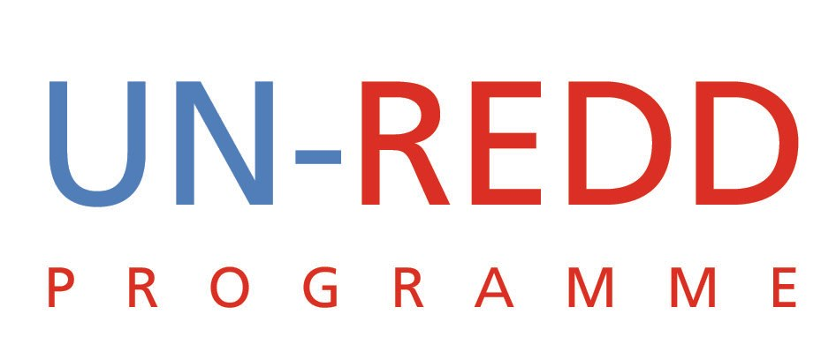 | UN-REDD/PB3/3

Press Release of the Secretary-General’s High Level Event on REDD, 23 September, New York
UN-REDD PROGRAMME
October 2009

Press Release
High Level Event on Forests and Climate Change Underscores North-South Agreement and
Support for New Emissions Reduction Mechanism, REDD
In an unprecedented display of cooperation between developed and developing countries on climate
change, fourteen Heads of State gathered at UN headquarters in New York to publicly express their commitment
and support for REDD. They asserted that the new climate change agreement to be negotiated in
Copenhagen must address in an effective and equitable way the role of forests as a mitigation option.

Following the previous day’s Summit on Climate Change, and ahead of the critical Climate Change
Conference in Copenhagen taking place this December, UN Secretary‐General Ban Ki‐moon convened
leaders and dignitaries from developed and developing countries to dialogue and publicly support REDD.
The event marked the largest gathering of countries to date on the issue of REDD, with the participation of
over 100 countries and over 150 dignitaries and leaders from international and non‐governmental
organizations, academia, think tanks and the private sector from around the world concerned with climate
change and forests.

“This convergence of world leaders highlights a positive, growing momentum in support of REDD and signals
how this mechanism may be feasible from a technical, financial and collaboration perspective,” Secretary‐
General Ban said about the event.
Industrialized countries (Australia, Belgium, Norway, Japan, Sweden, the United Kingdom) and World Bank
President Zoellick took the stand to support progress and actions on REDD.

“I believe immediate action on REDD+ should be included in the Copenhagen agreement,” said Prime
Minister of Sweden Mr. Fredrik Reinfeldt, speaking on behalf of the European Union. “It’s an important step
in the right direction – for our people, for the biodiversity of our forests, and for our climate.”
“One of the most important elements [in Copenhagen] is that we have to agree on how to save our forests
and halt deforestation,” said Norwegian Prime Minister Jens Stoltenberg. “We will allocate up to $500
million yearly to reduce deforestation and forest degradation.”

Australia is already investing AU$200 million (US$175 million) in Indonesia and Papua New Guinea.
Heads of States and high ranking officials from Bangladesh, Bolivia, Colombia, the Democratic Republic of
Congo, Ecuador, Gabon, Guyana, Indonesia, Papua New Guinea, the People’s Republic of China and the
Republic of Congo also underlined their commitment as well as the urgent need for action.

“We can’t afford to wait for the lessons of the pilots that are ongoing now,” warned President of Guyana Mr
Bharrat Jagdeo. “We need to act now.”
“By associating conservation and sustainable management of forests, REDD is a winning formula for the
climate and an efficient solution for mitigating climate change,” said President of the Republic of Congo
Denis Sassou‐Nguesso.

Participating developing countries also expressed their willingness to undertake significant cuts in
deforestation and forest degradation, provided that they receive sufficient financial support. Guyana, for
example, has committed to offer all of its forest to REDD, in exchange for the right financial incentive.

A report by the Informal Working Group on Interim Finance for Reducing Emissions from Deforestation and
Forest Degradation (IWG‐IFR) estimates a 25% reduction in deforestation could be achieved with a financial
commitment of 15‐20 billion Euros (US$22‐29 billion) by 2015. “This translates into 1.5 cent of a dollar per
day for each person in industrialized countries,” underlined Mr Bharrat Jagdeo, President of Guyana.

This would represent a reduction of 7 gigatonnes of CO2 equivalent by 2015. Without comparison, this
would be the biggest contribution to fighting climate change in that time period.

“Without global commitment, there will be no deal in Copenhagen,” said Prime Minister of Papua New
Guinea Mr Michael T. Somare. “We can’t seal the deal without REDD.”

There are still questions that need to be solved, such as the funding mechanism for REDD, and questions
related to how the funds and technology would trickle down to forest‐dependent communities. However,
there was no question about the fact that REDD is one of the smartest, quickest, and most cost‐effective
investments the world can make to combat climate change and reduce greenhouse gas emissions. It is now
clear that in order to constrain the impacts of climate change within limits that society will reasonably be
able to tolerate, the global average temperatures must be stabilized within two degrees Celsius.

“If we don’t reach an agreement on REDD in Copenhagen, those who will suffer most are the poor
countries,” said Nobel Peace Prize Laureate Wangari Maathai, speaking at a reception following the event.

“But in any case everyone will be worse off, since climate change will affect both developed and developing
nations alike. So it is in our common interest to do whatever is possible to reduce the threat posed by
climate change on our people.”

“With all these countries speaking on REDD, I don’t see why we shouldn’t be able to have an agreement at
Copenhagen,” noted Ms Victoria Tauli‐Corpuz, Chair of the UN Permanent Forum on Indigenous Peoples. “I
appeal to all countries to fully include forest communities and indigenous, otherwise REDD will not succeed.
Yet, we simply cannot afford to fail this time.”

