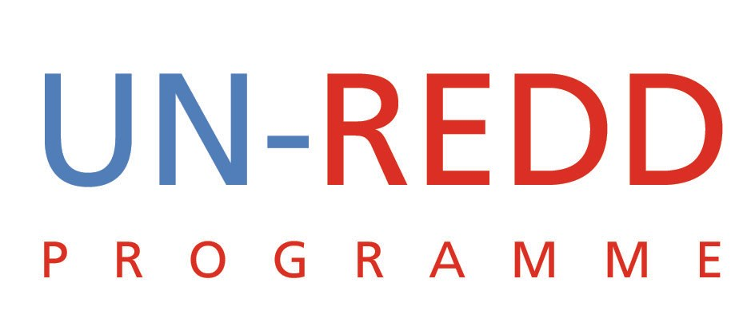

Conference Call: Summary of Decisions

UN-REDD PROGRAMME
June 29 2009
- Review Concept Note on Future UN-REDD positioning.
The concept note was circulated for comment and discussion during the teleconference. It is important to note that some of the contents are designed to stimulate discussion and will not necessarily be included in the final version.

Key decisions:
- The general consensus was that the concept note should be bold and clearly demonstrate that UN-REDD is a key player, has much to add and has a winning strategy.
- We need to urgently embark on an aggressive but targeted communications campaign especially going into Copenhagen.
- We should start working on clear deliverables for Copenhagen such as MRV etc
- Speed is of the essence
- By Friday July 3 we will get one page summaries on stakeholder and governance issues from UNDP, MRV from FAO and multiple benefits from UNEP
- We should consider including REDD into broader national development processes
- It was agreed that we would have another teleconference on Friday July 3 at the usual time to further discuss the concept note
- There was consensus that we should present the concept to Hans

- Update on Panama approval of Country Programme.
After a briefing on the progress to date the following was agreed:
- The principals of the three agencies have held discussions and generally support the approach
- The issues raised by the RC were noted and it was agreed that the issue of improved communication was a good one and something we should follow-up on
- The reference to postponing the submission of the NJP to the secretariat till October was raised. It was note that this had not been communicated to the government of Panama.
- Before responding to the RC’s letter to Yemi we should make sure that we have internal cross-referencing. We should check with the implementing agencies to make sure that the reply to the RC is consistent with the internal consultations that each agency has had with its representative in Panama.
- We should aim to provide the PB with some progress report on the approval process when the PB II report is sent out.

- Sept 21st Head of State event: This was the first opportunity of the small group coordinating preparations to provide feedback. Ibrahim Thiaw joined the call for this agenda item.

Key decisions and actions:
- Norway has accepted to co-host. DRC, the other co-host was consulting internally and a decision was expected shortly.
- The idea of having more than two countries hosting the event would likely complicate the logistics for the meeting. Resolved to limit co-hosts to two but that different roles for other countries can be considered
- To avoid creating a sense of exclusivity we should invite as many countries as possible
- Each agency should consider designating two representatives; one focusing on technical inputs and the other on diplomatic issues. The latter should be someone senior enough to handle diplomatic, policy and protocol matters. UNEP has designated Ibrahim. UNDP and FAO to provide names.
- To make this event a success we need to ensure excellent internal as well as external communications and to work closely with the SG’s office.
- A separate teleconference to discuss the meeting agenda was scheduled for Tuesday June 30 at 17:30 Rome time.
- Nikals to circulate event concept note

- Copenhagen: World Bank FCPF (Ken Andrasko) is inviting UN-REDD to join them in a joint Side Events at Forest Day 3 and in main COP venue. We should also decide if we want to do something in addition.
Key decisions:
    - In view of our strategy discussion it was agreed that we should keep our options open with respect to whether or not we hold a joint side-event with FCPF at the COP.
    - However, it was agreed that we should probably consider having a joint event with FCPF at Forest Day III but not investment too much time in this
    - It is more important that we have greater visibility at the COP and so we should put effort into organizing a side event there. Strategically, presenting a unified platform with FCPF at the COP would create a positive vision that a future financing mechanism for REDD is better served by a unified platform and would likely prevent the emergence of a “Third Way” such as GEF.
    - Niklas will lead in terms of getting UN-REDD Programme registered as a separate organization or through one of the implementing agencies and alerting everyone to intervene to emerging issues.

- New Donor strategy:
This issue was discussed under agenda item 1and the following was agreed:
- Agreed to have a donor working group comprising Mario (UNEP), Peter (FAO) and Charles (UNDP) with Yemi from the secretariat
- Look into a donor strategy and within that to consider the following items:
  - Who are the key donors to target? Who should approach the donors?
  - Is the MDTF restricted to “Quick Starts” or should it extend to the products being articulated in our new strategy?
  - Should funds be ear-marked or not? The concept note implies they are ear-marked.
  - Agreed that the group would have a teleconference call on Tuesday at 21:30 Jakarta time.

Finalisation of PB II Report:
- It seems that there is still some concern about the structure and quality of the report and that more work needs to be done before it is circulated.
- Agencies and secretariat were encouraged to submit their comments as soon as possible. [Telephone connection was lost at this point].

