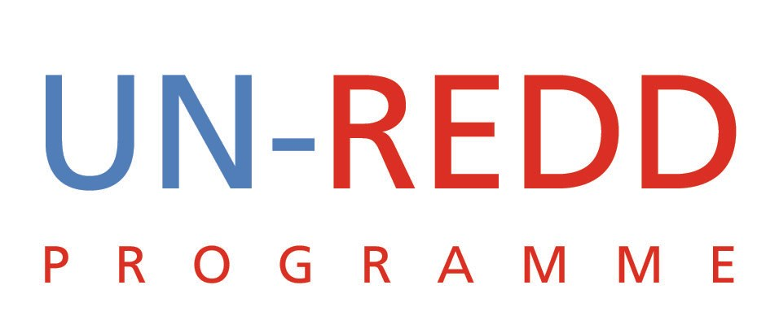

Conference Call: Summary of Decisions

UN-REDD PROGRAMME
June 22 2009

- Review Concept Note on Future UN-REDD positioning.
A 2-day brainstorm to develop our strategy between now and Copenhagen was held. Since the concept was not ready the following was agreed:
  - Finalise concept note by Friday 26 and circulate for comments
  - Hold an internal teleconference call Monday29
  - Run he concept past Norway (Hans) on Tuesday 30.
  - There was no discussion on how to engage the Policy Board

- Update on Panama approval of Country Programme. Tim C will give us an update.
  - The planned Validation Meeting is unlikely to take place this week as previously proposed. Neither Eduardo nor the representative of the Indigenous Peoples is available and the government has not called the meeting.
  - The UN Resident Coordinator (RC) received a letter from Minister Castro de Doens of ANAM last Thursday which was copied to many people around the world. This effectively puts the ball back into our court. To get things moving again Tim proposed that the RC write to ANAM making it clear that the UN stands ready to support Panama’s National Programme and will participate in a Validation Meeting called by the Government. The RC is proceeding very cautiously and requesting more information before he does anything.
  - Meanwhile David Kaimowitz has agreed to do the independent review.

Decision: It was agreed that the agencies would contact their principals in Panama to encourage the RC to move things forward.
- FCPF decisions. Tim C provided some information on the decisions taken at the FCPF meeting.
  - Panama:
    - The R-Plan can be accepted for funding but more due diligence will be required.
    - The WB review of the R-Plan states that the incoming government should be consulted about this proposal or at least be made aware of it.
  - Harmonisation:
    - The idea of a one day FCPF-UN-REDD discussion on harmonization was not supported by Switzerland (Daniel) and Etienne (Gabon). Switzerland argued that such a meeting would not likely achieve much and that FCPF had enough business to go through without adding another day.
    - We were informed that there might be logistical issues related to any back-to-back October meeting with FCPF in DC
    - FCPF March 2010 Participants Committee will meet in Gabon. This decision provides the first opportunity for UN-REDD to hold a separate meeting.
Decision: Yemi to clarify with Benoit:
- Whether the idea of a joint one day meeting back-to-back with the combined meetings in DC on harmonization is still possible
- Get more details on the logistics for the October meeting
- Collaborative Partnership on Forests Retreat:
Peter and Mario are attending the meeting and there are likely to be strategic issues around future REDD financing.
Decision: Mario and Peter will be liaise ahead of the meeting
- Latest Developments on MRV Guidelines.
Barney and Mario will work on the background note in Rome during the week of June 2. There has been no feedback from Australia regarding a planned meeting for key leaders in the field to agree on MRV guidelines for REDD countries. Australia is supposed to prepare an agenda and invitation list for the meeting.
Action: Charles will contact Australia and remind them of their obligations.
- Proposal for finalizing the budget revisions:
Concern was raised that the revisions had a 18 month timeline for the Global Prorgamme and 12 months for the secretariat.
Decision: It was agreed that there should be one timeline of 18 months but before finalizing the different agencies were to verify that there would be adequate funding.
- Other Business:
  - High Level Event in September
It was agreed that UNEP should chair a working group that would be responsible for coordinating arrangements.
    - Apparently the DRC has agreed to co-host possibly with Norway. Norway has been approached.
  - Ecuador: Rainforest Foundation of Norway wrote informing us that they had received Norwegian funding to work with Ecuador on social issues and REDD. They wanted to know UN-REDD’s decision to Ecuador’s request to join the Programme. It was agreed that Yemi would write to Rainforest Foundation stating our desire to engage with Ecuador.
  - Second Policy Board Meeting Report: The final report of the PB meeting is on workspace and comments are to be received by close of business on Wednesday.

