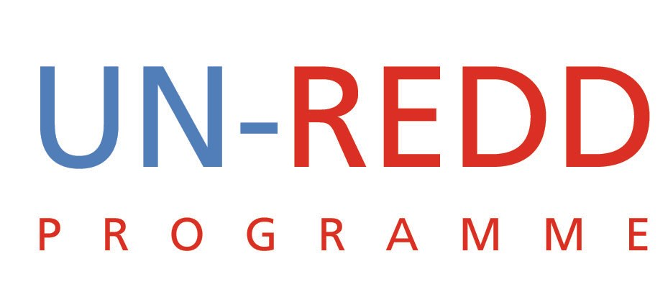

DONOR STRATEGY
Summary of Teleconference Discussion
UN-REDD PROGRAMME
June 30 2009
During the Monday June 29 teleconference a small group was convened to brain storm a fund raising strategy with a focus on Germany. The group comprising Charles, Peter, Mario and Yemi held a teleconference on Tuesday June 30.

Rationale:
Moving forward, the UN-REDD Programme has recognized the need to broaden its donor base beyond Norway. Such a diversification of the funding base will give the UN-REDD Programme greater legitimacy.
Further, in order to expand its work beyond the 9 Quick Start countries, the Programme needs to raise significantly more resources.
The group agreed that the donor strategy has to be guided by the strategic concept currently under development. This strategy concept has already identified funding requirements of up to USD 260 million between July and December.
Priority Donor Countries:
After some discussion it was agreed that between now and December we target the following donor countries:
- Germany
- Sweden
- Australia
- USA
- United Kingdom
Target
By December we should aim to raise USD 260 million from the above donors.
Discussion Points
- Be very specific about the funding window/s we intend to target since each donor country has several funding windows that are often not related
- Some of the donors might want to work more bi-laterally with REDD countries which can lead to ear-marking.
- The UN-REDD programme may want to explore the funding opportunities presented by these bilateral funding arrangements.
- Regarding MDTF versus ear-marking the feeling is that we should be open to both and possibly look at the arrangement with Denmark where the funds are ear-marked but still go through the MDTF.
- Alexander Müller, FAO ADG, advises that the right level of contact for donor contributions from Germany is at the Directors level in the Ministry of Environment, ie the level just under the State Secretary. This means Mr. Urban Rid for Climate Change issues, and Mr. Jochen Flasbarth for Nature Conservation/Forestry (Mr. Freiberg works under him). Agree focal persons are as follows:
  - Sweden; Peter. We would likely require an official letter from secretariat (Yemi)
- Germany: Peter will coordinate this with Alexander Muller.
  - Alexander has kindly offered to be the contact point as he knows the persons mentioned in point 5 above personally and also knows the Government extremely well since his time as State Secretary. As soon as we have the strategy note with planned deliverables, we can then take the next step
  - Australia: Charles to build on contacts made through the MRV Guidelines initiative
  - United Kingdom: Mario and Yemi to explore a strategy. Charles proposed contacting Mark Malloch Brown (Former UNDP Administrator) whom he knows quite well.
- Agreed that Yemi would monitor progress and remind the team to follow-up on agreed actions.

