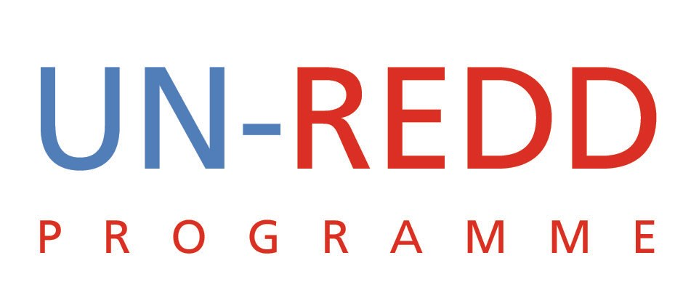

Points and Outcomes of Teleconference
UN-REDD PROGRAMME
27th July 2009

1 | Responding to requests to join UN-REDD programme
There was a lively discussion on how we should respond to frequent requests by countries to join the UN-REDD Programme and how we can translate these requests to strategic benefit.

Key points:
- Where possible requests should be signed by a minister or a senior government official
- We should not launch an “open call” to join the UN-REDD Programme
- Need to distinguish between countries like Ecuador and others hence we might want to consider seniority/formality when considering these requests
- We need to manage expectations
- We need to distinguish between countries requesting to join now and those in the post ‘quick start’ phase
  - The requests to join UN-REDD requires an urgent and immediate response as it is about legitimacy and demonstrates an interest in REDD
  - For those wanting to join beyond the quick start we need to link this to the new products that we are developing as part of our strategic note
- We might consider holding a side event with requesting countries and their requests to join UN-REDD could form the basis for them to request donors for additional funding
- To the extent possible we should have small missions to requesting countries to better understand their requests and interests. We need to find better ways to understand the nature of the requests so that we can respond appropriately
- At the moment UN-REDD could offer requesting countries:
  - Observe PB meetings at own cost. We could cast this as a privilege.
  - They can participate in regional workshops as a means of accessing knowledge on REDD
  - Assess how the global programme could assist countries in their readiness efforts
- RC could hold a meeting with national REDD counterparts and assess how the request fits with UN and other national programmes

What to do:
- Compile a list of all countries requesting to join UN-REDD and possibly develop a typology
- Formally recognize these requests and communicate them as a major development
- Engage with them e.g. organize a regional workshop/side event
Decision
- Small working group was asked to finalise this item and Invite countries that have expressed interest to observe policy board meetings
- The issue would be tabled at the next PB meeting for decision.

2 | Update on Heads of State event at the General Assembly
It was reported that the Coalition of Rainforest Nations was also planning a Heads of state meeting in parallel to ours. To avoid duplication and competition Norway has requested that we liaise with the Coalition and find a way for working together to host a single event. Two events would also likely over exposure Norway and they are concerned about becoming too visible. Kevin Conrad is the key person for the Coalition.

Charles has been in touch with Kevin who feels that the meeting:
- Should be inclusive
- Send a message that REDD is possible and viable
- Communicate that REDD needs additional financial support
- Confirm that FCPF and UN-REDD are collaborating on REDD
- Be a unifying G8-type meeting

Kevin is in touch with several countries in connection with the event:
- Algeria (On behalf of Africa/G77)
- Costa Rica
- Brazil
- UK (was concerned that this was moving forward without them)

Way forward
Request the Secretary General to play a stronger convening role and ask him to invite countries on behalf of Norway, DRC and three Agencies. This request should come from the Agencies as well as from the Coalition.

Questions that need closure
- How do we distinguish between the September 22 and 23 events?
  - On September 22 each head of state will make a statement and leave the room.
  - On September 22 they will stay in the room to have a discussion on REDD.
- How do we keep the coalition engaged?
  - They should mobilize participation from various countries.
  - The coalition can also convey to the secretary General a request for him to play a convening role.
3. What is the process to get a G8-type declaration? Declaration should:
- Sate that REDD is important
- That countries and donors should need to support UN-REDD and FCPF

The declaration would be prepared in advance. Each head of state should say why REDD is important and endorse the declaration. This risks the event looking more and more like the event of the 22nd. On the 23rd, we need to focus on what it means for REDD to work and what it will cost.
Decision
Identify communication strategies.

3. | Policy Board
- Dates: 3rd Policy Board Meeting: October 29-30 in Washington DC, USA
- Yemi will work on a draft agenda and circulate.
- Logistics:
- Updated participants list
- Book a room (same room as FCPF)
- Identify who has an office
  - Identify a logistics company to support the meeting
- Co-Chairs:
  - Mario will follow up with Angela about her continuing to co-chair till the end of the year, consistent with agreed procedures.
  - Panama: Could encourage the minister of Panama – this would send a strong message that Panama supports UN-REDD.

4. | Newsletter
The newsletter is necessary and should be produced frequently. There is already a lot of information on MRV, IP and the Policy Board and this can be packaged for different audiences.

Format
- A good layout/design is key
- A guest column should not be in the 1st issue
- We should aim to direct people back to the website
- Who do we get it to?
- Climate L
- CIFOR…etc
Decision:
  - First issue should focus on the key REDD issues and we should try to personalize the mailing of the newsletter.
  - Distribution of the newsletter should be at regular intervals and preferably at the middle of the month.
  - Include:
    - An item on hot REDD topics
    - CSO nomination of members
    - International Working Group on Interim Financial Resources (IWG-IFR)

5 | UN-REDD Working Groups
IWG-IFR
Kaveh to link to the wider group and whenever he is representing UN-REDD we should try to inform his engagement.
6 | Other Business
COP 15
Block book hotel rooms and rooms for side events
REDD Capacity Development Workshop
Tiina to share progress.

