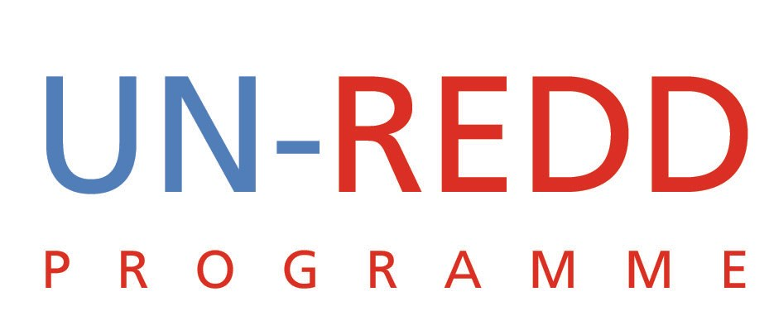

Points and Outcomes of Teleconference
UN-REDD PROGRAMME
20 July 2009

1 | SIDE EVENTS  - Registration, Observer status at COP 15  - FD3 and COP 15  - Regional capacity building workshop
a. Registration as observer at COP 15: The date to register UN-REDD as an observer at COP 15 has expired thus UN-REDD would not be able to request for a slot to hold a side event. There are 3 possible options:
- Request slot from one of the 3 implementing agencies. (Unlikely to happen)
- Request special consideration from UNFCCC. (This has not worked in the past) We could request SG’s office to assist get an observer status.
- Consider using the CEB option (but this would restrict us to a convening role)

Decision: Niklas and Charles to coordinate efforts to find a solution.
b. FD3 and COP 15: after much discussions the following was agreed:
    - It is important for UN-REDD to showcase its new products, expansion of UN-REDD countries, highlight the MRV work and follow-up on the heads of state meeting at the General Assembly. To do this we need to organize a UN-REDD focused side event during the first week of COP 15. This event will also try to line up countries that we want to join the expanded UN-REDD.
    - Similarly, we need to position UN-REDD and FCPF as well placed to be the platform for future REDD work. To do this a high profile joint event should be organized during the first week. The speakers at this event should be the most senior people that we can mobilize to grace the occasion such Kathy Sierra and the heads of the three agencies. One key message for this event will be that REDD is doable and that UN-REDD and FCPF have been working together towards this goal.
    - The third and final event would be at a joint FCPF-UN-REDD side event at Forest Day 3. This event will have a technical focus although with some overlap with number (ii) above.

c. Regional Capacity Building workshop: This workshop is being organized in Singapore by CBD. WCMC is attending and CBD has requested that UN-REDD participate. It was agreed that we should take advantage of this event especially given its links to our work on multiple benefits and our plans to hold regional consultations.

Decisions:
    - Prepare concept notes on each event. UNEP and Yemi will prepare concept notes on the joint FCPF-UN-REDD side events. Tim Clairs will prepare the one for UN-REDD alone.
    - It was greed that we hire a consultant to drive the preparations for the side events. Yemi to prepare the TOR for the consultant.
    - Yemi to write to Ken Andrasko of the WB and coordinate our approach including asking the WB to try to secure the second slot for the joint side event.
    - Regarding the proposal for a joint WCMC-CBD-UN-REDD side event at FD3 on forests and biodiversity it was agreed that this was a good idea.
    - UNEP to coordinate with WCMC regarding representation of UN-REDD at the Singapore meeting. Tim Clairs has also informed Tim Boyle about this meeting and UNEP should coordinate with Tim Boyle and define a role for him if needed.

2 | Communication plan with Norway  Who should be on the call?  Any additional inputs?
Isabelle has produced another version of the plan incorporating the inputs generated in NY. Isabelle explained the additional funding that is available to implement the plan. The need for a data base of contacts and opinion leaders to disseminate our information and products to was highlighted. Find out if there is any software out there that can be used for the database.
Norway sent a message that the planned teleconference to discuss the communication plan should take place between 10 and 15 August.
Decisions
- We should finalize the plan as quickly as possible and send to Norway (e.g Per) and get initial feedback before the planned teleconference.
- Isabelle to think through the issue of contacts data base and report back
- Isabelle to circulate the concept note for the additional $300K

3 | Second Board Policy Key Decisions  Key actions to follow up
Key issues to emerge from the 2nd PB meeting are:
    - We need to think through the feedback to Ecuador
    - We should thinking about an agenda for the next PB meeting. What exactly do we want this meeting to focus on?
    - Given that the next meeting will be in Washington we need to identify a Washington based organization to help us with logistical and administrative matters.

Decision:
    - Yemi and Mario to agree on a plan to respond to Ecuador’s request to join UN-REDD
    - Charles and Yemi to circulate list of task forces and members. The idea is to ensure that the task forces are undertaking agreed work and reporting back to the larger group

4 | Staffing Up-date  Tim Clairs with Administrator position  Mario with communications position  Yemi with UNV and JPO
Progress is being made with recruitment by the 3 agencies. UNDP has advertised for an L4 to be seconded to the secretariat.
The UNV position cannot be posted in Developed Countries. JPO position to be appointed within a couple of months.
5 | Heads of State Event at General Assembly.
Mario informed the group that they had made contact with Ian Johnson (former WB vice—president) to get his views on how we organize the event.

