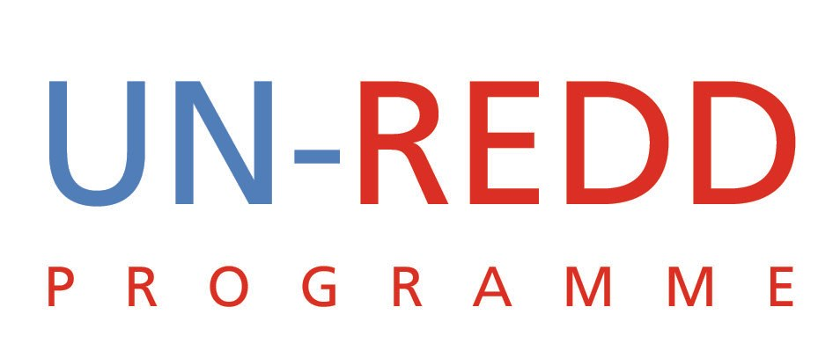

Points and Outcomes of Teleconference
UN-REDD PROGRAMME
19th Aug 2009

1 | Report from the CD REDD meeting in Bonn
Yemi and Tiina provide a short update of the meeting most of which was included in the agenda. Key issues:
  - Kevin Conrad wants to create a new body under the UNFCCC to:
    - coordinate support to REDD countries and to ensure that providers of support to the countries are also coordinated
    - To provide targeted capacity building
  - Many countries once again expressed their desire to join the UN-REDD Programme
  - Kevin will be writing a two page summary of the meeting to be submitted to the SBSTA Chair and is expected to become part of the negotiating text
  - DRC raised concerns about the lack of coordination between UN implementing agencies in the country with respect to financial arrangements. This item led to a lengthy discussion on how we can better organize ourselves at the country level.
Agreed Action:
  - We should learn from current experiences and we need to let the countries know that we will improve when delivering the new products
  - Design an approved mechanism for the new products preferably a pooled approach with an agreed management agent for each product
  - Each agency to appraise its management of the challenges and the agreed way forward
  - Everyone should speak to the principles outlined in the guidance note
IWG-IFR Meetings 2 and 4 September
  - Kaveh was invited to attend the meeting on August 31
  - For the 2 and 4 September meetings Yemi, Tim Clairs, Tiina and Kaveh would attend
Agreed Action:
- Internal working group on IWG-IFR should meet and ensure that Kaveh is adequately briefed
2 | Invitation from the Filipino Foresters
UN-REDD was invited to give a Keynote address at a convention being organized by the Filipino Foresters.

Agreed Action:
- UN-REDD should not send a representative as this was not a priority
- Before we can engage with the Filipino Foresters, UN-REDD should receive a formal expression of interest in REDD and UN-REDD from the Philippines government
- After such an expression of interest we can then consider the request form the Filipino Foresters
- Niklas to be copied on communication

3 | Strategy Paper
We should get initial reaction to the paper from key PB members such as Norway and PNG.
Agreed Action
- Paper to be finalized week of August 24 and circulated for internal comments
- Soon afterwards, it should be shared with Norway and PNG
4 | Policy Board
With respect to the agenda the following was proposed:
- focus on presenting country progress and approach
- Introduce new strategy
- Danida have no objections to having the budget allocations done between meetings

