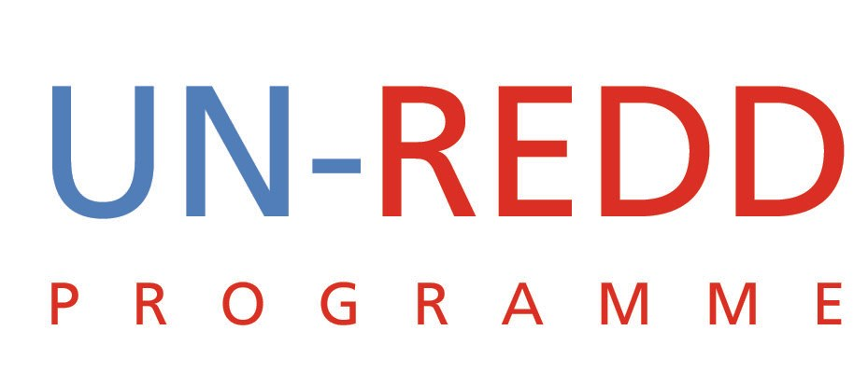

Points and Outcomes of Teleconference
UN-REDD PROGRAMME
14th Sept 2009

1 | Strategic Paper
Paper was shared with Norway. Two immediate questions from Norway are:
- What is our thinking on diversification of funding base?
- Budget- How did the funding proposal compare with the needs identified in the Interim Finance Paper?
We need to discuss in the upcoming meeting in New York how we can diversify our donor base.
- Identify our funding needs for the next 5 years
- How much should we request? This needs to be balanced by our absorption capacity for us to deliver
- Identify other donors. A Germany strategy is important
- The timeline needs to be adjusted.(the paper reflects $450 million over 2-4 yrs, while IWG identifies timeline as 5 yrs between 2010-2015)
- Frame funding in larger strategic framework over 5 yrs.
- The current funding strategy is not effective, another document is required to clarify the funding needs, what is doable.
What to bring forward to the policy board?
- Guidance and feedback, ideas and approaches towards funding level ambition
- Discussion on the future: Prepare a presentation reflecting on the future of the programme and what direction to take.
- We should ask the PB board to indicate what they see as the future role of the UN-REDD Programme and an indication on what they believe the future funding should be.
- What are the ambitions of other groups e.g. coalition of Rainforests, WB…etc
- To develop the capacity to deliver we need long-term funding
Decision:
- A strategic discussion on the future of the UN-REDD Programme will be carried out in NY and a decision will be take on the adequacy or otherwise of the existing paper
- A meeting with the WB should be organised to explore common ground
2 | Policy Board 3
Angela Cropper will not be available to co-chair PB III. UNEP considered the possibility of having Ibrahim or Tim K. as co-chair. It was resolved that the co-chair would need to be fairly senior and so UNDP will explore possibility of co-chairing.
Decision:
- Charles to explore and identify a suitable person in UNDP to co-chair
- Send names of observers to Amock.

3 | COP 15
We had a discussion on how we could register UN-REDD staff for the COP 15 meeting.
- The Secretariat could be registered through the agencies. Yemi will be registered through UNEP. There is a slight chance that Tiina could be registered through FAO, but it’s not certain. As for Anna and Reem, there were no ideas as to how they could be registered for the meeting.
- UNDP is under extreme scrutiny on COP 15 delegation so cannot extend to courtesy of including secretariat staff on their delegation.
4. | Globe International Commission on Land Use Change & Ecosystems.
There was a discussion on whether we will participate in this meeting.
Most people agreed that the event was not significant enough to prioritize. Perhaps we don’t need to send someone.
Decision:
- Mario to communicate to Globe International the decision of the Group
4. | September 24-25 UN-REDD Meeting  GA event
- UNDP will host us; they will provide a meeting room for the meeting.
- Expected participants.
Yemi, Tiina, Anna, Peter, Julie, Niklas, Ravi, Mario
- We need to contact UNFCCC by 23 sept regarding Name and Scope of the side event under CEB at COP 15 (we need to remember that the event is under CEB, not UN-REDD)
- SG strong communiqué not important, though it is important to have a strong representative of the US. This will make a strong visible statement.
Obama is unable to attend. Hilary Clinton is an alternative, but political sensitivities remain.
Compromise for U.S presence will be a weak statement.

