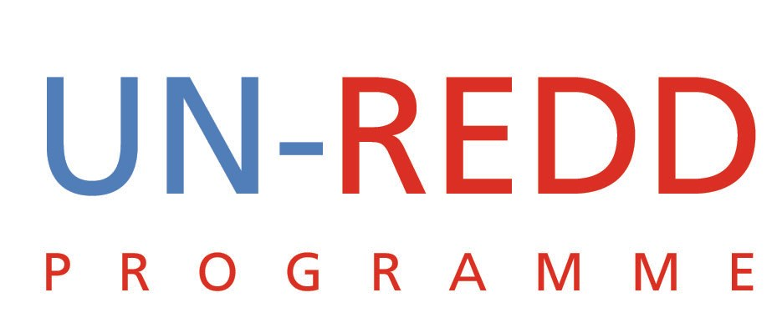

Points and Outcomes of Teleconference
UN-REDD PROGRAMME
10th Aug 2009

1 | IWG-IFR feedback on Paris Meeting.  CD-REDD meeting in Bonn 14-15 Aug.
Yemi and Kaveh were to represent UN-REDD at the Paris meeting. However Kaveh fell ill and was not able to attend.

The Paris meeting was co-chaired by France and Indonesia. The IWG-IFR secretariat was represented by Hans and Per.

The meeting did not stick to the circulated agenda. It essentially consisted of a presentation of the draft IWG report with reference to written comments provided by countries. The rest of the time was spent of reactions, questions and comments from participants. The working groups were abandoned and the meeting ended earlier than planned.

In addition there was some discussion on the Heads of States Event and a lot of countries expressed their interest in attending the meeting but wanted more information and the expected outcome.

A separate report of the meeting was circulated ahead of the teleconference.

On the sidelines of the meeting, Yemi met with the following:
- Nilla Thomson of the Swedish Environment ministry expressed her country’s interest in UN-REDD and was looking into how it can engage and eventually support the Programme
- Denmark will soon announce its contribution to UN-REDD. They are also making a similar contribution to FCPF
- Argentina confirmed that their request to join UN-REDD was indeed written by a junior officer. They will get a more senior official to write another request.
- Panama was very up-to-date regarding their engagement with UN-REDD Programme. They had already explored the possibility of their minister becoming the co-chair but due to the minister’s other commitments this will not be possible. They will instead nominate their vice minister.

There were several comments and concerns regarding the outcome of the meeting:
- The meeting failed to deal with the need to clarify the elements of the three phases as these will determine the nature of funding as well as the future institutional architecture
- Some concerns were raised at the premature end of the meeting. This could be an indication of lack of legitimacy in the process and hence the report. Some of the countries feel that the report is being influenced by organizations such as Meridian and hence the issues may not be in the interests of the countries.
- A question was raised about why the FCPF would be seen not to have a role beyond phase 2a when it was established to do exactly that.
- Some concern were raised about the link between the Paris meeting and the Capacity Development Workshop to be held on August 15

Decision
Put contact information of country representatives in workspace.

CD Meeting:
There was brief presentation on the meeting
It was agreed that our role should not just be a funder but include providing content into the agenda.

Given the strategic importance of the meeting, it was agreed Yemi should attend to interact with countries and to follow-up with the Bank and Kevin on some of the issues around interim finance and institutional architecture.

Donor working Group:
It was agreed that this group should meet as soon as Peter is back from vacation
2 | Policy Board 3
Some of the points from the previous meeting were repeated:
Some key issues:
- The general consensus is that we should have a feel good meeting
- Try to get Denmark donation ASAP
- The message is that UN-REDD is there to support you
- The budget allocation for the Danish contribution should be done inter-sessionally if possible

Decisions:
- Given the lack of comments we should send out a deadline for the participants to send comments on the PB2 report
- Solicit comments from Norway

The draft agenda is posted on the workspace, every one to pitch in.

Try to get a confirmed number of donors before the Copenhagen Event.

What are expected outcomes at high level event.
- Letter must not reference IWG-IFR
- Agenda should remain generic at the moment. It should not have an item on the working group
- Elspeth to reach out to CSO and IP representative to provide comments to the report

3. | Strategic Paper
- There was a new version of the Strategic paper posted on the workspace.
- Everyone should provide their inputs as soon as possible.
- Yemi to review it and send out the draft final document.

4. | Communication plan
- A Teleconference meeting with Norway has been set: 12th Aug.
- Attendees: (UNDP)Estelle/Elspeth, (FAO) Alberto & Tiina, (UNEP) Isabel (UN-REDD) Yemi
- Norway has agreed to send out comments by the end of business day on the 11th.

5. | Head of States Event 23rd Sept.
- Get guidance on who are the special guests that should be invited apart from the Heads of State.
- If possible, we should have 3 panels
- We should try to get either Obama, Hilary or Biden. If not, John Kerry is a possibility.

