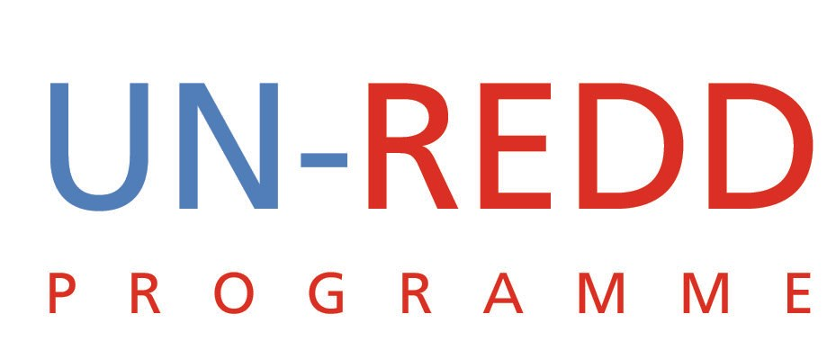

Points and Outcomes of Teleconference
UN-REDD PROGRAMME
03rd Aug 2009

1 | IWG-IFR
It was decided that the working group on IWG-IFR should hold a teleconference on August 4 to go through the draft paper and agree on key points for the IWG-IFR meeting in Paris on August 6.
2 | Managing Partner agency extra Budgetary contributions
UNEP clarified that the extra funding for communications which is a UNEP responsibility under the UN-REDD Programme came from surplus funds within UNEP. As such, this does not represent approaching specific donors for funding. UNDP similarly explained how they have structured funding for UN-REDD from internal resources. The concern is that if agencies start raising bi-lateral funds from donors this might result in inter-agency competition leading to delegitimisation the Policy Board and the UN-REDD Programme. It was agreed that we want to avoid this situation.
Outcome
Yemi to remind the donor group to convene soon.
3 | Policy Board III
Dates for the PB3 should be added to the workspace calendar. We should also include deadline dates for submission of documents. The deadlines will be internal but also include stipulating the last day for submitting documents if a decision is sought from the policy board. The agenda is also critical in helping to identify some of the documents that will be required.

Key Points:
- The agenda should not be controversial so that the meeting can be positive especially since this is the last meeting before Copenhagen.
- Holding the PB meeting in October will demonstrate that UN-REDD and FCPF are working closely.
- We should also consult with the policy board members e.g. Kevin Conrad on possible agenda items as part of the process to evolve a non-controversial agenda.
- We need to be visible between now and Copenhagen.

Outcome
- Provide inputs into the agenda
- Schedule of deadline for documents
- Contact PB members for possible agenda items
4 | Update on September 23 Heads of State Event
Update:
- The Norwegians will meet with Prime Minister to get him to sign the SG letter to SG.
- It is a matter of urgency that the SG’s letter to countries goes out soon. SG has essentially agreed to have the event at 3pm on 23rd September
- The possibility to invite his Royal Highness Prince Charles to the meeting still exists
- Details of how best to invite countries without necessarily opening up the programme agenda are still being discussed
- The idea of asking countries whether they would like to make a statement if they are not participating in the panel discussions has some risks if all countries respond positively
- There might be other conflicting events of the same day so we need to think about this to avoid being overshadowed
- Niklas has prepared a draft declaration but this needs to be linked to the main recommendations of the IWG-IFR draft report

5 | Capacity Development for REDD
There are two meetings being organized on this topic:
- A technical meeting on 10-11 September, in Rome focusing on MRV. This will also link to institutional issues
- CD-REDD meeting in Bonn on 14-15th Aug – this is closer to negotiations and organization by the Coalition of Rainforest Nations. (Niklas & Max have been working with Frederica)

Presence:
Yemi, Tiina, Alberto to attend meeting.
6 | UN-REDD RETREAT
Everyone thought this was a good idea. Several options of when to hold the meeting were considered. Finally the following was agreed:
- After the September 23 event in NY those present will convene to discuss business issues, preparation of documents/presentations for the PB so that the meeting can run smoothly
- The team building retreat will be held after the October PB meeting in Washington DC
Follow-up Actions: Decision:
Give suggestions of good facilitators for the team building event

