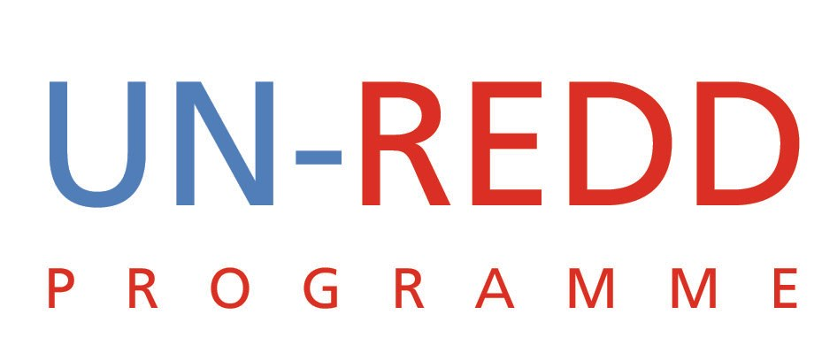

Points and Outcomes of Teleconference
UN-REDD PROGRAMME
18 January 2010

1 | Strategic Planning meeting: Geneva 26-28 January
Dates are now confirmed for the Strategic planning meeting—Tues, 26 January to Thurs, 28 January.
Yemi reviewed the thinking behind the way the agenda for the meeting has been structured. Efforts have been made to front-load the first day of meetings with the most important items, to take advantage of the fact that everyone will be there.
Key topics: 1) What is UN-REDD? Establishing boundaries and parameters for our work; 2) Defining our partnership with the FCPF as we move forward.
Suggested changes:
- Adding more time to the items in the morning of Day 1
- Fix the typo in the times in the afternoon of Day 1;
- Moving all funding matters to the same block of time instead of having the subject handled at different times over two days
- Add dates to various versions of the agenda so everyone is working off the most recent version

Outcomes:
- The Secretariat (Tiina & Yemi) will email out a revised agenda with corresponding background document on Wed, 20 January to everyone attending the strategy meeting.

2 | 2010 Budget
The request from Norway for the UN-REDD 2010 budget is being processed and needs to be sent to them by 22 January. Tiina has received input from the agencies regarding immediate operational costs.
Outcome
The Secretariat is combining all the agencies inputs and will finalize the budget with them this week, in order to submit the budget on time on 22 January.
3 | PB Meeting
A short letter was sent out to the Policy Board, providing a few updates and reminding them of the date of the next PB meeting.
Nina informed the group that the day before the field trip (16 March), there would be a meeting in Nairobi of IP/CSO groups to prepare for the policy board meeting.
Yemi informed the group that due to a scheduling conflict, the head of the FCPF would not likely be able to attend PB4.
Outcome
Nina will confirm if the IP/CSO meeting will require participation from the Secretariat.
4 | Newsletter lead article
A joint article between UN-REDD and the FCPF was not possible as our lead article for the Dec-Jan issue. A different lead article was drafted by the Secretariat and sent out on Friday for everyone’s review.

UNDP said the article needed some tweaking and said they would have their feedback in by end of day.

UNEP said comments on all articles would be sent in by Tuesday morning.

5 | Other business: UN-REDD 2009 Year in Review
Yemi asked the group for their thoughts on doing a 2009 Year in Review that would be a public, promotional document highlighting key activities and accomplishments over the past year.

Everyone agreed, that provided there is sufficient content, this was a good idea and a strategic document to have. Everyone agreed this should be ready in time for the policy board meeting or sooner if possible.

Charles suggested a brainstorming call to determine what content should be included in the report. Ie/ MRV, IP/CSO engagement, co-benefits, collaboration.

Tiina suggested that the annual progress report being developed for the MDTF could be a good source document for the Year in Review.

Outcome
Cheryl will get in touch with the communications contacts at the agencies to get the ball rolling on this project.

