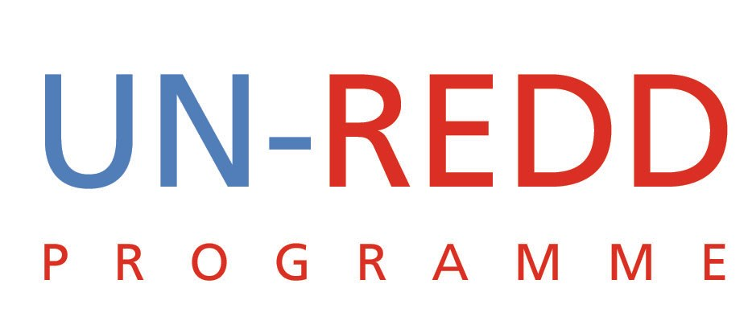

Points and Outcomes of Teleconference
UN-REDD PROGRAMME
11 January 2010

1 | COP 15
Many thoughts were expressed with respect to the consequences of the Copenhagen Accord for the UN-REDD Programme. Some positives were that REDD moved quicker, and with more agreement than any other issue at COP-15; that the final accord mentions REDD more than any other issue; that the accord establishes the Green Climate Fund; that there was $US3.5 billion in funding announced to slow and reverse deforestation in developing countries.
Some challenges for the Programme coming out of COP-15: COP-15 did not bring about any resolution on the institutional side of things (ie/ to merge or not to merge with FCPF). It left many things unresolved. And many now question whether bi-lateral negotiations and funding arrangements might be more effective than using the multilateral UN system.
The UN-REDD Programme dodged a bullet for the moment. But it won’t get another second chance to demonstrate its worth. The Programme cannot let the year go by and arrive at COP-16 in Mexico without establishing that it understands the outcomes of COP-15 and can make the necessary advancements.
The UN-REDD Programme needs to keep supporting countries, and continue to deliver results to prove its utility. And the Programme must make its good work known through strong communications.
The Programme also has to figure out how it moves forward with the FCPF and the FIP. The Programme needs to target new donors in 2010, and identify big, important events that it should be a part of. UN-REDD needs to be more active in its role as an international convenor on REDD issues. The Programme hasn’t done enough of this yet.
Because the Copenhagen Accord is not an official COP decision, questions were raised about what this means for the UNFCCC.
2 | Finalizing the Programme Strategy
The Programme strategy was discussed at COP-15, working with the document established in Rome. A minus-1 version of the strategy was made available on January 7th 2010 and is now being circulated.
Various dates were discussed for representatives from all agencies to come together to finalize the strategy. Urgency to complete this task was underscored by several on the call.
Outcome
Yemi will continue to explore dates in January that work for everyone to ensure the meeting happens as soon as possible.
3 | Newsletter
The newsletter is still in need of at least one more, lead article on the outcomes of COP-15. The UNDP suggested a lead article on the SG and World Bank’s joint letter on 5 December 2009, talking about their joint support and commitment for REDD+ moving forward. UNDP suggested that this might be an article jointly written by Yemi and the head of the FCPF.

UNEP pointed out that many groups felt excluded by the letter, so cautioned against an article that focused on the letter too much. UNDP pointed out there will be a lot of attention paid to its first newsletter after COP-15, and that it should avoid playing it too safe or neglecting to address the big issues.
Another suggestion for a lead article was to profile the UN-REDD Programme, highlighting what it delivers, and the growing interest in the Programme.
Outcome
Yemi will talk to Benoit as soon as possible to see if collaboration on an article would be possible.

4 | 4th Policy Board Meeting
Yemi brought it to everyone’s attention that the Secretariat has already started to plan for the next policy board meetings set to happen March 17-19, 2010. March 17th will be a field day visiting a forest, followed by two days of meetings.

5 | Communications Strategy
The communications strategy is currently being circulated around to all the agencies for feedback. Once all feedback is in, final approval will need to wait until it can incorporate and support the Programme Strategy, once it is fully defined.

Outcome
UNEP committed to posting their latest revisions to the strategy on the workspace by Tuesday, January 12, from which the other agencies could weigh in on it.
6 | Finalization of 2010 budget
Talk of this was tabled to a separate conference call to be set up by Yemi and Tiina.
7 | Request by Global Witness and others to UN-REDD to support campaign to stop a law targeting Environmental NGOs from passing into law
Everyone agreed that the Programme needs to consult people on the ground and not jump too quickly to support any one side of this issue.
Outcome
Clea will start a small group to look at this issue, and watch it unfold before formulating a response. All those originally approached on this issue will be cc’d on all steps forward in response to this.

