Planning for REDD readiness -- the Tanzania case
An illustration of concrete steps and activities initiated or planned under the Programme as they relate to REDD readiness components
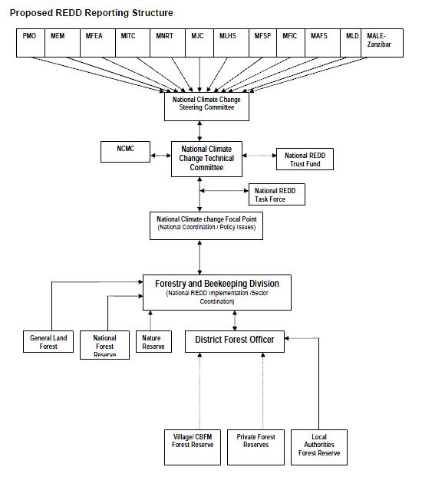
In the August issue of the UN-REDD Programme newsletter we described how the UN-REDD Programme and the Forest Carbon Partnership Facility have developed harmonized thinking on what constitutes REDD readiness, facilitating the activities and coordination for countries supported by both readiness platforms. These activities include coordinating and engaging stakeholders, designing a REDD strategy and implementation framework, developing a reference scenario and establishing monitoring system. While Tanzania launched its national UN-REDD Programme on 6 November 2009, below is an illustration of concrete steps and activities initiated or planned under the Programme as they relate to REDD readiness components.

Organizing and consulting
The first step in preparing for REDD is designing the appropriate institutional arrangements and engaging a multiplicity of relevant stakeholders, from civil society to regional partners.
[LEGEND] Figure 1: Proposed REDD reporting structure
PMO | Prime Minister’s Office
MEM | Ministry of Energy and Minerals
MFEA | Ministry of Finance and Economic Affairs
MITC | Ministry of Information Technology an d Communication
MNRT | Ministry of Natural Resources and Tourism
MJC | Ministry of Justice and Constitution Affairs
MLHS | Ministry of Lands and Human Settlements
MFIC | Ministry of Foreign Affairs and International Co-operation
MAFS | Ministry of Agriculture and Food Security
MLD | Ministry of local development

The National Climate Change Steering Committee and the National Climate Change Technical Committee oversee and guide the implementation of climate change activities in the country. The Forestry and Beekeeping Division (FBD) of the Ministry of Natural Resources and Tourism is primarily responsible for forestry policy and coordination matters. The Tanzania UN-REDD Programme includes training on REDD and study tours provided to FBD staff to develop their capacity to plan for, monitor and enforce the REDD process.
The National Task Force, which comprises eight members from the Vice President Office (Environment Division) and Forestry & Beekeeping Division, and the from academic, non-governmental and private sectors, leads the process of developing a National REDD Strategy and framework, and coordinates activities related to REDD in Tanzania, including those of the UN-REDD Programme, Norwegian Government and the Forest Carbon Partnership Facility. Its Secretariat is the Institute of Resource Assessment (IRA) of the University of Dar es Salaam, funded by the Royal Norwegian Embassy. The IRA maintains the Tanzania REDD Initiative web site [www.reddtz.org] that supports processes of establishing and implementing REDD programmes in Tanzania and raises awareness on REDD to relevant stakeholders and the public at large.

Stakeholder participation and consultation
Permeating all REDD readiness activities is the engagement of all stakeholders. The national REDD strategy recognizes that involvement of local and indigenous communities is one of the very few effective means of controlling degradation over large areas, drawing from existing success stories in participatory forest management.
Activities under the UN-REDD Programme in Tanzania will seek to stimulate broad-based stakeholder support for REDD in Tanzania. Stakeholder engagement has begun with through the development and implementation of an awareness programme around the issues raised by REDD, including the potential for REDD and how it may reduce carbon emissions. To build broad consensus with forest communities regarding the REDD framework, national and regional workshops are planned: ward and village representatives from selected districts will provide stakeholders information on the potential for REDD, hear their concerns and build their understanding of the process. A pilot rural appraisal to establish community opinions on the potential for REDD is also planned.
There are already fourteen REDD-related initiatives funded by national and/or international partners in Tanzania, and linkages and partnerships will be key. Academic partners include for example the Sokoine University of Agriculture and the University of Dar es Salaam’s Institute of Resource Assessment. Also partners in the REDD strategy are a number of local civil society organizations. For example, a partnership between the Government of Norway and the Tanzania Forest Conservation Group [www.tfcg.org], a non-governmental organization with 20 years of experience with issues relating to forest conservation in Tanzania, was launched in August 2009 for a first large-scale pilot project for REDD, to be implemented in partnership with the UN-REDD Programme. A project called “Making REDD and the carbon market work for communities and forest conservation in Tanzania” was launched in November by the Tanzania Community Forestry Network (MJUMITA), a non-governmental organization providing a national network of community groups involved in participatory forest management with members in 22 districts.
The Tanzania UN-REDD Programme includes a specific component for exchanging information with other UN-REDD pilot countries. Also committed to knowledge sharing with neighboring countries, Tanzania hosted a Southern Africa Development Community (SADC) conference on 18 November 2009.

Preparing a REDD strategy
The strategy under the UN-REDD Tanzania Programme is embedded into the Tanzanian National Forest Programme, a framework with specific aims for elaborating the role of forests in national development. A REDD production chain (figure 2) sketches the four quadrants of the strategy.
As mentioned above, the development of the National REDD Strategy is envisioned as a continuous process that involves a series of consultations, stakeholder engagement, research and knowledge dissemination. Implementing this strategy includes considerations of carbon ownership, benefit distribution systems, the relationship between local interventions and national accounting, and governance issues.
Towards these objectives, it is important to first note that forest management types in Tanzania includes nature reserves, government forest reserves, local authority forest reserves, private forests, village land forest reserves and village land in general. With support from the World Bank and the Danish Government, a report commissioned by the FBD [LINDA: Please create tiny URL of report and place here] reviewed the past fifteen years of experience with participatory forest management in Tanzania, and recommended specific actions towards the legal basis for sharing costs and benefits, approaches to service delivery, monitoring and evaluation and safeguards to avoid leakage will inform the National REDD Strategy. Building on its leadership in community forestry in Africa, Tanzania’s roll-out mechanism for REDD will be participatory forest management, both community-based forest management and joint forest management. Local governments will ensure smooth implementation of REDD related activities in their areas of jurisdiction. In addition, REDD coordination will be based on institutional structures in place, with existing environmental officers at district and municipal levels serving as coordinators for REDD activities in their respective areas. Three pilot districts will serve as test pilot to test the decentralized governance framework.
To further inform the implementation of REDD processes, the Tanzania UN-REDD Programme work plan includes:
- determining the methodologies to calculate the costs of REDD, including opportunity costs economic with analyses of forest goods and services in select forest landscapes and barriers to triggering sustainable forest management from unsustainable forest resource use
- mapping the distribution of costs and benefits (social, private, budget etc)
- performing costs economic analyses of nature-based adaptation options in forest landscapes to reduce vulnerability to climate change
- developing a REDD cost curve for Tanzania plotting abatement costs against abatement potential for different land uses (protected areas, production forests, village lands, etc), and including deforestation drivers. Capacity building of stakeholders to understand and participate in these cost analysis is a cross cutting component of this workplan.

Ensuring that payments reach local stakeholders
Different payment distribution system will be tested so that REDD compensation reaches the local stakeholders active in the forest management work on the ground. Under the National REDD Framework, these payments can take the form of direct payments, social or infrastructure services, direct employment, community development grants or microcredit loans, and it is acknowledged that in order to be optimal, solutions will be location-specific. The payment system will combine REDD payments with payments for non-carbon ecosystem services, such as payment for water and biodiversity services.

Designing a reference scenario and a monitoring system
As the baseline for forest area and deforestation is only partly available in Tanzania, further work will be necessary to provide the statistics relevant to establishing a reference scenario that builds on historical trends and takes into account national development projections. Work to develop the reference emission levels will involve a combination of remote sensing, verification on the ground and local level resource assessments. A number of initiatives with high relevance to forest carbon have been undertaken by national and international partners on community carbon monitoring, carbon storage, forest disturbance and impact on carbon.
Capacity building on carbon measurement, reporting and verification (MRV), whose system will be implemented by the FBD and the Vice President’s Office, will start with training on remote sensing, Geographic Information Systems, the InterGovernmental Panel on Climate Change’s Good Practice Guidance, and will link to the Tanzanian National Inventory work launched in May 2009. First, a system for REDD information synthesis and sharing will be established at the FBD and linked to the National Forestry Database (NAFOBEDA), which will include a mechanism for sharing data linked to the Forestry Database. Second, training will be provided to forest staff on MRV, starting with training on the establishment of such systems for REDD. Targeted fieldwork will calculate the degradation of forest habitats in specific areas across Tanzania.
Finally, Tanzania has started creating simple maps of carbon distribution linked to biodiversity and livelihoods, which can be used for advocacy purposes. In November 2009 a two-week visit by the UNEP World Conservation Monitoring Centre, based in Cambridge, provided practical training to members of the FBD in geographic information systems whilst undertaking novel analysis of the distribution of carbon and co-benefits in Tanzania. This workshop produced a new carbon map for Tanzania (figure 3), including estimates of carbon in biomass and soils to 1 meter depth, as well as analyses of the distribution of carbon in relation to human population, protected areas, key biodiversity areas and fire. These illustrate the extent to which areas that are high in carbon are also high in other benefits such as biodiversity, and conversely which forests are low in carbon but nevertheless offer ecosystem benefits. This first step will contribute to developing mechanisms that bundle payments for non-carbon services to REDD as to deliver a higher premium on reduced emissions. These will be tested under the Tanzania UN-REDD programme in the two pilot landscapes of Uluguru and East Usambara.
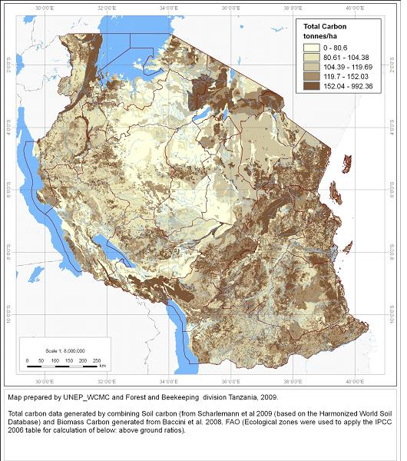
Figure 3: Carbon pools in Tanzania

A detailed description of the REDD production chain is available in the Tanzania UN-REDD Programme document, online at www.un-redd.org

