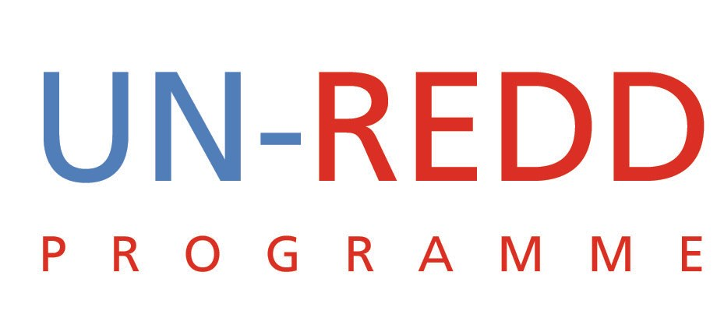

UN-REDD Programme Strategic Alignment Plan 2011-2015
28 February 2011

Introduction

The United Nations Collaborative Programme on Reducing Emissions from Deforestation and Forest Degradation in Developing Countries (UN-REDD Programme) was created in September 2008 to assist developing countries to build capacity to reduce emissions and to participate in a future REDD+ mechanism. REDD+ refers to reducing emissions from deforestation and forest degradation in developing countries; and the role of conservation, sustainable management of forests and enhancement of forest carbon stocks in developing countries.

In order to optimize the approach and effectiveness of the UN-REDD Programme, the three participating UN organizations embarked on the preparation of a Programme Strategy covering the period 2011-2015. The five-year strategy was adopted by the three agencies and endorsed by the UN-REDD Programme’s Policy Board. The Strategy is a living document that will be adjusted as appropriate in response to the development of the REDD+ mechanism. In particular, in 2012 the Strategy will be reviewed by the three agencies in light of the outcomes of the UNFCCC process, allowing the programme to adapt to changing needs and conditions in the global architecture for REDD+. The Strategy will be implemented through results-based joint programming, and annual work programmes and budgets.

The purpose of the Strategic Alignment Plan is to translate the UN-REDD Programme strategy into viable, effective and efficient capacity building activities to support partner countries develop and implement REDD+ strategies. The Strategic Alignment Plan lays out the activities and steps the UN-REDD Programme will take to ensure smooth transitions in all areas of the Programme’s operations over the next two to three years.
The Plan provides a list of all activities, clarifies responsibilities, provides tentative timelines, and expected budgetary expenses. By doing this the Strategic Alignment Plan will be an important tool for monitoring progress of activities defined in the Programme Strategy. Also, it will be a guiding tool for the development of the Global Programme, the National Programme and the work plan of the Programme Secretariat by clarifying responsibilities. The role of the Strategic Alignment Plan is illustrated by Figure 1 (Page 3).

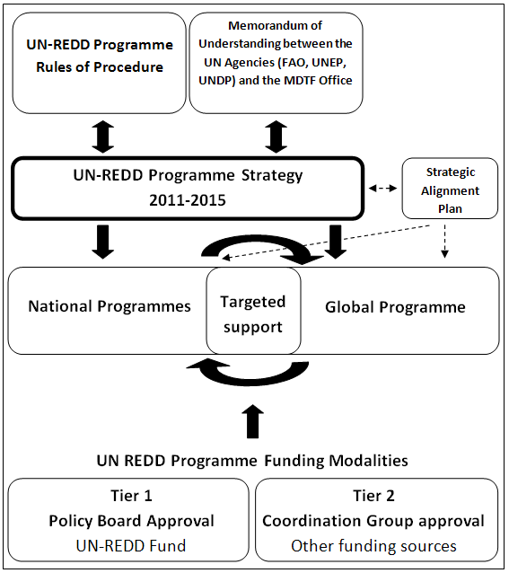
Figure 1: The Strategic Alignment Plan in relations to the UN-REDD Programme Strategy

- Management and Strategic Alignment
 | Activities | Responsible | Timeline | Budget  Implications | Indicators of Progress
 | Define and clarify nature of the collaborative UN-REDD Programme, including if the collaboration is limited to the UN-REDD Programme (MDTF) or includes part or all REDD activities carried out by the three partner UN Agencies:  - Prepare concept notes  - Hold retreats with senior managers and larger UN-REDD team | Strategic Directions Group (SDG) and Coordination Group (CG) supported by Secretariat | Finalized by December 2011 | Costs of holding retreats, hiring a facilitator and staff time | - Retreat reports and outputs  - Engagement with wider UN-REDD team reveals improved understanding
 | Memorandum of Understanding (MoU) between the MDTF and the partner UN Agencies revised in alignment with the UN-REDD Programme Strategy | SDG and CG, supported by the Secretariat | Finalized by December 2011 | Staff time | Signed copy of the revised MoU
 | Align all UN-REDD teams with strategy and agreed policies | CG and HQ agency focal points, supported by the Secretariat | Finalized by December 2012 | Staff time | Performance review process indicates better alignment
 | Agree on the number of new countries to be accepted as partners of UN-REDD Programme | CG | Finalized by the sixth Policy Board (PB) (March 2011) | Staff time | Decision approved by the PB and communicated to partners
 | Clarification of targeted support | CG | Finalized by December 2011 | Staff time | CG decisions and countries requesting targeted support

- Programme Delivery and Performance
 | Activities | Responsible | Timeline | Budget Implications | Indicators of Progress
 | Institute regular independent reviews and evaluations of the entire UN-REDD Programme | CG and Secretariat | Conducted in 2011 and 2013 | Fees for consultants and staff time | - Recommendations endorsed by CG and PB  - Course correction
 | Finalise design of the Project Tracker and implement it as the Programme reporting tool | Secretariat and the three UN Agencies | Finalized by December 2011 | Staff time and fees for programmers | Financial and narrative reports produced and used
 | Develop the UN-REDD Programme Planning, Monitoring and Reporting Framework Document | Secretariat | Finalized by December 2011 | Staff time | Framework Document approved by CG
 | Conduct regular synthesis and analysis of our work | CG and Secretariat |  | Staff time and fees for consultants | - Published reports available  - Reports used as learning process
 | Review operations and decision making process of the Policy Board, including clarify membership and responsibilities of the Policy Board and clarify rotation of membership | Secretariat | Finalized by December 2011 | Staff time | - Approved copy of the revised UN-REDD Programme Rules of Procedure and Operational Guidance  - Approved copy of the revised Policy Board ToR  - New arrangements reflected in internal and external communication materials
 | Align the National Programmes, including:  - Review and improve templates  - Improve independent review process for NP documents  - Develop criteria for allocation of funding to new countries  - Review and revise Guidelines for development of NP  - Decide on who is the NP focal point | CG and Secretariat | Finalized by December 2012 | Staff time and consultancy fees | - New templates endorsed by the CG  - New criteria for allocation of funding to new countries endorsed by the CG  - Guidelines for development endorsed by the CG  - CG endorse NP focal point
 | Develop a strategy for implementing minimum social and environmental standards, together with an accompanying due-diligence style risk assessment tool | Work to be lead by UNDP with inputs from other agencies | Finalized by December 2012 | Staff time and fees for consultants | - Endorsed by CG  - Wide dissemination of guidelines  - Feedback from stakeholders
 | Clarify how joint programme funds are to be managed at country level | CG, supported by Secretariat | Finalized by December 2012 | Staff time | New approach adopted by the CG
 | Prepared and present a new Global Programme Framework Document to the PB | CG and Secretariat | Finalized by April 2011 | Staff time | New framework document approved by CG and PB
 | Lead agency for Global Programme work areas to develop detailed work plan and budget | Three UN Agencies | Finalized by April 2011 | Staff time | Work plans approved by CG

- External Partnerships
 | Activities | Responsible | Timeline | Budget Implications | Indicators of Progress
 | Leverage additional resources, through partnerships, and capacity for implementing the Programme | CG and Secretariat |  | Staff time | Strategy approved by CG
 | Continue to explore efficient ways for collaboration with FCPF and FIP | CG and Secretariat | Continuously | Staff time | - Joint planning meetings  - Revised protocols and templates
- Knowledge Management and Dissemination
 | Activities | Responsible | Timeline | Budget Implications | Indicators of Progress
 | Rationalise the interplay between workspace and website and clarify access and maintenance issues | Secretariat with agency inputs especially UNDP | Finalized by December 2012 | Mainly staff time but might require IT inputs | Less complaints from partners regarding disclosure and exclusivity
 | Develop a detailed Communications and Events Plan that also address regional and country communication needs | Secretariat and the Partner UN Agencies | Finalized by 2012 | Staff time | Strategy approved by CG
 | Develop targeted communication products including for donors | Secretariat and the Partner UN Agencies | Continuously | Staff time

- Funding the Programme
 | Activities | Responsible | Timeline | Budget Implications | Indicators of Progress
 | Finalise and implement the Resource Mobilisation Plan to increase funding and diversify donor base | Secretariat | Finalized by 2012 | Staff time | - Increased funding  - More donors contributing to UN-REDD
 | Clearly define Tier 2 funding arrangement | SDG and CG | Finalized by December 2012 | Staff time | Clear definition of new funding window, oversight, links to PB etc approved by CG and SDG
 | Leverage a significant level of co-financing by the three participating UN agencies as well as by participating pilot countries | Agencies | Finalized by December 2013 | Staff time | - National Programme document budgets  - Global Programme funding framework

The strategy was submitted to and endorsed by the UN-REDD Programme Policy Board at its fifth meeting, 4-5 November 2010 in Washington D.C.
Options include review of the Policy Board Terms of Reverence and the UN-REDD Programme Rules of Procedure and Operational Guidance

