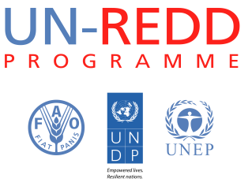

NEEDS ASSESSMENT SURVEY ON GENDER (SAMPLE)

- PARTICIPANT’S BACKGROUND INFORMATION

- What is your sex?

- Female
- Male

- How long have you been involved in / working on REDD+?

- What is your affiliation?

- National Government (forestry sector)
- National Government (non-forestry sector)
- Civil Society or Indigenous Peoples’ Organization (CSO or IPO)
- Forest-Dependent Community
- Private sector
- Academia
- International Development Partner—Specify

- What is your main job function?

- Management (senior management, team leader, manager)
- Thematic Specialist (environment, climate change, forestry)
- Other Specialist (reporting, communications, evaluation, donor relations, etc.)
- Project Management
- Operations Support (finance, procurement, logistics, etc.)
- Other

- To what extent you are engaged in REDD+ process?

- Involved in REDD+ decision-making process
- Technical Work
- Participation in REDD+ meetings
- Observer with occasional participation
Other (please specify)

- GENDER RELATED KNOWLEDGE

- Have you ever participated in a training/workshop on gender equality, gender mainstreaming and/or women’s empowerment?

- Yes
- No

- In your opinion, what is your level of understanding on the topic of gender equality and women’s empowerment? (Mark only one box)

1: Beginner Expert: 10
1 | 2 | 3 | 4 | 5 | 6 | 7 | 8 | 9 | 10
- Is there a law or policy that promotes gender equality within your country?

- Yes
- No
- Not sure

- Do you believe that gender equality and women’s empowerment are the same thing?

- Yes
- No
- Not sure

- In your country, do women and men have the same access to the following resources: (Only check one for each of the resources listed)
Resources | Yes, women and men have the same access | No, women have more access than men | No, men have more access than women | Unsure
Land
Agricultural Resources
Credit
Agricultural extension and Support
Capital
Capacity building on REDD+

- Which of the following REDD+ thematic areas do you believe should take gender considerations into account? (Mark all that apply)

- REDD+ National Strategies/Action Plans
- Stakeholder engagement
- Policies and measures
- Governance and institutional arrangements
- Safeguards and Safeguards Information Systems
- National Forest Monitoring Systems
- REDD+ finance (results-based payments/finance)
- Not sure

