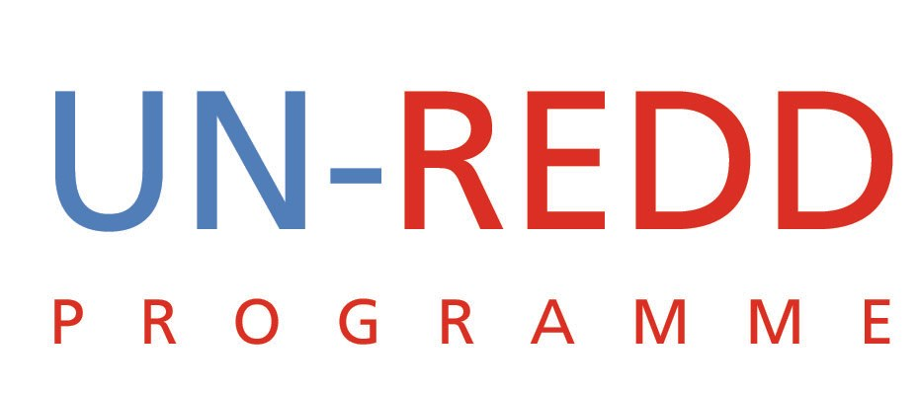

Teleconference on Tier 2 proposal:
Promoting Regional REDD+ Approach and REDD+ Readiness in Under-Supported Regions of Asia/Pacific
UN-REDD PROGRAMME

Date of teleconference: July 8 2010
Participants:
UNDP: Tim Clair, Charles McNeill, Asako Takimoto, Jackson Hewett
FAO: Peter Holmgren, Alberto Sandoval
UNEP: Mario Boccucci
UN-REDD Programme Secretariat: Yemi Katerere, Tiina Vahanen, Clea Paz, Linda Rosengren
Objective: To take a decision on a Tier 2 proposal “Promoting Regional REDD+ Approach and REDD+ Readiness in Under-Supported Regions of Asia/Pacific” tabled by UNDP.
Outcome:
This was the first Tier 2 proposal to be considered by the Coordination Group and as might be expected the discussion also generated some broader strategic issues concerning implications of Tier 2 on the UN-REDD Programme.
UNDP presented the background of the proposal that is part of the Japan-UNDP Partnership Fund. UNDP pointed out the importance of establishing a link between Japan, given the present Japanese co-chairmanship of the Interim REDD+ Partnership, and potential future collaboration with Japan beyond the tabled Tier 2 proposal. UNDP explained that the proposed project would be coordinated by the regional UNDP UN-REDD team.
The overall response of the Coordination Group was positive. The project offers the UN-REDD Programme an opportunity to expand, strengthen and elaborate more resources for the UN-REDD. However, some concerns were raised. Even though the concept of Tier 2 was welcomed by the Policy Board in March 2010 in Nairobi, Kenya, we need to manage perceived sensitivities in channelling funds to non-UN-REDD countries without PB approval. Further, it was pointed out that a Tier 2 project is an agency/ies activity that contribute/s to UN-REDD Programme. The CG concluded that the tabled proposal should be labelled as a UNDP project but associated to the UN-REDD Programme. The project document can include a UN-REDD logo accompanied by an explanatory note that the project is contributing to the efforts of the UN-REDD Programme.
Consistent with the above remarks, the project budget should show clearly that co-financing is from UNDP rather than from UN-REDD. It was yet stated that also the UN-REDD Global Programme provides normative technical backstopping to non-UN-REDD members. It was agreed that output 1 activities of the tabled proposal will be done in close coordination with the UN-REDD South-South initiatives in the region. The involvement of FAO and UNEP in relation to the work areas of UN-REDD in the tabled proposal was discussed. The project document states that FAO and UNEP are “implementing partners”. However, fiduciary responsibility remains with UNDP. It was agreed to change the wording in order to emphasize the role of FAO and UNEP providing leadership and guidance in the technical areas of their competence. UNDP agreed to review the TOR for the Expert on MRV to change FAO as supervisor or otherwise make it clear that this work is done under FAO leadership.
While not only related to this particular proposal, for clarity UNDP agreed to use the title “UNDP Regional Coordinator (Asia Pacific) for UN-REDD”, instead of “UN-REDD Programme Regional Coordinator (UNDP) for Asia-Pacific”.
There was agreement to hold further dedicated discussion on the meaning and implications of Tier 2 on the UN-REDD Programme.
Decision on the tabled Tier 2 proposal: the Coordination Group decided to grant the tabled proposal Tier 2 status subject to incorporation of changes agreed.

