Strategy and planning meeting on
Anti-Corruption for REDD+, 10-11 October 2011 Kathmandu, Nepal

LOGISTICS NOTE

I Hotel & Conference venue

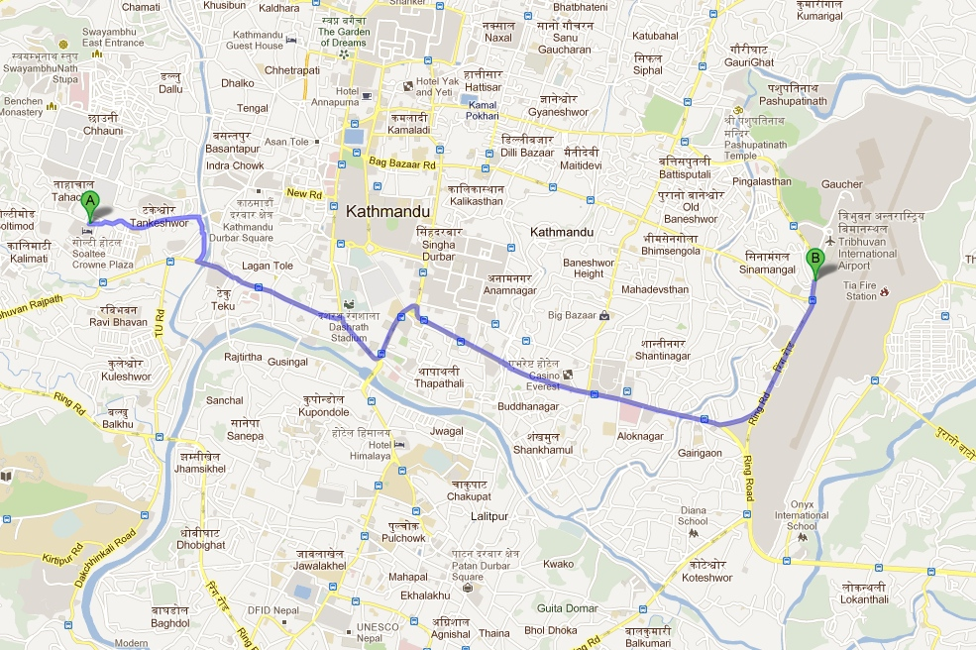
Crowne Plaza
KATHMANDU-SOALTEE
TAHACHAL KATHMANDU
P O BOX 97
KATHMANDU, NA
NEPAL

Hotel Front Desk: |  | 977-1-4273999
Hotel Fax: |  | 977-1-4272205
Email: reservation@scp.com.np

All workshop participants will be accommodated at the “Soaltee” hotel in Kathmandu, Nepal. The hotel is approximately 8 kilometres from the Tribhuvan International Airport (see map above). The workshop meetings will take place at the Yak & Yeti hotel in Kathmandu (see map below). Transport will be provided every morning and evening from the hotel to the meeting venue. Both venues are located near Durbar Square, the city centre of Kathmandu. Hotel Yak & Yeti is located in the touristic centre of the city.

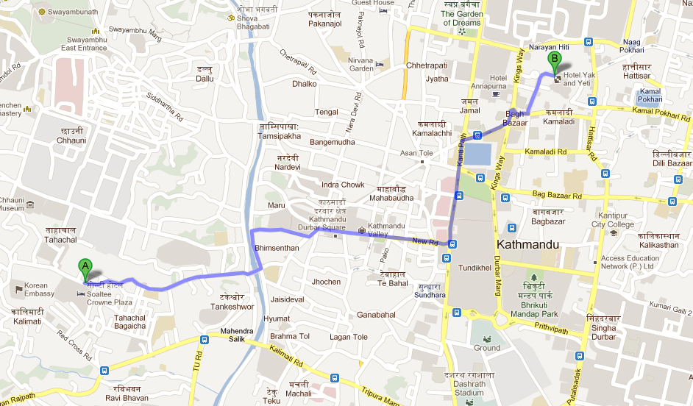
Kathmandu Metropolitan City (KMC) is the capital and largest city of Nepal. It is the cosmopolitan heart of the Himalayan Region. It is the gateway to Nepal. It has a glorious history going back two thousand years, and a refined culture that ranks among the highest in Asia. It is also a modern financial and business hub, exotic tourist destination, and a sacred goal for pilgrims. Kathmandu is situated in a bowl shaped valley in central Nepal. II Travel & Daily Subsistence Allowance (DSA) for UNDP funded participants.

The Asia Pacific Regional Center (APRC) and the Pacific Centre (PC) will send travel authorizations with an instruction on travel arrangement and Chart of Account to you’re the UNDP country offices in your country for arranging the travel to Kathmandu, paying DSA, as well as facilitating the reimbursement of other travel-related expense (if any). Below is the standard DSA calculation based on official rates in September 2011.

Date/Details | DSA Breakdown Cost |  |  |  |  | Total
Date/Details | Accomm.  50%DSA | Breakfast  6%DSA | Lunch  12%DSA | Dinner  12%DSA | Misc.  20%DSA | Total
Ticket: Most Direct/ Most Economical |  |  |  |  |  | At Cost
Visa to Nepal |  |  |  |  |  | At Cost
Unavoidable Stopover |  |  |  |  |  | At Cost
Sun 9 October 11 - Arrival Day | Provided | $9.12 | $18.24 | $18.24 | $30.40 | $76.00
Mon 10 October 11 | Provided | Provided | Provided | $18.24 | $30.40 | $48.64
Tue 11 October 11 | Provided | Provided | Provided | $18.24 | $30.40 | $48.64
Wed 12 October - Departure Day | No DSA will be given on departure date
Transportation: To airport in the home country |  |  |  |  | $38.00 | $38.00
Transportation: From airport in the home country |  |  |  |  | $38.00 | $38.00
Total |  |  |  |  |  | $249.28

III. Accommodation

Room bookings have been made for all participants at the “Soaltee” hotel in Kathmandu. Based on your travel itineraries, the hotel will take note of your likely check in and checkout time and will try to accommodate late checkout and early check in upon your request.

a) If you are funded by UNDP, your room rate will be paid directly by the workshop organizers to the hotel. Any extra amenities, such as minibar consumptions, telephone calls or business centre expenses, will be paid by the participants themselves. Breakfast is included in the room rate. Should you require the room outside the approved dates; your booking and all charges will be your responsibility.

c) If you are self-funded, you will have to settle your own bill. Please note that the cost of the single accommodation (including buffet breakfast) is of 95 $US per day. Should you require the room outside the approved dates; the booking and all charges will be your responsibility.

IV. Airport Transfer

The Soaltee hotel will provide airport pick-up and drop-off at the Airport. In order to organize your airport transfer, please kindly share your flight itinerary (including arrival and departure time) with Issarapan Chaiyato (issarapan.chaiyato@undp.org), copied to Samuel De Jaegere (samuel.de.jaegere@undp.org). UNDP APRC will provide a full list of participants with flight details to the hotel management.

As indicated above, the distance from the Tribhuvan International Airport to the hotel is approximately 8 kilometres, which will take 30 to 45 minutes depending upon the traffic condition.

V. Contact details

Logistics & support:

- Issarapan Chaiyato (Pang)
Programme Assistant
Democratic GovernanceTeam
UNDP APRC
Email: issarapan.chaiyato@undp.org

- Eden Lama
Secretary
Governance Unit
UNDP Nepal
Tel. 9771 5523200 Ext. 1005
Mobile 9851113083
Email : eden.lama@undp.org

- Ambika Amatya
Email: Ambika.Amatya@undp.org

- Yeshoda Basnet
Access to Justice Project Officer
Email: yeshoda.basnet@a2j.org.np

Programme:

- Samuel De Jaegere
Policy Specialist Anti-Corruption
Democratic Governance Team
UNDP APRC
Email : samuel.de.jaegere@undp.org

- Timothy Boyle
UN-REDD Regional Coordinator
Energy and Environment Team
UNDP APRC
Email: timothy.boyle@undp.org

- Sharad Neupane
Assistant Resident Representative
Governance Unit
UNDP Nepal
Tel. 9771 5523200 Ext. 1004
Mobile 9851059512
Email: sharad.neupane@undp.org

