UN-REDD Programme Online Workspace
Quick Facts—Uploading a document under “All documents”
Updated June 2013

How ?

- Select Upload a Document in the pull down menu under “All Documents”
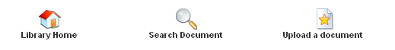

- Click on Choose file, select one or several files from your computer, and click on “Upload” – If you upload more than one file, note that they will be uploaded to the same folders
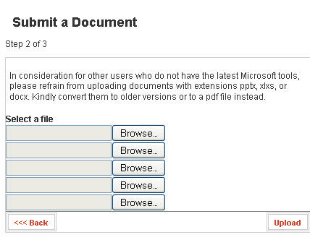

- Title: The Title appears by default as the title of the document in your files. Change the name to a descriptive title that indicates what your file contains
- Author: This field is not relevant but should be filled in when appropriate
- Date: The date field will be automatically entered as the date of when you upload the file, but you can change this as needed. At a minimum, include the year in this field.
- File in Folder: If you were in a specific folder when you clicked on the upload button, this last folder will appear highlighted for easier and faster selection. If you upload from the main library page, you need to browse the folders tree for the one you wish to upload to.
- Language: Select the language of your file
- Tags: Add keywords to help users search for the document and separate the tags with commas
- Make Full Access: By default this is “Yes” which means that the document is public and can be seen by even non workspace users. If you would like to restrict the document, select “No” here and only high access users can view the document. The background of your document will be pink colored to indicate that it is a restricted file.
- Click on “Submit”
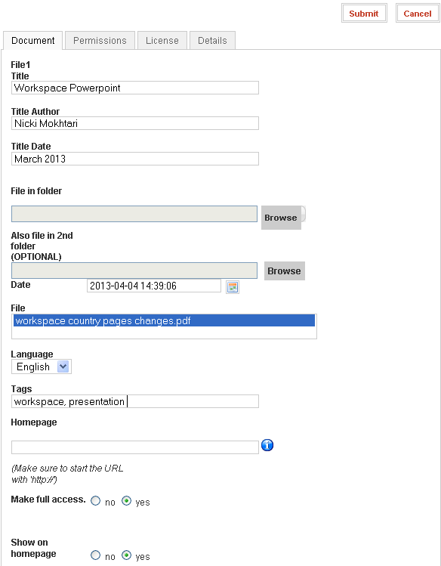

By default your document will now appear:
  - In the folder(s) you have selected for it to appear
  - As a link on the front page under “latest documents”
  - In the UN-REDD document RSS feed
  - If this is a document in the “Global Programme” folder or the “UN-REDD Partner countries” folder, it will automatically appear in the corresponding global programme pages or country pages of the workspace

Did you know you could upload one document and have it appear in two folders?
1. Click on All Documents>> Upload a Document
2. In step 3, choose your 1st folder under "File in folder" and a 2nd folder under "Also file in 2nd folder (OPTIONAL)
3. Click on Submit
The language, tags, access level that you choose and description that you add will be reflected in both folders.
Yes, but where should I upload?
All Documents is organized in 9 folders:
- Donors and institutional partners
- Foundation Documents
- Global programme
- Knowledge Management
- Policy Board
- Programme Progress Reports
- REDD resources
- Regional and HQ Teams only***
- REDD Papers and Publications
- Secretariat
- Templates, Forms and Guidance
- Tier 2
- UN-REDD Partner Countries
- Workspace Help

Depending on your access level, you may or may not be able to upload in every folder. If you have difficulties and wish to upload a document in a specific folder, simply ask admin@unredd.net.

