Consultation on the UN-REDD Programme Guidelines on Free, Prior and Informed Consent


Tuesday, May 24
3 – 4.25 pm
Conference Room 1
UN Secretariat North Lawn Building, NY

As a UN body, the UN-REDD Programme is obliged to promote respect for, and seek the full application of, the provisions of the UN Declaration on the Rights of Indigenous Peoples (UNDRIP), including the right to give or withhold free, prior and informed consent (FPIC), particularly at the country level (UNDRIP, Art 42).

To support UN-REDD Programme countries to implement the UNDRIP, the Programme conducted three regional consultations (Vietnam, June 2010; Panama, October 2010; Tanzania, January 2011) with representatives of Indigenous Peoples’ and civil society organizations, and other stakeholders to develop specific FPIC guidelines for countries participating in the Programme. This initiative responded to the demand from participating countries for concrete guidance on how to seek FPIC and provide effective grievance within the context of the UN-REDD Programme.

At this side event, the UN-REDD Programme will present the consolidated draft guidelines resulting from the three regional consultations and seek participants’ feedback before being released for broader public comment.

Programme and Speakers:
- Opening remarks by Vicky Tauli-Corpuz, Executive Director, Tebtebba, Moderator

- History and Design the FPIC Guidelines, Nina Kantcheva, UN-REDD Programme

- Reflections on the Process from a Regional Perspective: Diego Escobar, COICA

- Presentation of the FPIC guidelines: Gaya Sriskanthan, UN-REDD Programme

- Comments and input from participants
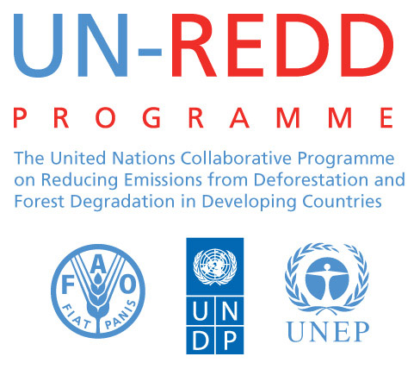

English/French/Spanish translation will be provided

