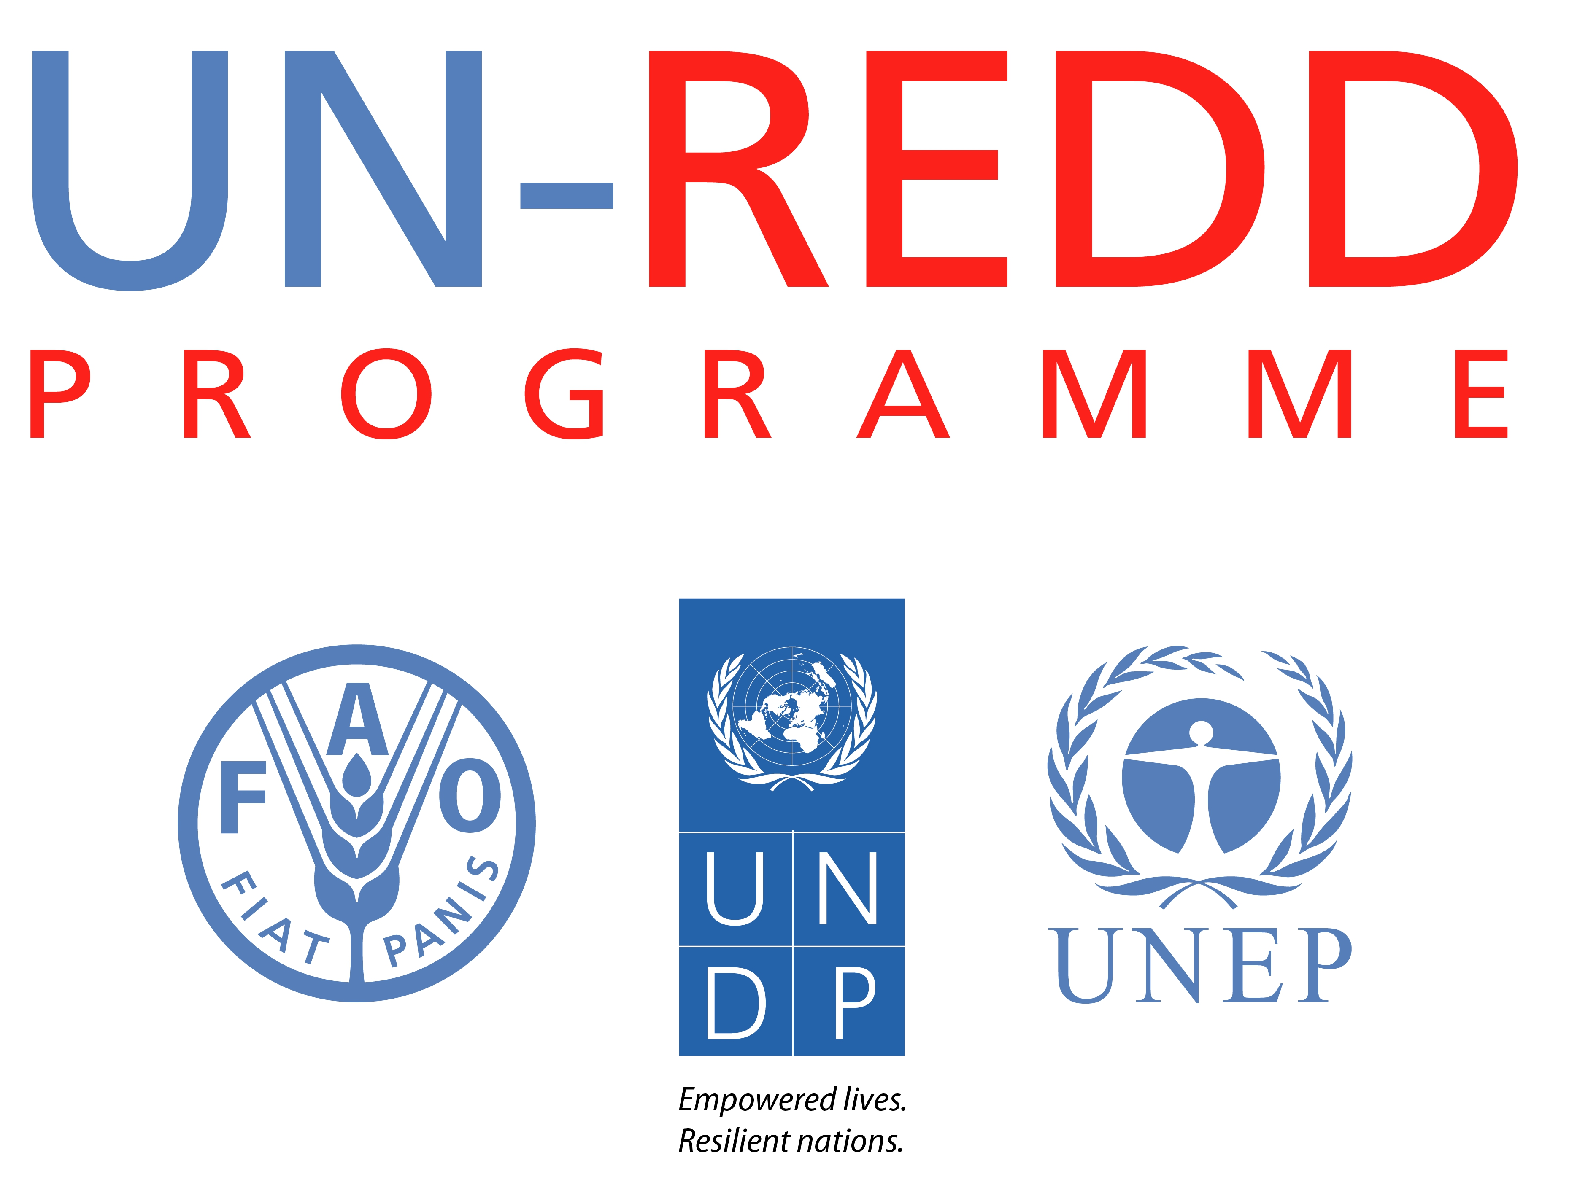
Concept Note
UN-REDD Programme Success Stories

Background
While the UN-REDD Programme has developed communications materials that report on the overall progress and results of partner countries, strong examples or case studies of tangible results are also needed as a compliment to existing products, to help the Programme bring new donors onboard.
UN-REDD Programme Success Stories
Leveraging existing work done to capture examples of success stories (longer case studies, newsletter articles, etc), the UN-REDD Programme develops compelling short case studies that profile examples of tangible progress and results achieved by partner countries with the support of the Programme. Between 800-1,000 words in length, each success story is written in a journalistic style, with a strong title/headline, quotes and photos from stakeholders at the heart of the story. The final content is laid out in a four-page, branded A4 leaflet to present the information in a manner that is easy to digest.
These success stories can also be paired with appropriate existing communication products to form a "donor kit" for current and prospective donors. The success stories can also be leveraged into fresh content for the newsletter, website and workspace, and potentially be featured in future publications, including lessons learned booklets and annual reports.
Target Audience for Success Stories
- Current and prospective donors
- Private sector
- Media that reaches the above audiences

Take-away Message of Success Stories
With the technical and financial support of the UN-REDD Programme, partner countries have made significant progress in their nationally led REDD+ readiness and implementation efforts, achieving results and producing valuable REDD+ knowledge and lessons learned. There is value in supporting the UN-REDD Programme.
Proposed Success Story Structure
The content in each success story is organized according to the following structure:
- Title and one sentence summary of the story. The writing style, for example:
Nigeria Hosts Innovative "REDD+ University"
With support from the UN-REDD Programme, a new university course in Nigeria's Cross-River State brought together an international group of experts to teach the basics of REDD+ to more than 200 participants from across the country.
- "The Challenge"
  - This section gives the context/background, laying out the problem being tackled
  - Approx. 150 words

- "The Initiative"
  - This is the heart of the success story, where the initiative is described
  - Should give evidence to substantiate claims
  - Approx. 450 words

- "The Impact"
  - This section gives the results, lessons learned, and how the initiative improved things of relevance to REDD+
  - It should be able to answer: a)what will change as a results of the activity; b) what are the anticipated benefits for REDD+ ; c) who is likely to benefit and how
  - Approx. 300 words

Division of Labour
Working through the Communications and Knowledge Management Working Group, agencies will share/clear their list of success story topics before writing them to ensure no overlap occurs. Success stories will be written by the agencies, and agencies will also provide graphics and/or photos to be include with each success story, and manage layout and translations. The Secretariat will manage online dissemination. Printed versions will be produced by the agencies as needed.

