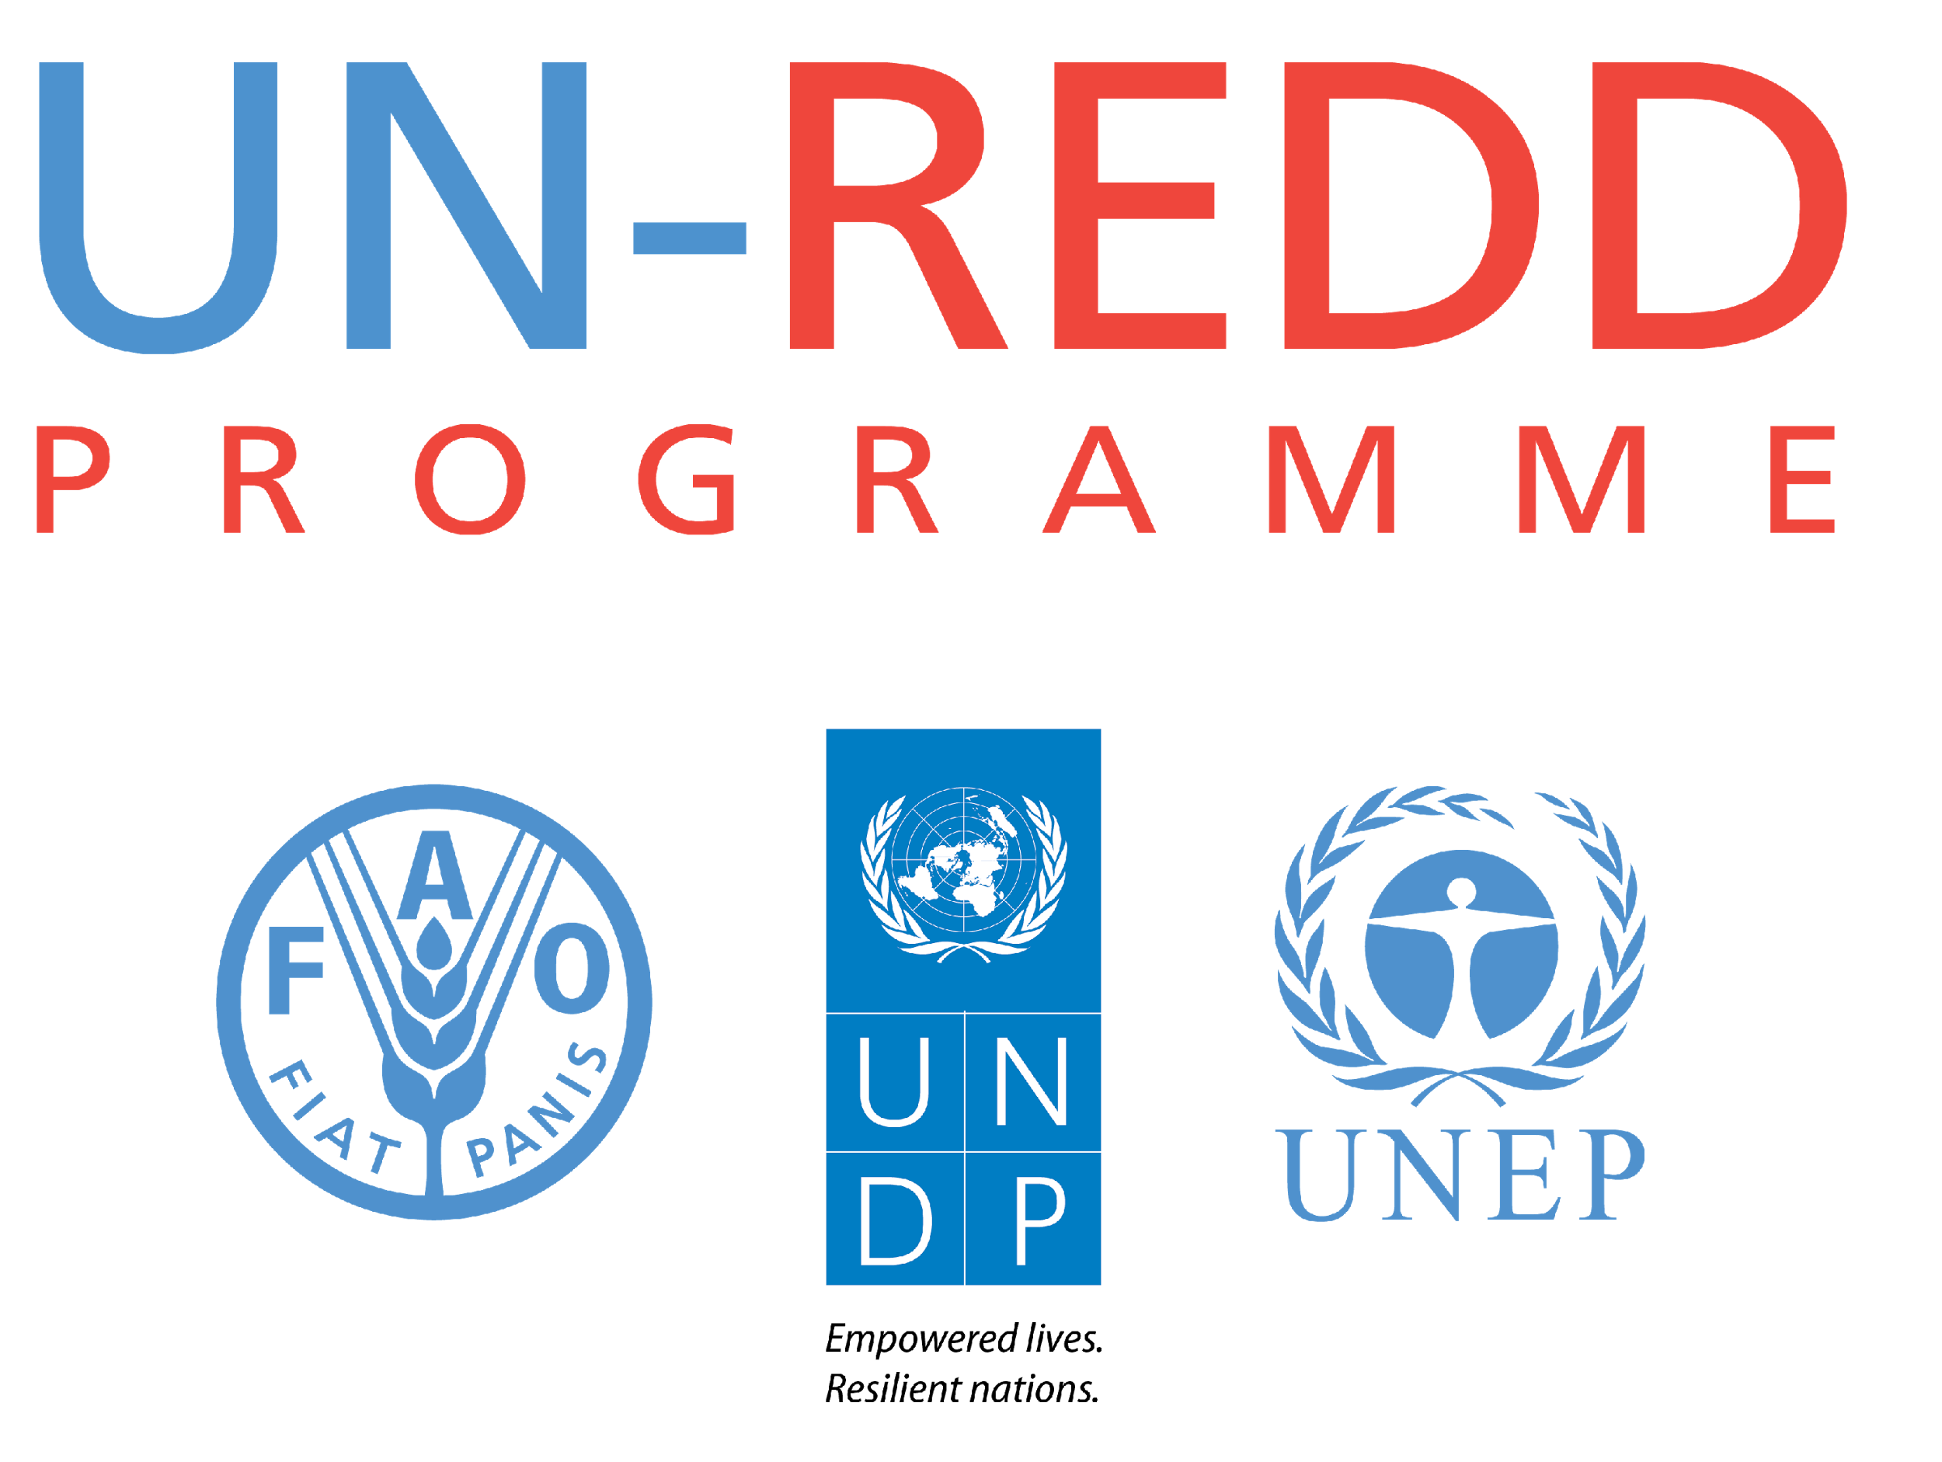

Country Approach to Safeguards:

Framework for Clarifying the Cancun Safeguards
UN-REDD PROGRAMME
V1.2: last updated December 2016

This document presents a non-prescriptive and indicative list of key issues that countries may wish to consider when clarifying each of the seven broad principles embodied in the Cancun safeguards relevant to the specific country context. The substantive content of this framework comprises an elaboration of the Cancun safeguards from an international legal and normative best practice perspective, drawing primarily on the: (2015) UN-REDD Benefits & Risks Tool (BeRT v2.0), (2014) Meridian paper REDD+ Safeguards: Practical Considerations for Developing a Summary of Information, (2013) ClientEarth Guide to Understanding and Implementing the UNFCCC REDD+ Safeguards, and the (2012) UN-REDD Social and Environmental Principles and Criteria.

Depending on the country’s circumstances, clarification of the Cancun safeguards may comprise country-specific thematic criteria, indicators or narrative statements, in relation to the REDD+ actions comprising the national REDD+ strategy or action plan (NS/AP). It should be noted that countries may wish to set safeguard goals beyond the requirements of the UNFCCC and, consequently, additional ‘clarifications’ of substantive content of these other international safeguard frameworks, may be relevant to a country’s specific context and ambition.

Clarifying the Cancun safeguards within the country context contributes to the country approach to safeguards and constitutes a step in the process of how the Cancun safeguards can be addressed and respected (see figure below).

This document is maintained as a living document and updated by the UN-REDD Safeguards Coordination Group (SCG), who aim to ensure inter-agency consensus on the Programme’s support to countries on safeguards. Users of this document are encouraged to submit any feedback to the Safeguards Coordination Group (safeguards@un-redd.org) to inform future versions of this document.



Framework for Clarifying the Cancun Safeguards

CANCUN SAFEGUARD | KEY ISSUES OF SUBSTANTIVE THEMATIC CONTENT
Safeguard (a) - [REDD+] actions complement or are consistent with the objectives of national forest programmes and relevant international conventions and agreements | - Consistency and complementarities with the objectives of the national forest programme.  - Consistency with international commitments on climate; contribution to national climate policy objectives, including those of mitigation and adaptation strategies.  - Coordination among agencies and implementing bodies for REDD+, national forest programmes and national policy(ies) that enact the relevant international conventions and agreements.  - Consistency with the achievement of the Sustainable Development Goals; contribution to national poverty reduction strategies.  - Consistency with international commitments on the environment; contribution to national biodiversity conservation policies (including National Biodiversity Strategies and Action Plans), other environmental and natural resource management policy objectives.  - Consistency with the State’s human rights obligations under international law, including the core international human rights treaties and ILO 169, where applicable.  - Consistency with other relevant international conventions and agreements.
Safeguard (b) - Transparent and effective national forest governance structures, taking into account national legislation and sovereignty | - Access to information  - Accountability  - Land tenure  - Enforcement of the rule of law  - Adequate access to justice, including procedures that can provide effective remedy for infringement of rights, and to resolve disputes (i.e., grievance mechanisms) (NB: overlaps with Safeguard (c))  - Gender equality  - Coherency of national/subnational legal, policy and regulatory framework for transparent and effective forest governance  - Corruption risks  - Resource allocation/capacity to meet institutional mandate  - Institutional capacity to conduct appropriate data collection and planning for forest management  - Participation in decision-making processes (overlaps with Safeguards (c) and (d))
Safeguard (c) - Respect for the knowledge and rights of indigenous peoples and members of local communities, by taking into account relevant international obligations, national circumstances and laws, and noting that the United Nations General Assembly has adopted the United Nations Declaration on the Rights of Indigenous Peoples | - Definition/determination of indigenous peoples and local communities  - Recognition of rights to lands, territories and resources  - Right to compensation and/or other remedies in the case of involuntary resettlement and/or economic displacement  - Right to share in benefits when appropriate  - Right to self-determination  - Right to participate in decision making on issues that may affect them  - Free, prior and informed consent (FPIC)  - Recognition and protection of indigenous peoples’ and local communities’ traditional knowledge, cultural heritage, intellectual property
Safeguard (d) - The full and effective participation of relevant stakeholders, in particular indigenous peoples and local communities [in REDD+ actions] | - Identification of relevant stakeholders - those who may affect, or be affected by, specific REDD+ actions  - Legitimacy and accountability of bodies representing relevant stakeholders  - Mechanisms or platforms to facilitate participatory processes during design, implementation and monitoring of REDD+ architecture, particularly NS/APs, and associated social and environmental safeguard measures  - Functional feedback and grievance redress mechanisms  - Recognition and implementation of procedural rights, such as access to information, consultation and participation (including FPIC) and provision of justice  - Transparency and accessibility of information related to REDD+ (NB: overlaps with Safeguard (b))
Safeguard (e) - [REDD+] actions are consistent with the conservation of natural forests and biological diversity, ensuring that REDD+ actions are not used for the conversion of natural forests, but are instead used to incentivize the protection and conservation of natural forests and their ecosystem services, and to enhance other social and environmental benefits | - Definition of natural forest (consistent across legal framework, forest reference emission level/forest reference level, NS/AP) and understanding of the spatial distribution of natural forest  - Design, prioritisation and implementation of REDD+ actions in a way that avoids or minimises adverse impacts, including through indirect land-use change, on natural forests, carbon stocks, biodiversity and other ecosystem services, both within and outside forests, and that instead promotes their conservation  - Design, prioritisation and implementation of REDD+ actions in a way that avoids or minimises adverse social impacts and that promotes and enhances economic and social well-being, with special attention to the most vulnerable and marginalised groups  - REDD+ actions are not used for the conversion of natural forest, including conversion from natural to planted forest  - Where significant deforestation and forest degradation is ongoing, prioritization of REDD+ actions that incentivize the protection and conservation of natural forests and avoid or minimize degradation of natural forest, over other types of REDD+ actions  - Identification and use of opportunities to incentivise enhanced environmental and social benefits through the way REDD+ actions are designed, located and implemented  - Promotion of actions that involve the management of planted and natural forests to maintain or restore biodiversity and ecosystem services
Safeguard (f) - Actions to address the risks of reversals | - Selection and design of REDD+ actions taking into account the risk of reversals; this may involve consideration of the long-term financial and ecological sustainability of planned actions, legal and regulatory frameworks including tenure, support and ownership among stakeholders, and potential changes in environmental conditions and the drivers of deforestation and forest degradation, and the barriers to sustainable management, conservation, enhancement of forest carbon stocks  - Design, prioritization and implementation of REDD+ actions that address the underlying and indirect drivers of deforestation and forest degradation, and barriers to sustainable management, conservation, enhancement of forest carbon stocks and land use change rather than only addressing direct drivers at specific locations  - Analysis of the risk of reversals of emissions reductions, also referred to as 'non-permanence'  - National Forest Monitoring System (NFMS) - including satellite land monitoring system, national forest inventory, greenhouse gas inventory designed, maintained and implemented with the appropriate frequency to detect and provide information on reversals and to perform the functions of monitoring, measuring and reporting results of REDD+ policies and measures, with human resources and technical capacities institutionalized
Safeguard (g) - Actions to reduce displacement of emissions | - Preparation, endorsement and continuous updating of a NS/AP covering the entire national territory  - Plan to move towards national scale REDD+ implementation, including all significant REDD+ activities  - Design, prioritization and implementation of REDD+ actions that address the underlying and indirect drivers of deforestation and forest degradation, and barriers to the conservation, enhancement, and sustainable management of forests, as well as other land-use changes, rather than only addressing direct drivers at specific locations  - Design, prioritization and implementation of actions to reduce displacement of emissions from specific REDD+ actions at the local, sub-national and national scales, taking into account the potential impacts of REDD+ actions on livelihoods, as well as the demand for and supply of forest and agricultural products  - Selection and design of REDD+ actions taking into consideration the risk of emissions displacement; displacement risk analysis for the selected REDD+ actions, including risk of emissions displacement to other ecosystems, e.g. through draining of peatlands for agricultural use or displacement of pressures on forests to another region or area  - NFMS designed, maintained and implemented with the appropriate frequency to detect and provide information on displacement (i.e. to detect land use changes) at national, subnational and local levels, and human resources and technical capacities institutionalized  - Analysis of possible reasons for displacement of emissions, such as ineffective implementation of REDD+ actions, or REDD+ actions that are not designed to address underlying (local, subnational, national) drivers of deforestation and forest degradation, and the barriers to sustainable management, conservation and enhancement of forest carbon stocks

