Cambodia National REDD Roadmap

Proposed Actions and Points for Consideration

National REDD management arrangements
  - REDD coordination
A REDD Technical Taskforce will be established to oversee development of REDD readiness in Cambodia. An informal meeting including participants from relevant agencies and organisations was held on 26th November 2009 at which initial arrangements for the Taskforce were discussed.
Draft Terms of Reference for the Taskforce will be developed in consultation with relevant stakeholders. The ToRs are expected to include duties of the group including in relation to REDD readiness coordination, information collection and reporting.
The Taskforce will meet during January-May 2010. An early meeting should review and approve the Taskforce ToRs and workplan. The group should then meet regularly until May 2010 when the Roadmap is finalised.

Stakeholder consultation and participation
Consultation and REDD training workshops will be held regularly during the initial REDD readiness process, beginning with Government agencies.
Additionally, a REDD consultation plan will be drafted during the initial period of readiness planning for execution during implementation of the readiness plan.

REDD Roadmap preparation assessments
To develop a REDD Readiness Roadmap a series of technical, policy and sectoral assessments are necessary. Several are already planned or underway and a key task for the REDD Technical Taskforce will be to coordinate and plan activities to ensure consistency with national policy and appropriate capacity building inputs, etc. Several activities will be necessary in to assist decision making in relation to REDD Roadmap development, including:

Review of legal, policy and institutional arrangements relevant to REDD
Review of Cambodian laws and the policies in the context of REDD would potentially include areas associated with:
- forestry and environment legislation,
- land and forest tenure / title, carbon ownership, land concessions, community forestry,
- tax, trade and investment legislation,
- local communities and indigenous peoples,
- environmental and social impact assessment,
- benefit-sharing and financial disbursement, and
- organic law reform (decentralization and deconcentration).
This review could also include recommendations on how REDD might be integrated into existing institutional arrangements and in which areas further development of laws and policies might be required.

Assessment of land use, drivers of land use change and forest governance
An assessment of land-use change and forest governance would include a consideration of:
- Direct and indirect drivers of land use and forest cover change in recent years;
- Leakage, both domestic and regional, a plan for how associated drivers might be better studied and understood
- Changes in the timber supply-demand situation since the logging moratorium
- How the future productivity of plantation resources and community forestry schemes, etc. might help in meeting future demand for forest products
- Existing efforts to reduce deforestation and forest degradation
- Work required to better understand drivers as part of a REDD policy development process

Assessment of potential REDD co-benefits (Technical assistance by UNEP-WCMC)
Co-benefits of REDD implementation in terms of poverty alleviation, water resources and biodiversity conservation will be assessed to help inform REDD strategy development.

REDD strategy options analysis
Achieving REDD will require the development of new policies and implementation strategies. At present there is little information to inform what decisions about what types of strategies might be implemented. However, several organisations are undertaking analyses or demonstration of different strategy options, including CCAP, PACT/CCI and WCS. Based on these analyses and examples a series of briefing papers may be developed by the REDD Technical Taskforce describing possible REDD strategies, including how sub-national efforts might be linked to a national REDD framework.

National-level REDD standard and international requirements
Cambodia’s REDD Roadmap will need to adhere to international requirements, e.g. from the UN REDD programme. Cambodia may also want to consider participating in the ongoing development of the REDD+ Social and Environmental Standards. A briefing to the Taskforce will need to be developed about how these could be integrated into the Roadmap.

Reference Emissions Levels (RELs) and Monitoring, Reporting and Verification Systems
To develop a monitoring, reporting and verification system for REDD, assessment of current information and capacity in relevant areas will be undertaken including review of existing data sources, focusing on land-use change and carbon stock data. The review should also investigate options for establishing subnational MRV systems, drawing upon experience from the large number of existing forest conservation efforts underway. In addition, a costed plan for MRV establishment, including monitoring of leakage, should be developed.
Based on information gathered under 2 above, a costed plan for the further activities required in order to develop a REL for Cambodia should also be developed.

Development of the REDD Roadmap

The REDD Roadmap will be a document that describes how Cambodia proposes to move forward with REDD Readiness activities. The Roadmap sections should include:
- Management of National REDD Readiness (based on the results of section 1.1 above)
- Development of Reference Emission Levels and establishment and implementation of national Monitoring, Reporting and Verification systems (based on the results of section 3 above)
- Development and selection of REDD strategies (based on the results of sections 2.1, 2.2, 2.3, 2.4 and 2.5 above)
- Implementation framework (based on the results of sections 2.1 and 2.5 above)
- Consultation, stakeholder engagement and awareness-raising (based on the results of section 1.2 above)
- Environmental and Social Impact Assessment
The Roadmap drafting process will need to be consultative, including discussions with government agencies and civil society.
Schedule

Phase 1a: National Coordination and Information Collection

- November 23-December 4. Initial documents on the Roadmap process, including the Terms of Reference for the REDD Technical Taskforce, the membership, the Roadmap outline and the Roadmap development process will be drafted, following extensive consultations. An initial meeting of the Taskforce will take place.
- December 7-18: COP15
- January 2010: First meeting of the REDD Technical Taskforce
- January-February 2010: A call for information to inform the process, and presentations by key stakeholders on ongoing activities.

Phase 1b: Scoping studies and Readiness Planning

- February 2010-April 2010: Completion of Roadmap preparation assessments, including the institutional mapping.
- April 2010-May 2010: Drafting the Roadmap

Figure 1: Phases and Outputs
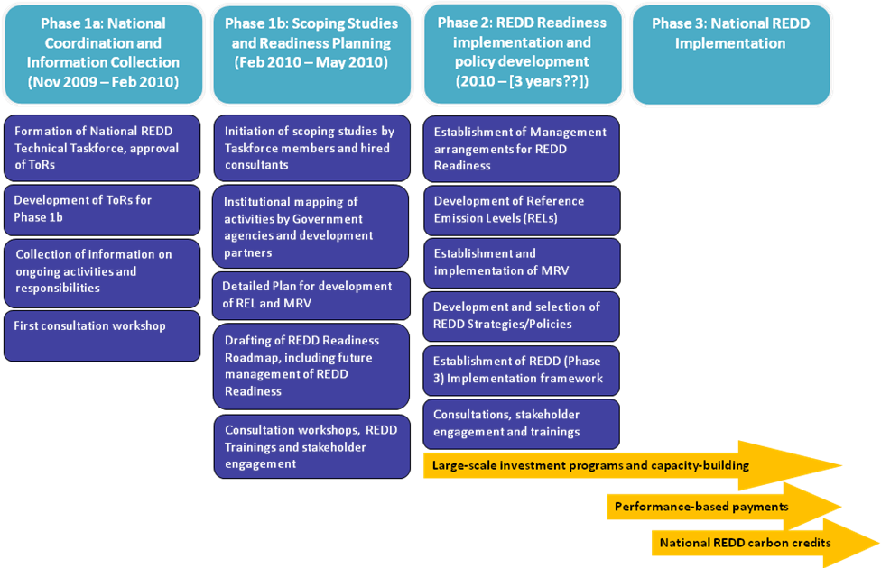

Forestry Administration; Ministry of Environment; Ministry of Land Management, Urban Planning and Construction; Fisheries Administration; FAO, WCS/UNDP; Clinton Climate Initiative; RECOFTC.
It is expected that significant contribution to the national REDD process will be gained through sub-national level REDD related efforts supported by, e.g. FA, WCS, CCI and PACT. Additionally, CCAP (Center for Clean Air Policy, Washington D.C.) has received NORAD funding to analyse REDD options for Cambodia including assessment of drivers of deforestation, estimation of deforestation and degradation rates and associated GHG emissions and identification and analysis of options to reduce deforestation and degradation. The study will also include analysis of the costs and benefits of alternative land-uses (including REDD) and co-benefits. Winrock International have received direct support from USAID to assist the Cambodian Government with assessment of MRV options and plans to develop a REL.

