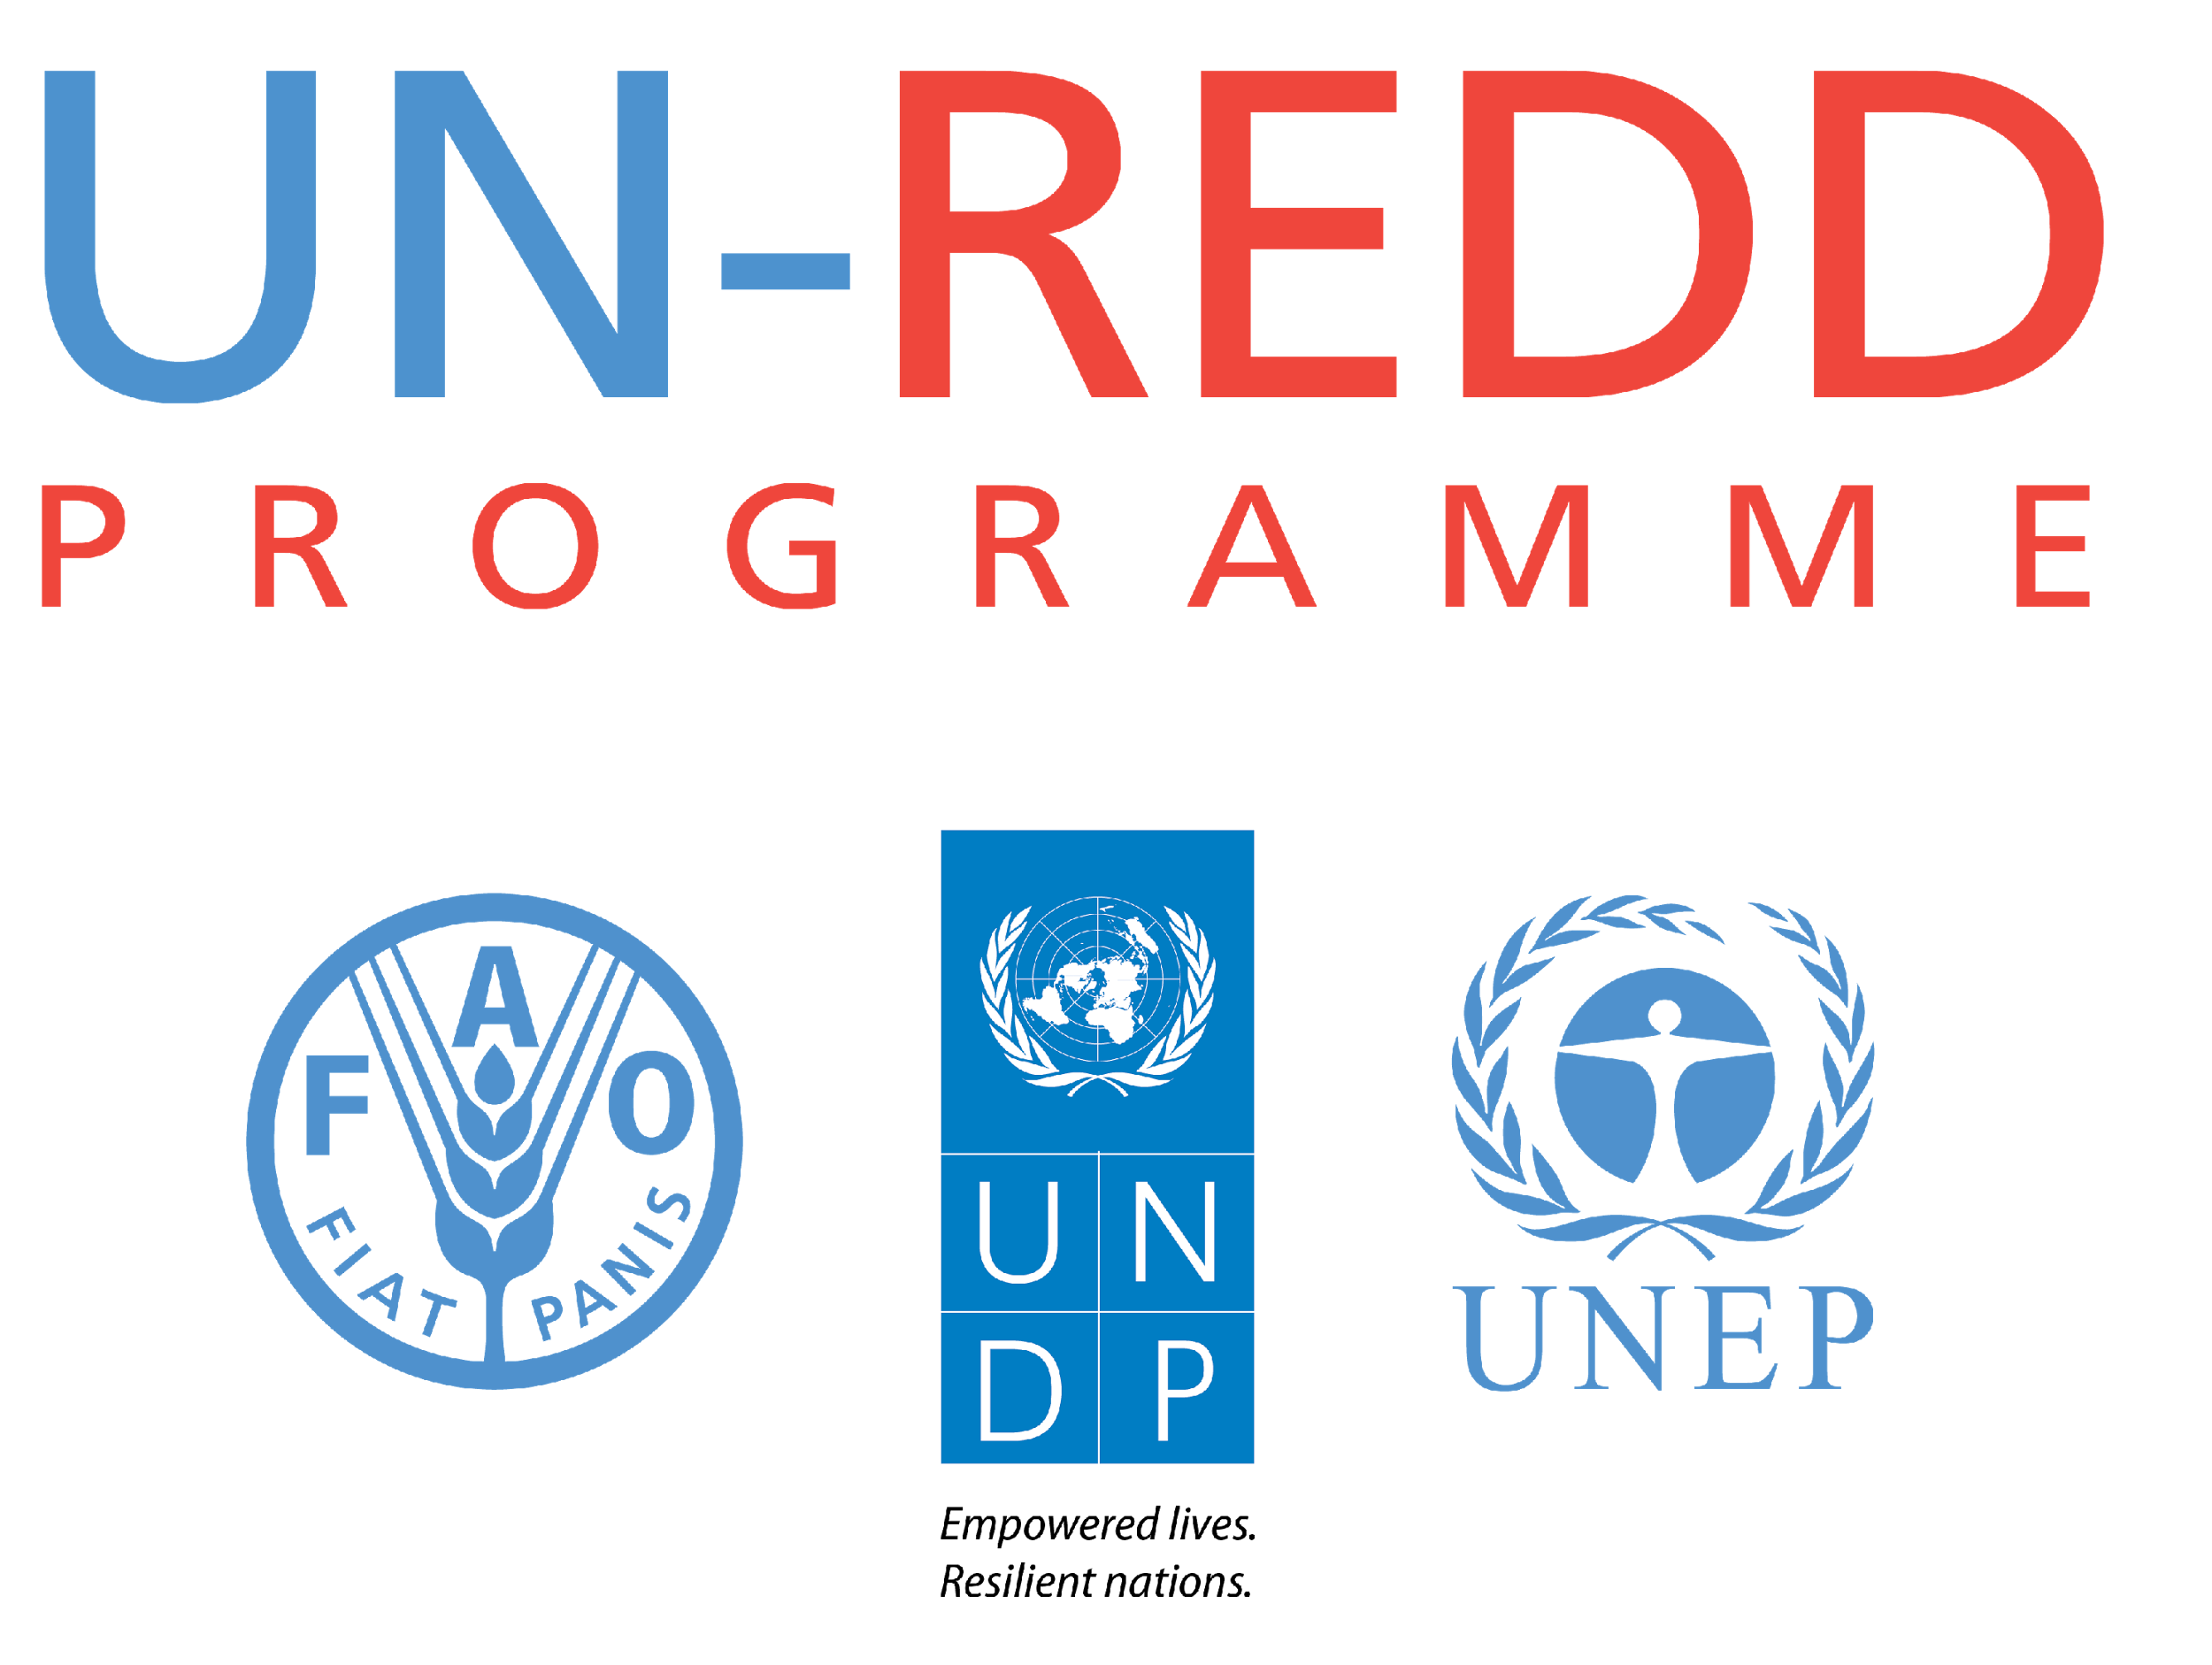

Country Approach to Safeguards:

Benefits and Risk Assessment Framework
UN-REDD PROGRAMME
June 2015

This document presents a series of tables that extract the guiding questions used in the UN-REDD Programme’s Benefits & Risk Tool (BeRT v2.0) to serve as quick reference guide or an alternative way to access the various components of the Tool in a linear format. This tabular format of the BeRT contents is intended as a complementary product to be used in conjunction with the BeRT. Users of this document are encouraged to submit any feedback on contents and structure of this framework, as well as the BeRT to the Safeguards Coordination Group (safeguards@un-redd.org). User feedback will be used to inform future versions of these knowledge products.

The BeRT is designed to support countries to identify benefits and risks associated with REDD+ actions or policies and measures (PaMs) that a country defines as it develops its REDD+ national strategy/action plan. It helps to determine how the country’s existing policies, laws and regulations (PLRs) already address the risks or promote the benefits identified, as well as identify the gaps in addressing and respecting the Cancun safeguards (1/CP.16, appendix I) in REDD+ implementation. It can inform a decision on which actions to include in a REDD+ Strategy of a country.

The tool (BeRT) contributes to the country approach to safeguards (see Figure below) by assessing the benefits and risks of PaMs and provides content for use in the summary of information on how countries are addressing and respecting the safeguards through existing PLRs.



The interactive BeRT is available in an Excel format and is designed to inform multi-stakeholder workshops as part of a country’s approach to REDD+ safeguards. Through the application of the tool’s three modules, stakeholders can generate a table of REDD+ actions or candidate PaMs; a table of potential benefits and risks under each of the safeguards; and a table of existing PLRs that address the safeguards, how the PLRs address the benefits and risks and a list of gaps in the PLRs.

Safeguard (a) - Consistency with national objectives and international agreements
Key Issues
- Consistency with international commitments on climate; contribution to national climate policy objectives, including those of mitigation and adaptation strategies.
- Consistency with the achievement of the Millennium Development Goals and post-2015 Sustainable Development Goals; contribution to national poverty reduction strategies.
- Consistency with international commitments on the environment; contribution to national biodiversity conservation policies (including National Biodiversity Strategies and Action Plans), other environmental and natural resource management policy objectives.
- Consistency with State’s human rights obligations under international law, including the core international human rights treaties and ILO 169, where applicable.
- Consistency and complementarities with the objectives of the national forest programme.
- Coordination among agencies and implementing bodies for REDD+, national forest programmes and national policy(ies) that enact the relevant international conventions and agreements.
- Consistency with other relevant international conventions and agreements.
Risk/Benefit Analysis | Policy, law and regulation review
Are any of the candidate REDD+ actions / PAMs likely to:  - Make a specific contribution to achieving the objectives of the national forest programme?  - Make a specific contribution to achieving policy objectives on climate change adaptation (e.g. on restoring degraded watersheds to reduce flood risk), or objectives for additional climate change mitigation?  - Make a specific contribution to achieving the Millennium Development Goals or other international commitments on poverty reduction?  - Make a specific contribution to achieving the objectives of the Convention on Biological Diversity (e.g. through forest restoration using native species)?  - Potentially have inequitable or discriminatory adverse impacts on affected populations, particularly people living in poverty or marginalized or excluded individuals or groups?  Is there a risk of conflict between the candidate REDD+ actions / PAMS and:  - Other climate change mitigation strategies (e.g. concerning land or woody biomass requirements for bioenergy production, or alternative energy development such as hydropower or wind farms)?  - National poverty reduction strategies (e.g. plans for infrastructure development or agriculture)?  - Other environmental policy objectives and strategies (e.g. plans for community or production forests under the national forest programme, or for increased protected area coverage under the National Biodiversity Strategy and Action Plan)?  - State’s human rights obligations under international law, including the nine core international human rights treaties and ILO 169? | Does the national REDD+ strategy or action plan refer to, and make use of, the following national laws and policies contributing to the implementation of relevant international conventions and agreements:  - National forest programme?  - Forest code/Forest law?  - Climate change mitigation strategy/policy?  - Climate change adaptation strategy/policy?  - Development policies / national poverty reduction strategies?  - Law on biodiversity/ecosystem services?  - Legal instruments related to protected areas?  - Infrastructure development plans?  - Agricultural development plans and policies?  - Other existing land-use plans?  - Registry of mining and logging concessions?  - Land tenure?  Are there policies, laws, regulations or other measures in place (or planned) to:  - Identify and address any inconsistencies between proposed REDD+ actions and:  - the National Forest Programme?  - national implementation of relevant international agreements on climate, development and biodiversity?  - Explore and enhance complementarities between the REDD+ and National Forest Programme and these relevant international agreements?  - Facilitate coordination and communication between the agencies and actors implementing these national policies and those involved with REDD+?  How accessible, predictable, equitable are each of these PLRs? Are they implemented?

Safeguard (b) - Transparent, effective forest governance and sovereignty
Key Issues
- Access to information.
- Accountability.
- Land tenure.
- Enforcement of the rule of law.
- Adequate access to justice, including procedures that can provide effective remedy for infringement of rights, and to resolve disputes (ie grievance mechanisms) (NB: Overlaps with Safeguard (c)).
- Gender equality.
- Coherency of national/subnational legal, policy and regulatory framework for transparent and effective forest governance.
- Corruption risks.
- Resource allocation/capacity to meet institutional mandate.
- Participation in decision-making processes (NB: overlaps with Safeguards (c) & (d)).
Risk/Benefit Analysis | Policy, law and regulation review
Are any of the candidate REDD+ actions / PAMs likely to:  - Generate and share relevant and timely information (i.e. financial information, information about decision-making processes, bidding and procurement processes, etc.) with stakeholders in the appropriate language and format?  - Set up new, or enhanced existing forest organizational decision-making structures, with clear and defined roles and responsibilities?  - Be monitored against a set of clear, measurable and time-bound targets?  - Be framed and codified by legal/regulatory systems that are provided the means to be enforceable?  - Create and apply appropriate sanctions?  - Be safeguarded against corruption risks through additional specific detection, prevention and sanction measures?  - Have the appropriate capacities (individual, institutional, collaborative, financial capacities) to be effectively implemented?  - Have inequitable adverse impacts on gender equality and/or the situation of women and girls?  - Discriminate against women or other groups based on gender, especially regarding participation in design and implementation or access to opportunities and benefits?  - Have impacts that could adversely affect women’s and men’s ability to use, develop and protect natural resources, taking into account different roles and positions of women and men in accessing environmental goods and services? | Are there policies, laws, regulations or other measures in place (or planned) to:  - Provide access to timely, relevant and usable information about REDD+ actions?  - Establish information disclosure procedures?  - Undertake active dissemination through multiple and appropriate channels?  - Educate stakeholders about where to access this information?  - Designate focal points within REDD+ agencies who are responsible and accountable for sharing information effectively?  - Establish organizational decision making structures, with description of the principles that guide decisions and a clear timetable for decision making processes?  - Evaluate the effectiveness of REDD+ actions on a regular basis, in consultation with stakeholders, and release evaluation results on a regular basis?  - Include or propose approaches to ensure the accountability of bodies representing stakeholders?  - Prevent, detect and sanction abuses of power and corruption in the implementation of REDD+ actions?  - Promote gender equality and the empowerment of women while seeking to reduce gender inequalities in access to and control over resources and the benefits of development?  How accessible, predictable, equitable are each of these PLRs? Are they implemented?

Safeguard (c) - Respect for knowledge and rights of indigenous peoples and local communities
Key Issues
- Definition/determination of indigenous peoples and local communities.
- Recognition of rights to land, territories and resources.
- Right to compensation and/or other remedies in case of involuntary resettlement and/or economic displacement.
- Right to share in benefits when appropriate.
- Right to self-determination.
- Right to participate in decision making on issues that may affect them.
- Free, Prior & Informed Consent (FPIC).
- Recognition and protection of indigenous peoples’ and local communities’ traditional knowledge, cultural heritage, intellectual property.
Risk/Benefit Analysis | Policy, law and regulation review
Are any of the candidate REDD+ actions / PAMs likely to:  - Potentially affect the rights, lands and territories of indigenous peoples and/or local communities (regardless of whether Indigenous Peoples possess the legal titles to such areas)?  - Involve the utilization and/or commercial development of natural resources on lands and territories claimed by indigenous peoples and/or local communities?  - Potentially result in forced eviction or the whole or partial physical displacement of indigenous peoples and/or local communities, including through access restrictions to lands, territories, and resources?  - Potentially result in economic displacement of indigenous peoples and/or local communities (e.g. loss of assets or access to resources due to land acquisition or access restrictions – even in the absence of physical relocation)?  - Adversely affect the development priorities of indigenous peoples and/or local communities as defined by them?  - Potentially affect the traditional livelihoods, physical and cultural survival of indigenous peoples and/or local communities?  - Potentially affect the Cultural Heritage of indigenous peoples and/or local communities, including through the commercialization or use of their traditional knowledge and practices?  - Result in interventions that would potentially adversely impact sites, structures, or objects with historical, cultural, artistic, traditional or religious values or intangible forms of culture (e.g. knowledge, innovations, practices)?  - Potentially affect land tenure arrangements and/or community based property rights/customary rights to land, territories and/or resources?  - Potentially discriminate against indigenous peoples and/or local communities regarding participation in design and implementation or access to opportunities and benefits? | Are there policies, laws, regulations or other measures in place (or planned) to:  - Recognize and foster full respect for indigenous peoples and local communities’ human rights, in line with State’s obligations under international law (including their rights to self-determination, their lands, resources and territories, traditional livelihoods and cultures)?  - Ensure indigenous peoples and local communities’ full and effective participation, with the objective of securing their FPIC where their rights, lands, resources, territories, traditional livelihoods may be affected?  - Promote greater control and management by indigenous peoples and local communities over developments affecting them, including their lands, resources and territories?  - Avoid adverse impacts on the rights of indigenous peoples and local communities, their lands, resources and territories, to mitigate and remedy residual impacts, and to ensure provision of just and equitable benefits?  - Recognize and respect the prohibition on forced evictions of indigenous peoples and local communities?  - Anticipate and avoid, or, when avoidance is not possible, minimize adverse social and economic impacts from land or resource acquisition or restrictions on land or resource use?  - Enhance or at least restore the livelihoods of all displaced persons and to improve the standards of living of the displaced poor and other displaced groups?  - Protect and manage Cultural Heritage?  - Conserve Cultural Heritage and avoid its alteration, damage or removal?  - Promote the equitable sharing of benefits when benefits are derived from the lands, resources and/or territories of indigenous peoples and/or local communities?  How accessible, predictable, equitable are each of these PLRs? Are they implemented?

Safeguard (d) - Full and effective participation of relevant stakeholders,
in particular indigenous peoples and local communities
Key Issues
- Full and effective participation of relevant stakeholders.
- Legitimacy and accountability of bodies representing relevant stakeholders.
- Participatory mechanisms or platforms
- Access to justice, grievance mechanisms.
- Transparency and accessibility of information related to REDD+ (NB: overlaps with Safeguard (b))
Risk/Benefit Analysis | Policy, law and regulation review
- Are any of the candidate REDD+ actions / PAMs likely to exclude any affected stakeholders, in particular marginalized groups, from fully participating in decisions that may affect them?  - Are any of the candidate REDD+ actions / PAMs likely to exacerbate conflicts among and/or the risk of violence to project-affected communities and individuals?  - Has a process/platform been established for the relevant stakeholders to engage fully and effectively (e.g. in a gender-responsive, culturally sensitive, non-discriminatory and inclusive manner)?  - Has a process been established to outline how the government will secure the free, prior and informed consent of relevant rights-holders for REDD+ actions that will impact their rights, lands, territories or resources?  - Have the relevant stakeholders identified their own representation structures, including representatives?  - Have the relevant stakeholders been consulted fully and effectively in the design and agreement of the REDD+ actions?  - Has a process been established for those impacted/affected by REDD+ actions to have their complaints heard and addressed?  - Has a process been established to ensure the timely dissemination of information about REDD+ actions to relevant stakeholders in an accessible form and language? | Are there policies, laws, regulations or other measures in place (or planned) to:  - Ensure meaningful, effective and informed participation of stakeholders in the formulation and implementation of REDD+?  - Ensure stakeholder analysis and engagement will be conducted in a gender-responsive, culturally sensitive, non-discriminatory and inclusive manner, ensuring that potentially affected vulnerable and marginalized groups are identified and provided opportunities to participate?  - Ensure the scale and frequency of the engagement will reflect the nature of the activity, the magnitude of potential risks and adverse impacts, and concerns raised by affected communities?  - Ensure FPIC for activities that may affect the rights and interests, lands, resources, territories and traditional livelihoods of indigenous peoples?  - Ensure that stakeholders who may be adversely affected by REDD+ action(s) can communicate their concerns about the social and environmental performance and impacts through various entry points?  - Support the self-selection of representatives to participate in decision-making about REDD+?  How accessible, predictable, equitable are each of these PLRs? Are they implemented?

Safeguard (e) –Natural forest, biological diversity and enhancement of benefits
Key Issues
- Definition of natural forest and understanding of the distribution of natural forest.
- Understanding the potential impacts of REDD+ policy options on biodiversity and forest ecosystem services.
- Conservation of natural forests; avoiding degradation, or conversion to planted forest (unless as part of forest restoration).
- Management of planted and natural forests to maintain or restore biodiversity and ecosystem services (e.g. soil erosion control, water purity, non-timber forest products).
- Identification and enhancement of social benefits (e.g. improved livelihoods, benefit sharing).
- Conservation of biodiversity outside forest.
Risk/Benefit Analysis | Policy, law and regulation review
Are any of the candidate REDD+ actions / PAMs likely to:  - Result in enhanced conservation of biodiversity, natural forests and their ecosystem services, such as:  - Improving the status of areas of biodiversity importance (e.g. through better management of protected areas, or targeting REDD+ actions in areas of biodiversity importance)?  - Avoiding soil erosion and maintaining water quality (e.g. through targeted reduction of forest clearance or of intensive logging on steep slopes and riverine forests)?  - Pose risks to the conservation of biodiversity, natural forests and their ecosystem services, through:  - Conversion (e.g. establishment of plantations in degraded or secondary forest)?  - Degradation of biodiversity and ecosystem services (e.g. by intensifying the use of forests leading to increased hunting pressure on vulnerable species, or by favoring highly productive tree species at the expense of species diversity)?  - Pose risks to biodiversity outside forests, through:  - Displacement of land-use change (e.g. new grazing land in other ecosystems rather than in forest)?  - Unintended impacts on neighbouring lands (e.g. from pesticide drift from intensified agriculture, water abstraction, or fire resulting from forest management)?  - Afforestation in areas of conservation importance?  - Pose risks to biodiversity in other countries, through:  - Increased imports of agricultural products to offset reductions in domestic production?  - Increased imports of timber?  - Improve local communities’ access to forest products, such as fuel wood, forest foods and medicinal plants?  Are any of the candidate REDD+ actions / PAMs likely to:  - Restrict availability, quality of and access to forest products, in particular to local communities?  - Enhance communities’ capacity to adapt to climate change and hence reduce their vulnerability to climate change?  - Provide incentives related to the conservation of natural forests and their ecosystem services (e.g. benefit-sharing, Payments for Ecosystem Services (PES))?  - Provide livelihood opportunities for local communities (e.g. employment in assisted natural regeneration project, development of alternative income generating opportunities that reduce pressures on forests?  - Negatively impact local livelihoods (e.g. through loss of livelihoods due to closures in timber and timber-related industries or controls on agricultural expansion)?  - Conserve forests and forest products of traditional and spiritual importance for indigenous and local communities? (e.g. conservation of sacred sites, medicinal plants)  Will the REDD+ programme incentivize forest conservation by prioritizing actions that reduce conversion of natural forest (e.g. to agriculture) over other REDD+ activities?  - If actions that reduce conversion are not prioritized, is there a risk that forest clearance will continue while effort is expended on other REDD+ activities such as afforestation?  Will the REDD+ programme prioritize interventions that reduce degradation of natural forest over other REDD+ activities? | Relating to natural forests  Are there policies, laws, regulations or other measures in place (or planned) to:  - Define a natural forest (including guidance about age, composition and degree of degradation)?  - Develop and maintain information on the distribution of forests and their value for biodiversity and ecosystem services?  - Understand drivers of deforestation and forest degradation?  - Limit conversion and degradation of natural forests (e.g. land use plans, coverage by protected areas, forest management standards and plans, guidance on the use of fire in agriculture)?  Relating to biodiversity  Are there policies, laws, regulations or other measures in place (or planned) to:  - Define specific goals or targets for biodiversity conservation (species and/or ecosystems); including for REDD+?  - Identify and map unique and threatened ecosystems or ecosystems associated with endemic and endangered species?  - Consider and monitor effects of forest management on biodiversity and ecosystem services?  - Ensure that land-use planning takes account of ecosystem services and biodiversity conservation, including outside forest (e.g. contribution of wetlands to flood regulation); and aim to maintain or increase forest connectivity (reduce fragmentation)?  - Avoid or minimise adverse impacts of REDD+ on non-forest ecosystems (e.g. existing land use plans, coverage by protected areas, requirements for Environmental Impact Assessment (EIA))?  - Avoid or minimise impacts of REDD+ on biodiversity in other countries (e.g. by choosing to promote reduced-impact logging rather than to increase timber imports)?  Relating to other social and environmental benefits  Are there policies, laws, regulations, or other measures in place (or planned) to:  - Identify and map the value of ecosystem services to local communities?  - Incorporate these values into land-use planning?  - Define local communities’ rights to use ecosystem services?  - Improve long-term economic, social and political well-being of indigenous peoples and local communities?

Safeguard (f) - Address risk of reversals
Key Issues
- Analysis of the risk of reversals of emissions reductions, also referred to as ‘non-permanence’.
- National Forest Monitoring System (NFMS) may be designed to detect and provide information on reversals.
- Plausible reference scenarios for REDD+ that give a reasonable indication of the risk of deforestation in the absence of REDD+. If this is underestimated, then REDD+ successes may be at a greater risk of reversal.
Risk/Benefit Analysis | Policy, law and regulation review
Are any of the candidate REDD+ actions / PAMs likely to:  - Climate change (e.g. more frequent drought, flooding)?  - Wildfire?  - Institutional failure?  - Projected demographic trends and changing demands on land, including through international trade?  - Instability in neighbouring countries (e.g. REDD+ actions in troubled border areas)? | Are there policies, laws, regulations or other measures in place (or planned) to:  - Improve information on the magnitude, distribution and current trends in carbon stocks?  - Identify potential drivers of land use change and forest degradation into the future?  - Use concessions to permit or discourage different forest activities?  - Limit the potential impacts of climate change and/or demographic change on forests and ecosystem services (e.g. NAPAs, NAMAs, agricultural, forest or other sectoral planning)?  - Integrate REDD+ planning with other planning procedures?  - Identify and/or respond to new information on the risks of reversal of REDD+ achievements?  - Enable monitoring of reversals of REDD+ achievements, such as through a National Forest Monitoring System (NFMS)?  How accessible, predictable, equitable are each of these PLRs? Are they implemented?

Safeguard (g) - Reduce displacement of emissions
Key Issues
- Addressing direct and indirect drivers of land-use change.
- Displacement of emissions at the local level (e.g. across REDD+ project boundaries) may result from some REDD+ options.
- Displacement of emissions at the national level (to other locations within the country) may result from some REDD+ options.
- National Forest Monitoring System (NFMS) may be designed to detect and provide information on displacement at national, regional and local levels.
Risk/Benefit Analysis | Policy, law and regulation review
Are there drivers of land-use change and forest degradation that are likely to persist despite REDD+ actions?  Are any of the candidate REDD+ actions / PAMs likely to:  - Result in displacement of land-use change at the local level (e.g. forest protection leading to agricultural conversion of bushland)?  - Give rise to displacement of land-use change within national borders?  - Is the significance of the carbon storage role of non-forest ecosystems in the country/ region understood (i.e. the extent of damage to the climate from displaced land-use change)?  - Is the vulnerability of non-forest ecosystems to land-use change understood (e.g. agricultural suitability, accessibility, protection status, potential importance for extractive uses, fragmentation)? | Are there policies, laws, regulations or other measures in place (or planned) to:  - Identify possible displacement of land use change and/or forest degradation within and across national borders?  - Monitor displacement as part of a National Forest Monitoring System (NFMS)?  - Avoid or minimize displacement of emissions by enhancing cropland or grazing land areas (e.g. tree planting, agricultural intensification, fertilisation, fodder production)?  - Avoid or minimize displacement at the local level by development of alternative livelihoods (e.g. payments for ecosystem services (PES) and integrated conservation and development projects (ICDP))?  - Provide for bilateral or multilateral cooperation on tackling land-use change across national borders?  How accessible, predictable, equitable are each of these PLRs? Are they implemented?

