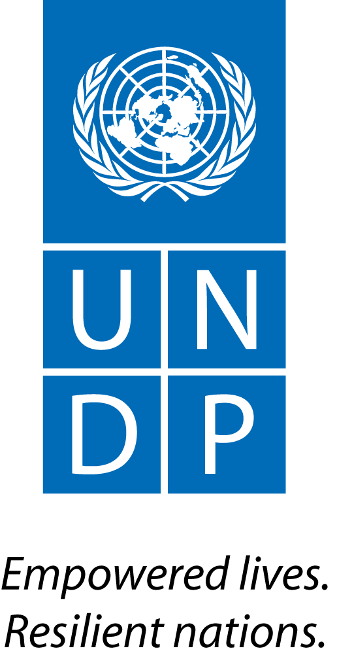 | Back to Office Report  Submitted by: Joel Scriven  Title: Regional Technical Specialist  Date submitted: 14 March 2016
1. Practice area: Environment & Energy
2. Mission period (incl. of travel days)
From: 10-11 March 2016
3. Type of mission: FCPF Readiness Project backstopping | 4. Clients:  FCPF PMU, REDD+ Taskforce Secretariat, Forest Administration, Ministry of Environment
5. Purpose of mission:  - Attendance of 10th Policy Board of FCPF and UN-REDD | 6. Documents, materials, resources:  Mission agenda
7. Mission members:  Joel Scriven | 8. Costs:  UNDP/UN-REDD Global Budget
9. Brief summary of the mission:

Cambodia is in the readiness phase of REDD+ implementation. Key milestones in REDD+ readiness include the development of a national REDD+ strategy (NRS) and policies and measures (PAMs) for REDD+ implementation. Cambodia developed its NRS in 2015 and presented a draft version at the 21st Conference of the Parties (COP21) to the United Nations Framework Convention on Climate Change (UNFCCC) in Paris, December 2015. REDD+ readiness in Cambodia has received various lines of bilateral and multilateral support, including through the UN-REDD Programme and the World Bank’s Forest Carbon Partnership Facility (FCPF). A UN-REDD National Programme ran from 2011 to 2015; a 3-year $3.8m FCPF readiness grant began implementation in March 2014, with UNDP as delivery partner. A project management unit (PMU), with staff including an international technical specialist and national project manager, was established in the Forest Administration to support FCFP implementation.

9.a Findings
  - 10th meeting of the joint UN-REDD/FCPF PEB conducted.
  - The meeting marks the end of the UN-REDD National Programme in Cambodia; subsequent meetings will be for the FCPF project only and be co-chaired by UNDP Country Director.

9.b Results achieved (key outputs)
  - FCPF 2016 AWP and budget approved by the board.
  - Discussions held with FAO on implementation of FCPF Outcome 4; revised project document expected within one week for UNDP review.

10. Key counterparts:
- FCPF PMU – Anupam Bhatia (TS), Sovanna Nhem (National Project Advisor), Lun Kimhy (Coordinator)
- REDD+ Taskforce Secretariat
- Forest Administration, Fisheries Administration, Ministry of Environment
- UNDP CO – Chhum Sovanny (Programme Analyst ) and Moeko Saito-Jensen (Policy Analyst)
11. Follow up action matrix
Action to be taken: |  | By whom | Expected completion date
Continued support to FCPF implementation (see previous BTOR for specific activities and milestones) |  | Joel | Ongoing
12. Distribution list:
- PMU (Anupam Bhatia, Sovanna Nhem, Kimhy Lun)
- UNDP Country Office (Setsuko Yamazaki, Napoleon Navarro, Chhum Sovanny, Moeko Saito-Jensen)
- UNDP REDD+ Team
- UNDP Bangkok Regional Hub (Gordon Johnson – Environment and Energy Regional Practice Leader, Sharad Neupane – Desk Officer, COSQA)

Annex: Mission agenda

10 March
PM | Travel BKK – Phnom Penh
11 March
AM | Attendance of PEB meeting
PM | Travel Phnom Penh – BKK

Annex 2: PEB meeting agenda

