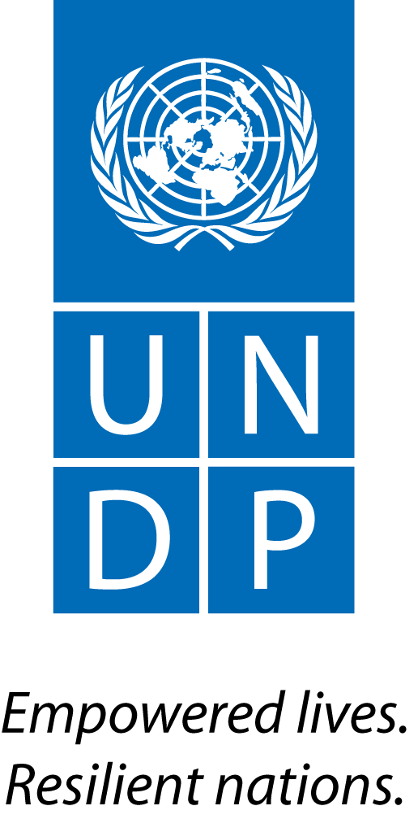 | Back to Office Report  Submitted by: Bruno Hugel & Joel Scriven  Title: Global Advisor & Regional Technical Specialist  Date submitted: 14 July 2015
1. Practice area : Environment & Energy
2. Mission period (incl. of travel days)
From : 5-8 July 2015
3. Type of mission : Attendance Second National Consultation on Cambodia’s National REDD+ Strategy | 4. Clients:  FCPF, REDD+ Taskforce Secretariat, Forest Administration, Ministry of Environment
5. Purpose of mission:  - Provision of technical advice for the consultation | 6. Documents, materials, resources  List of potential PAMs
7. Mission members:  Bruno Hugel and Joel Scriven | 8. Costs:  UNDP/UN-REDD Global Budget
9. Brief summary of the mission:

The Royal Government of Cambodia (RGC) is developing its National REDD+ Strategy (NRS) that will guide the implementation of REDD+ activities under the UN Framework Convention on Climate Change (UNFCCC). The NRS development process is being supported by UNDP, as delivery partner for the Forest Carbon Partnership Facility (FCPF) project. The NRS development process includes national and subnational consultations: the first national consultation took place in Sihanoukville, 20-21 May 2015.

The objective of the present mission was to provide technical support to deliberations at the second national consultation in Siem Reap, 6-7 July. The objectives of the consultation were to 1) present the current status of the NRS, 2) collect technical inputs and general concerns from stakeholders and technical experts, and 3) identify issues requiring further inputs to revise the second (working) draft.

A secondary objective of the mission was to participate in a safeguards consultation meeting, at the same location in Siem Reap, on 8 July.

The mission also served as an opportunity to meet with FCPF CTA, RCG and JICA regarding arrangements for the implementation of FCPF Outcome 4 (National Forest Monitoring System – NFMS – and Forest Reference Emission Levels – FRELs/FRLs) (FAO officers/representatives were not present).

9.a Findings
  - The NRS is currently in its second draft format; a third draft will be produced by the two lead authors following this consultation to incorporate feedback received.
  - Day 1 largely focused on assessing and documenting the drivers of deforestation and forest degradation, and proposing appropriate policies and measures (PAMs) to address these drivers. See annex for a draft list of 14 PAMs that were documented following Day 1.
  - In Day 2 the focus shifted to NFMS/MRV, FRELs and safeguards; with group discussions matching safeguards to the PAMs developed the previous day.
  - The FAO proposal for the implementation of FCPF Outcome 4 was discussed with relevant partners (with the exception of FAO), with a focus on 1) the approximately $200,000 over-budgeting by FAO; 2) the exclusion of activities relating to FREL and BUR development and submission (which FAO propose to support bilaterally); 3) the methodological approaches proposed and potential alternatives, e.g. a point sampling approach to activity data generation instead of the proposed wall-to-wall approach, and gain-loss emission factor calculation methodology instead of the proposed stock-difference approach. This discussion also touched upon the RGC’s data needs to meet its objective of submitting an initial FREL within 2015.
  - The safeguards meeting presented the status of the RGC’s progress on developing principles, indicators and criteria (PCI) for the Cancun safeguards in the Cambodian context, and set out the next steps towards the development of Cambodia’s safeguards information system. The RGC’s safeguards work has been relatively static since progress achieved in 2014 in identifying PCI and potential data sources. The next step is to relate the safeguards to concrete PAMs the RGC will adopt to implement REDD+ (which will necessarily require waiting until the list of PAMs is finalized).

9.b Results achieved (key outputs)
- Perspectives collected from stakeholders on drivers and proposed PAMs.
- Alternative methodological options proposed for NFMS/MRV will be considered by the MRV Technical Team.
- FCPF Outcome 4: a) Dr. Saret of the FA will chair a meeting on 10 July to discuss and review progress with the development of Cambodia’s FREL, including data needs and gaps, with a view to informing a decision on whether to pursue the submission of Cambodia’s FREL in 2015 or whether to postpone this activity; b) Mr. Bhatia, FCPF CTA, will liaise with FAO regarding UNDP’s feedback on FAO’s Outcome 4 proposal and determine/report back on next steps.

10. Key counterparts:
- FCPF PMU – Anupam Bhatia (CTA), Sovanna Nhem (Manager), Lun Kimhy (Coordinator), Nhem Sareth (Communications and Stakeholder Engagement Officer)
- REDD+ Taskforce Secretariat
- Forest Administration, Fisheries Administration, Ministry of Environment
- UNDP CO – Moeko Saito-Jensen (Policy Analyst)

11. Follow up action matrix
Action to be taken: |  | By whom | Expected completion date
Decision to be made on FREL submission and data needs |  | RGC | 17 July 2015
Liaise with FAO to provide feedback on Outcome 4 proposal |  | Anupam Bhatia | 17 July 2015
Further technical input to be provided on NRS development |  | Joel, Bruno | Ongoing
Further technical input to be provided on FCPF Outcome 4 proposal |  | Joel | Ongoing
Feedback from consultation to be incorporated into a third draft of Cambodia’s NRS; followed by subnational consultations |  | RGC | 31 July 2015
12. Distribution list:
UNDP REDD+ Team

Annex: List of potential PAMs

- Continue to hold/stop ELCs until there is a clear strategy on land use
2. Monitor the implementation of a master plan and be strict on the ELC contract
3. Clearly define and demarcate the ELC boundaries in the field
4. Convert the ELC taken back from concessionaires to be under local communities management (CF, CPA, CFi)
5. Convert the ELCs taken back into protected forest areas
6. Monitoring and implementation of the sub-decree No 19 (SLC)
7. Strengthen Provincial Land Use Plan
8. Strengthen the monitoring technology on forest land use change
9. Restore areas of forest degradation
10. Strengthen the national policies relating to the sustainable forest management as well as to look for ways to incorporate the forest management by local communities in the investment policies and plans at national and subnational levels
11. Strengthen law enforcement relevant to illegal logging
12. Strengthen the implementation of laws related to land encroachment
13. Create tree plantations for meeting domestic demands
14. Create various options for reducing the demand of fuelwood and charcoal

