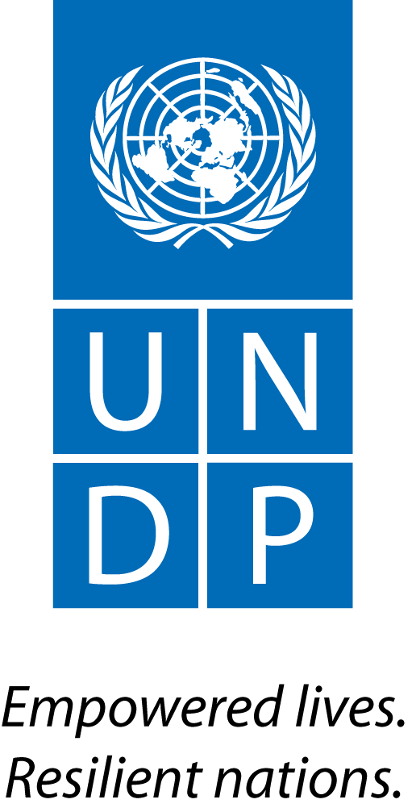 | Back to Office Report  Submitted by: Joel Scriven  Title: Regional Technical Specialist  Date submitted: 2 May 2016
1. Practice area: BPPS
2. Mission period (incl. of travel days)
- 25-30 April 2016
3. Type of mission: Official | 4. Clients:  - UNDP CO  - PMU
5. Purpose of mission:  - Support implementation of transition phase | 6. Documents, materials, resources  - Mission agenda
7. Mission members:  - Joel Scriven | 8. Costs:  - UNDP/UN-REDD Global Budget
9. Brief summary of the mission:

As Indonesia and Norway prepare for the implementation of Phase 2 of their bilateral REDD+ partnership – Letter of Intent (LoI), an interim phase is being implemented to 1) address immediate priorities of GoI relating to forests (including a reduction in fire incidence) and 2) put in place systems and institutional arrangements for Phase 2 implementation (including arrangements for MRV and safeguards). UNDP is delivery partner for the Transition Phase. Due to a three-month delay in the inception of the Transition Phase project, Norway have granted a no-cost extension from June until September 2016. The six programmes of the transition phase are:

- Fire prevention (more than half of the budget is allocated here)
- Legal reform and law enforcement for REDD+ implementation
- Improved management of land-related conflicts (two priority National Parks)
- Recognition and protection of the rights of customary law communities
- Support to social forestry
- Support to Phase 2 preparation

As part of efforts to address emissions from peatlands, the Government of Indonesia recently established the Peatland Restoration Agency (BRG). UNDP is hosting a BRG Support Facility to assist with the establishment of this agency. One third of allocated Norwegian funds for Phase 2 of the LoI ($50m out of $150m) have been allocated to support the BRG. The BRG, with support from UNDP, has developed an implementation proposal which must be approved by Norway before being taken forward.

The purpose of this mission was to support implementation of Transition Phase activities, specifically to support the development of the Phase 2 REDD+ investment portfolio, and to attend a national REDD+ seminar.

9.a Findings
  - Phase 2 investment portfolio: The Phase 2 interventions proposed in the draft Phase 2 project document (finalized end-2014) will be revised according to present-day circumstances and needs. To this end, an evaluation of (demonstration) interventions will be carried out along with an analysis of drivers of deforestation and forest degradation; the findings of these will inform the development and prioritization of a revised investment portfolio. In parallel, UNDP – through the Green Commodities Programme (GCP) – is leading the development of a palm oil intensification programme proposal.
  - BRG implementation proposal: Norway have received the proposal from BRG and are now reviewing it.
  - FREL: The initial FREL submitted by Indonesia to the UNFCCC Secretariat is currently undergoing technical assessment (TA), which is expected to come to an end by September 2016. Initial interactions with the TA team have reportedly raised clarification questions but no major issues with the figure itself or the reference period used. Following the finalization of the national FREL, the government plans to develop an individual FREL for each province.
  - MRV: Norway developed and submitted a proposal to Indonesia in March 2016 a protocol for the MRV of emissions reductions under the LoI (which would follow a distinct method to the MRV of emissions reductions reported to the UNFCCC). Norway are awaiting feedback from Indonesia. The Climate Change Control Directorate of the Ministry of Environment and Forestry (MOEF) is yet to give further guidance on MRV capacity building support needs.
  - Registry: The Climate Change Control Directorate is leading the development of a registry of climate change actions in Indonesia, including mitigation and adaptation measures, support received and technology transfer. This will include REDD+ projects and programmes. The government aim to launch this registry in 2016.
  - REDD+ funding instrument: The operationalization of the funding instrument is a priority for all parties, as this will be the primary channel for Phase 2, BRG and other REDD+ investment funds. Further coordination discussions between the MOEF, the Ministry of Finance and Norway are pending.
- Safeguards/SIS: The Climate Change Control Directorate has developed a web-based information system (http://sisredd.menlhk.go.id) to manage safeguards-related data and information. Indonesia plan to submit their summary of safeguards information to the UNFCCC Secretariat in 2016.
- A Transition Phase project board meeting that was due to take place on 27th April was postponed to 2nd May.

9.b Results achieved (key outputs)
- Agreement was reached with Norway on next steps to be taken towards development of the Phase 2 investment portfolio: meeting to be held with the World Bank to request them to carry out a background analysis of the National REDD+ Strategy, the drivers of deforestation and forest degradation, and other relevant REDD+ plans, to provide a basis for decision making for the development and prioritization of intervention programmes. This meeting will be held between 10-12 May; Hugel, Lux and Scriven will attend to support discussions. In parallel, UNDP will undertake an analysis of successes, lessons and gaps from the implementation of the five Transition Phase programmes (outlined above), to identify opportunities for scale-up as Phase 2 investments. Proposed investment programmes will then be developed and go through consultation with relevant stakeholders.
- A meeting held with the World Bank yielded productive discussions on the status of REDD+ readiness support activities and marked the initiation of a closer working relationship to ensure alignment and avoid overlap of future activities. The World Bank are working on similar activities to those of the Transition Phase project, such as on MRV, FREL, safeguards and REDD+ investments, through the FCPF Readiness Fund and Carbon Fund, as well as the BioCarbon Fund and Forest Investment Program (FIP).
- Status of MRV and FREL activities were clarified; capacity building on MRV is needed by technical-level staff of the Climate Change Control Directorate but a decision on the format for delivery of such support is pending.
- A national workshop on the status of REDD+ development and implementation in Indonesia brought together diverse national and subnational stakeholders as well as donors.

10. Key counterparts:
- UNDP PMU
- UNDP Country Office

11. Distribution list:
- PMU (Roy Rahendra, Matthieu Lux)
- UNDP Country Office (Christophe Bahuet)
- UNDP REDD+ Team
- UNDP Bangkok Regional Hub (Gordon Johnson, Devanand Ramiah, Mazen Gharzeddine, Tshering Pem)

Annexes

Annex 1: Mission agenda

25 April
PM | Travel BKK-Jakarta
26 April
AM | Discussions with CO
PM | Meeting with World Bank
27 April
AM | Meeting with Belinda Margono (DG-CCC, MOEF)
PM | Discussions with CO: investment portfolio
28 April
AM | Preparation for meeting with Norway
PM | Meeting with Norwegian Embassy
29 April
AM-PM | National REDD+ Seminar: Moving REDD+ Indonesia Forward
30 April
AM-PM | Travel Jakarta-BKK

