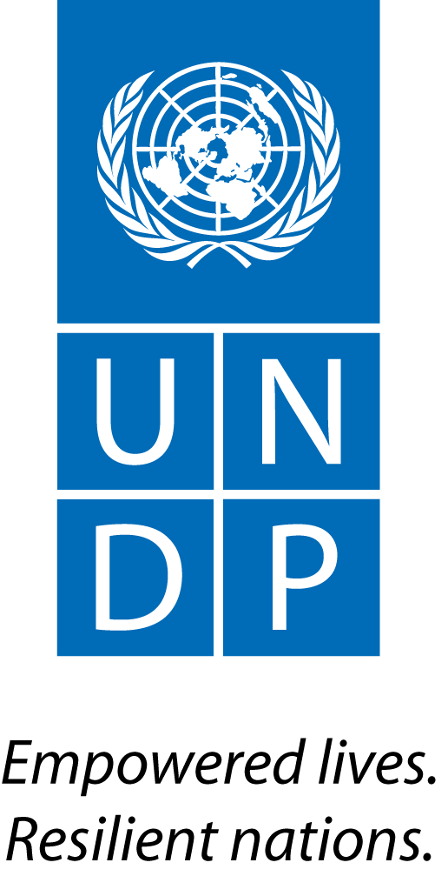 | Back to Office Report  Submitted by: Joel Scriven  Title: Regional Technical Specialist  Date submitted: 12 November 2015
1. Practice area: BPPS
2. Mission period (incl. of travel days)
- 7-9 November 2015
3. Type of mission: Official | 4. Clients:  - UNDP CO  - PMU  - Directorate of Climate Change, Ministry of Environment and Forestry
5. Purpose of mission:  - Support preparations for implementation of transition phase | 6. Documents, materials, resources  - Mission agenda  - Draft MRV and FREL work plan
7. Mission members:  - Joel Scriven | 8. Costs:  - UNDP/UN-REDD Global Budget
9. Brief summary of the mission:
Recent changes in the Government of Indonesia (GoI) have resulted in the absorption of the REDD+ Agency and integration of its staff and functions into the new Ministry of Environment and Forests (MOEF). This has coincided with the closing of Phase 1 of the Indonesia-Norway Letter of Intent (LoI), a $1b bilateral agreement for the reduction of emissions from deforestation and forest degradation in Indonesia. The new focal point for REDD+ in Indonesia is the Directorate of Climate Change (DG-CCC) in the MOEF, led by Dr. Nur Masripatin.

As Indonesia and Norway prepare for the implementation of Phase 2 of the LoI, an interim phase is required to 1) address immediate priorities of GoI relating to forests (including a reduction in fire incidence) and 2) put in place systems and institutional arrangements for Phase 2 implementation (including arrangements for MRV and safeguards). To this end, a ‘Transition towards Phase 2’ document was prepared by the UNDP Country Office (CO) in close coordination with the DG-CCC and Embassy of Norway in Jakarta. The six programmes of the transition phase are:
- Fire prevention (more than half of the budget is allocated here)
- Legal reform and law enforcement for REDD+ implementation
- Improved management of land-related conflicts (two priority National Parks)
- Recognition and protection of the rights of customary law communities
- Support to social forestry
- Support to Phase 2 preparation

An agreement to channel the funds for the transition phase through UNDP was signed on 30 September.

9.a Findings
  - Final agreement on the wording of the transition phase document has not yet been reached between Indonesia and Norway; two remaining issues are: 1) the inclusion of the term ‘independent’ in reference to the 3rd party review of REDD+ mitigation results; and 2) the extent to which spatial data (shapefiles) are made publicly available, given the considerable extent of on-the-ground overlaps and potential conflicts open access to this data could cause. Norway will not transfer any funds until agreement on the wording is reached. A meeting was held between Norway and DG-CCC on 9th October and a compromise is being sought on the wording, to the effect that final arrangements for these issues will be mutually agreed in future by both parties. The delay incurred in agreeing on this wording may affect the implementation timeline, including the timing of the first transition programme Policy Board (currently set for the last week of October).
  - A Project Management Unit (PMU) remains in place from Phase 1 implementation, though much reduced in staff numbers. Recruitment is underway to build its HR base for transition phase implementation.
  - Programmes 1-5 of the transition phase are largely (scaled-up) continuations of activities initiated under Phase 1 of LoI implementation; each programme has a team leader, work plans are being finalised, TORs drafted and recruitment is underway. Work plans for each of these will be reviewed with a view to contribute technical inputs from the UNDP REDD+ Team where deemed appropriate.
  - Programme 6 (preparation for Phase 2), the priority for Norway and UNDP, is currently the least well-structured; the work plan is being developed by Roy Rahendra, the PMU manager, with the support of the RTA to sequence UNDP REDD+ team support throughout its implementation. The results framework requires the completion of the following steps under Programme 6:
- The FREL methodology has been reviewed by MOEF in line with IPCC methodology and is submitted to the UNFCCC for technical evaluation before the COP21. An agreement is reached between the Governments of Indonesia and Norway on the reference level of the REDD+ Partnership.
- After a decision is reached on the modality and host used to established the REDD+ Fund, the fund is legally established by the host, with the approval of the Ministry of Finance and operational.
- A revised version of the design document for the national MRV system is released including a clarification of the roles and responsibilities for the MRV system, based on international developments and on emerging lessons to ensure that there is sufficient impartiality and no conflict of interests are emerging.
- Integration of the national set of REDD+ Safeguards ‘PRISAI’ and implementation of the Safeguards Information System.
- Agreement is reached with partner provinces on the prioritization of provincial/jurisdictional REDD+ programs to be implemented in phase 2, based on their respective Provincial Strategic Action Plans (PSAPs).
- Investment portfolio of programmes in line with the objectives of Phase 2 is developed, based on above mentioned agreement with partner provinces:
  - Preparation of Outcome 2.2 programs especially by entering into formal cooperation with ongoing initiatives related to sustainable palm oil, as an effort to move toward a landscape-based approach of land-use management.
  - Preparation of the scale-up of social forestry program based on the example of community-based forestry management (HKm) in South Sumatra.
- An agreement is signed with the Government of Norway to start the implementation of the programme design document for Phase 2 that incorporate the investment portfolio and policy directions of the programme.

  - Based on the above, and discussions held during this mission, priority areas of support from the UNDP REDD+ team on Programme 6 implementation include: capacity building on MRV, FREL and SIS (including an MRV action plan/roadmap with clear institutional arrangements), SIS development, advice on establishing Indonesia’s REDD+ funding instrument, preparation of Phase 2 project document, design of investment portfolio of programmes including provincial plans. In addition, though not specified in the document, the transition phase period should be leveraged as an opportunity to support the revisiting of Indonesia’s REDD+ National Strategy – though transition phase time restrictions may push this activity into Phase 2 itself.
  - Extensive work was done through Phase 1 on the design of Indonesia’s REDD+ funding instrument, including development of Standard Operating Procedures (SOPs) and initial trials. Support is requested from the UNDP global REDD+ team to review draft arrangements and support discussions on the host of the fund (likely either Ministry of Finance or MOEF) and its legal basis.
  - Dr. Belinda Arunarwati, a technical officer in DG-CCC, highlighted the need for broad-ranging support on MRV (and support to prepare for the FREL TA process) – starting with DG-CCC staff, followed by wider MOEF staff and other ministries/sectors. In addition to technical capacity building and the need for support to develop an MRV roadmap/action plan, Dr. Arunarwati emphasised the importance of establishing a coordination arrangement that brings together all sectors involved in the GHG inventory compilation process. The need for support to develop a REDD+ project registry was also highlighted.
  - Communications was highlighted by the PMU as an issue requiring support to ensure greater visibility of transition phase (and Phase 2) implementation and products.

9.b Results achieved (key outputs)
- Improved understanding of the current status of preparations for transition phase implementation, including Norway’s and the government’s priorities and positions.
- Identification of the technical and operational support needs of the PMU.
- Understanding of the current status of REDD+ readiness, particularly on MRV, FREL and safeguards.
- Identification of priority training needs on MRV and FREL; agreement on delivery of capacity building for these through transition phase; draft MRV/FREL work plan (see Annex 2).

10. Key counterparts:
- UNDP PMU
- UNDP Country Office
- Directorate of Climate Change, Ministry of Environment and Forestry

11. Follow up action matrix
Action to be taken: | By whom | Expected completion date
Support the finalization of work plans, new staff TORs and sequencing of global team inputs | Joel, global team | 23 October
Support first Transition Phase Policy Board meeting | PMU, CO, Joel | Last week of October (tentative)
Deliver initial training on MRV (focus on UNFCCC decisions and IPCC guidance and guidelines) to DG-CCC staff | Joel (Danae?) | TBD but potentially to coincide with next mission
Review REDD+ fund proposal / documentation and provide advice on suitability | Joel, Berta | 30 October
Deliver training on the FREL TA process to DG-CCC staff | Joel (Danae, Kim?) | Post-COP / pre-TA initiation
12. Distribution list:
- PMU (Roy Rahendra)
- UNDP Country Office (Matthieu Lux, Christophe Bahuet)
- UNDP REDD+ Team
- UNDP Bangkok Regional Hub (Gordon Johnson, Devanand Ramiah, Tshering Pem)

Annexes

Annex 1: Mission agenda

7 October
AM | Travel BKK-Jakarta
14.00 | Meeting with Roy Rahendra (PMU manager) and PMU team
17.30 | Meeting with Gita Syahrani (formerly of the REDD+ Agency, now at Indonesian Palm Oil Platform, IPOP)
8 October
10.00 | Meeting with Belinda Arunawati, Technical Officer in DG-CCC on MRV and FREL issues
PM | Meetings and working in PMU
9 October
08.00 | Meeting with Johan Kieft, currently UNEP manager in UNORCID
13.00 | Meeting with Lisetta Trebbi, Royal Embassy of Norway
PM | Travel Jakarta-BKK

Annex 2: Draft MRV/FREL work plan

 | 2015 |  |  | 2016
 | O | N | D | J | F | M | A | M | J
MRV training
Training of internal (DG-CCC) staff
Training of Ministry-wide staff
Training across Ministries / sectors
MRV Roadmap
Consultations on MRV status
Development of first draft (including QA/QC plan)
Consultations on draft
Development of second draft
Further consultation & finalization
FREL review support
Training of key D-CC staff on FREL TA process
Ongoing ad-hoc support on technical assessment process
REDD+ Registry/Accounting support
Training of internal staff on REDD+ accounting / registries

