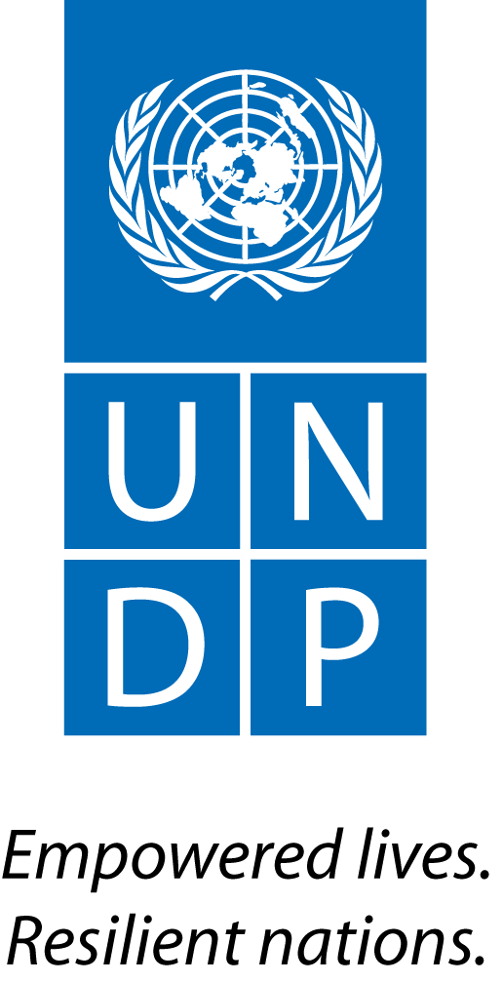 | Back to Office Report  Submitted by: Joel Scriven  Title: Regional Technical Specialist  Date submitted: 6 December 2015
1. Practice area: BPPS
2. Mission period (incl. of travel days)
- 29 November to 4 December 2015
3. Type of mission: Official | 4. Clients:  - UNDP CO  - PMU
5. Purpose of mission:  - Support implementation of transition phase | 6. Documents, materials, resources  - Mission agenda  - Draft MRV institutional arrangements
7. Mission members:  - Joel Scriven | 8. Costs:  - UNDP/UN-REDD Global Budget
9. Brief summary of the mission:
Recent changes in the Government of Indonesia (GoI) have resulted in the absorption of the REDD+ Agency and integration of its staff and functions into the new Ministry of Environment and Forests (MOEF). This has coincided with the closing of Phase 1 of the Indonesia-Norway Letter of Intent (LoI), a $1b bilateral agreement for the reduction of emissions from deforestation and forest degradation in Indonesia. The new focal point for REDD+ in Indonesia is the Directorate of Climate Change (DG-CCC) in the MOEF, led by Dr. Nur Masripatin.

As Indonesia and Norway prepare for the implementation of Phase 2 of the LoI, an interim phase is required to 1) address immediate priorities of GoI relating to forests (including a reduction in fire incidence) and 2) put in place systems and institutional arrangements for Phase 2 implementation (including arrangements for MRV and safeguards). To this end, a ‘Transition towards Phase 2’ document was prepared by the UNDP Country Office (CO) in close coordination with the DG-CCC and Embassy of Norway in Jakarta. The six programmes of the transition phase are:
- Fire prevention (more than half of the budget is allocated here)
- Legal reform and law enforcement for REDD+ implementation
- Improved management of land-related conflicts (two priority National Parks)
- Recognition and protection of the rights of customary law communities
- Support to social forestry
- Support to Phase 2 preparation

An agreement to channel the funds for the transition phase through UNDP was signed on 30 September. While all relevant government officials were out of the country at COP21, this mission was an opportunity for internal coordination and work planning for 2016.

9.a Findings
  - Final agreement was reached on the Transition Phase document between the governments of Norway and Indonesia. Wording on MRV was removed from the document.
  - National REDD+ Strategy: three separate strategies were produced by different institutions under the previous national REDD+ institutional architecture. Revision of any of these is not a deliverable under the Transition Phase. The country is in need of a clear strategy but other priorities (meeting the Transition Phase deliverables) currently take precedent, particularly as revising the strategy would ideally involve a comprehensive consultation process. An alternative (and more feasible) approach would be to develop Implementation / ‘Action Plans’ for fixed time periods that are generically guided by the officially endorsed National REDD+ Strategy published by the REDD+ Agency.
  - MRV institutional arrangements: following an internal discussion, a draft proposal for MRV institutional arrangements was developed (see Annex 2).
  - MRV work plan / guidance: the priority for the transition phase is the revision of the 2012 document “Strategy and Implementation Plan for REDD+ Measurement, Monitoring, Reporting, and Verification (MRV) in Indonesia”, to reflect new institutional arrangements, technical capacities and work flows.
  - MRV: national forest inventory (NFI): Indonesia has had a NFI since 1990 but it has not been implemented consistently, the approach to sampling is sub-optimal and the method is highly laborious. The government are now in the process of revising their NFI methodology, with a view to completing this process by April 2016. The government are seeking external technical support for this (though this message was received through GIZ rather than directly from the government, as officials were at COP21 at the time of this mission). While this is not a line of support detailed in the Transition Phase, this is an important (unique) opportunity to contribute to a key process for REDD+ MRV.
  - MRV: GIZ are supporting the government through the FORCLIME project to improve forest monitoring, inventory and management capacities; this support is focused primarily at the Forest Management Unit level.
  - Forest Reference Emission Level (FREL): Indonesia developed its initial FREL in 2014 and submitted it to the UNFCCC Secretariat in November 2015. It is due for technical assessment in 2016, and the government are seeking support to prepare for and respond to the technical assessment.
  - Safeguards and Safeguards Information System (SIS): initial work on assessing principles, criteria and indicators (PCI) for safeguards was carried out in 2012-13. Work is now needed to update / revise this analysis in light of policies and measures to be implemented, and to develop Indonesia’s safeguards information system.
  - Fund: the Embassy of Norway recently met with the Ministry of Finance, who are ready to proceed with the establishment of the REDD+ funding mechanism. Norway requested this action to be postponed until a clear agreement has been reached on the mandate and operation of the fund by all stakeholders, importantly the MOEF.
  - UN-REDD Targeted Support (TS): a TS request has been in development by the government with support from the CO since April 2015. The request covers support from all three UN-REDD agencies, with the UNDP component focusing primarily on continuing the support on forest governance (Participatory Governance Assessment – PGA and Forest Governance Index – FGI). The request was submitted to the UN-REDD Secretariat in November 2015. Given the inception of the Transition Phase, the TS request requires revision to avoid duplication of efforts. During discussions, the following overlaps were found: TS work under UNDP on law enforcement, social forestry and policy coherence, and TS work under FAO on developing a MRV roadmap – these elements are covered under the Transition Phase. Recommendations for appropriate revisions will need to be made to the request when it reaches agencies for their endorsement.

9.b Results achieved (key outputs)
- Mapping out of institutions involved in the REDD+ MRV cycle; new institutional arrangements proposed (Annex 2).
- Agreement on next steps (internally) on MRV.
- Alignment with Embassy of Norway on the status of activities under Programme 6 of the Transition Phase, with particular focus on MRV and funding mechanism.
- Agreement to work closely with the Norway MRV team to deliver a training workshop in January 2016.
- Details of GIZ support on forest inventory and monitoring.
- Alignment of UN-REDD TS and Transition Phase.

10. Key counterparts:
- UNDP PMU
- UNDP Country Office

11. Follow up action matrix
Action to be taken: | By whom | Expected completion date
Development of a ppt on MRV and proposed institutional arrangements, to use for consultation with government | Joel, Arief, Matthieu | 11 December
Coordination with GIZ and government on the provision of technical input to the NFI re-design | Arief, Joel, Matthieu | 11 December
Coordination with the Embassy of Norway to plan a joint mission with the Norway MRV team in January (potentially with a planning meeting in Bangkok followed by jointly travelling to Jakarta to deliver the training) | Matthieu, Joel, Arief, Danae | Ongoing
Revisions to be made to TS request when it reaches UN-REDD agencies for their endorsement. The UNEP request is unchanged; FAO and UNDP activities should be modified as per above | UN-REDD agencies / Indonesia focal points | When TS request reaches agencies for endorsement
Coordination with MOEF on how and when to deliver technical support for the FREL technical assessment process | Matthieu, Arief, Joel, Danae | Ongoing
Follow-up mission to Jakarta to deliver MRV (and FREL) training possibly involving MRV experts from the Norwegian Climate and Environment Ministry | Joel, Danae | Late January
12. Distribution list:
- PMU (Roy Rahendra, Matthieu Lux, Johan Kieft (UNEP))
- UNDP Country Office (Christophe Bahuet)
- UNDP REDD+ Team
- UNDP Bangkok Regional Hub (Gordon Johnson, Devanand Ramiah, Mazen Gharzeddine, Tshering Pem)

Annexes

Annex 1: Mission agenda

29 November
AM | Travel BKK-Jakarta
30 November: sick
1 December
AM | Meeting with Matthieu Lux and Johan Kieft: Transition Phase
PM | Meeting with Arief Darmawan: MRV
2 December
AM | Meetings with Matthieu Lux, Johan Kieft and Abdul Situmorang: Transition Phase and UN-REDD Targeted Support
PM | Writing up / meeting preparation
3 December
AM | Meeting with Embassy of Norway
PM | Meeting with GIZ / PROCLIME
PM | Meeting with Arief Darmawan, Matthieu Lux and Johan Kieft
4 December
 | Travel Jakarta-BKK

Annex 2: Institutional arrangements for REDD+ MRV in Indonesia

