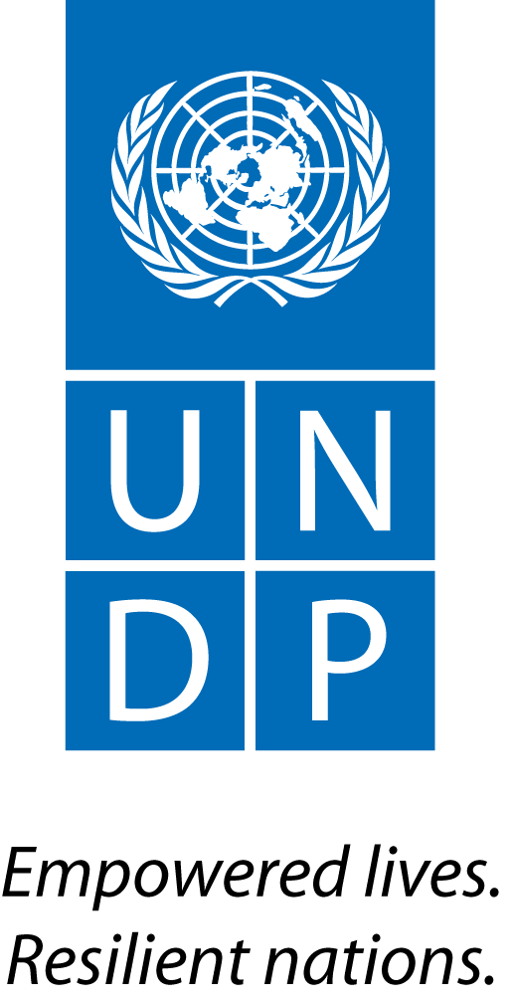 | Back to Office Report  Submitted by: Bruno Hugel & Joel Scriven  Title: Global Advisor & Regional Technical Specialist  Date submitted: 16 May 2016
1. Practice area: BPPS
2. Mission period (incl. of travel days)
- 9-12 May 2016
3. Type of mission: Official | 4. Clients:  - UNDP CO  - PMU
5. Purpose of mission:  - Support implementation of transition phase | 6. Documents, materials, resources  - Mission agenda
7. Mission members:  - Bruno Hugel  - Joel Scriven | 8. Costs:  - UNDP/UN-REDD Global Budget
9. Brief summary of the mission:

As Indonesia and Norway prepare for the implementation of Phase 2 of their bilateral REDD+ partnership – Letter of Intent (LoI), an interim phase is being implemented to 1) address immediate priorities of GoI relating to forests (including a reduction in fire incidence) and 2) put in place systems and institutional arrangements for Phase 2 implementation (including arrangements for MRV and safeguards). UNDP is delivery partner for the Transition Phase. Due to a three-month delay in the inception of the Transition Phase project, Norway have granted a no-cost extension from June until September 2016. The six programmes of the transition phase are:

- Fire prevention (more than half of the budget is allocated here)
- Legal reform and law enforcement for REDD+ implementation
- Improved management of land-related conflicts (two priority National Parks)
- Recognition and protection of the rights of customary law communities
- Support to social forestry
- Support to Phase 2 preparation

As part of efforts to address emissions from peatlands, the Government of Indonesia recently established the Peatland Restoration Agency (BRG). UNDP is hosting a BRG Support Facility to assist with the establishment of this agency. One third of allocated Norwegian funds for Phase 2 of the LoI ($50m out of $150m) have been allocated to support the BRG. The BRG, with support from UNDP, has developed an implementation proposal which must be approved by Norway before being taken forward.

The purpose of this mission was to support the planning of the development of the Phase 2 REDD+ investment portfolio through discussions with the UNDP CO, the Royal Embassy of Norway and the World Bank, taking advantage of a mission from Oslo.

9.a Findings
  - A Transition Phase project board meeting was held on 9th May, during which the Director General of Climate Change Control (DG-CCC) in the Ministry of Environment and Foresry reiterated her commitment to Indonesia entering Phase 2 (investment) of the LoI in 2016 and Phase 3 (results-based payments) in 2018.
  - A number of work streams are required to prepare the Phase 2 investment portfolio, including 1) identification of priority drivers to be tackled; 2) assessment of REDD+ mitigation potential (including thematic/geographic priorities, technical/political/financial feasibility); 3) alignment with political priorities (i.e. alignment with development plans); 4) mapping of existing REDD+/REDD+-relevant interventions and opportunities for partnerships; 5) development of a financing strategy (i.e. opportunities beyond Norway).
  - The deliverables required by Norway relating to the Phase 2 investment portfolio are: 1) an operational manual for the (REDD+ window of the) forthcoming environment and climate change fund (to be established in the Ministry of Finance), and 2) an investment plan that includes a results framework.
  - Norway will meet with the GoI to discuss next steps on the development of the Phase 2 investment portfolio and will recommend that, among other things, an updated analysis of the drivers of deforestation and forest degradation be carried out.
  - Norway requested more information on the technical expertise available in UNDP for supporting ongoing and upcoming work on establishment of the funding instrument and development of the Phase 2 investment plan; they were assured that this expertise and support is available, from HQ and Bangkok offices upon request from CO.
  - REDD+ funding instrument: The operationalization of the funding instrument is a priority for all parties, as this will be the primary channel for Phase 2, BRG and other REDD+ investment funds. Further coordination discussions between the MOEF, the Ministry of Finance and Norway are pending.
  - With REDD+ Programme Officer Matthieu Lux departing at the end of June 2016, his responsibilities (day-to-day implementation of the Transition Phase, with a focus on managing the relationship between GoI and Norway) will be divided between Rini Astuti (focus on operational responsibilities) and Tomoyuki Uno (focus on technical and policy responsibilities).
  - The UNDP CO is developing a $60m Green Climate Fund proposal focused on adaptation and commodities (coffee and cocoa) which will include REDD+-relevant activities. A $100k seed grant has been approved to support development of the proposal.

9.b Results achieved (key outputs)
- Achievement of deliverables under Programme 6 of the Transition Phase is now a priority and there was consensus on the need for more regular liaison between UNDP and Norway on project implementation and progress on these.
- A presentation was delivered to Norway and the WB by Hugel on the national REDD+ strategy and investment plan development process in DRC, which informed subsequent discussions on the key issues and process to be followed in Indonesia and was followed by extensive discussion on the achievement of the deliverables required to enter Phase 2.
- An outline structure of the Phase 2 investment framework will be developed by UNDP, to serve as a basis for discussions with the GoI.
- The UNDP CO will carry out an evaluation exercise of the Transition Phase programmes 1-5, with the aim of understanding REDD+ impact, geographical relevance, challenges and opportunities, political traction, scalability and potential implementation partners for further work.
- The UNDP CO will map out existing REDD-relevant initiatives on which the investment framework should build, to identify strategic thematic/geographic gaps and opportunities for synergies).
- The UNDP CO will develop a sustainable palm oil project proposal (focused on intensification) to submit for consideration as a Phase 2 investment programme.

10. Key counterparts:
- UNDP PMU
- UNDP Country Office

11. Distribution list:
- PMU (Roy Rahendra, Matthieu Lux, Rini Astuti)
- UNDP Country Office (Christophe Bahuet)
- UNDP REDD+ Team
- UNDP Bangkok Regional Hub (Gordon Johnson, Devanand Ramiah, Mazen Gharzeddine, Tshering Pem)

Annexes

Annex 1: Mission agenda

9 May
PM | Travel BKK-Jakarta
10 May
AM-PM | Internal planning meeting (UNDP CO)
11 May
AM | Internal planning meeting (UNDP CO)
PM | Meeting with Norway and World Bank
12 May
AM | Debriefing meeting with UNDP CO
PM | Travel Jakarta-BKK

