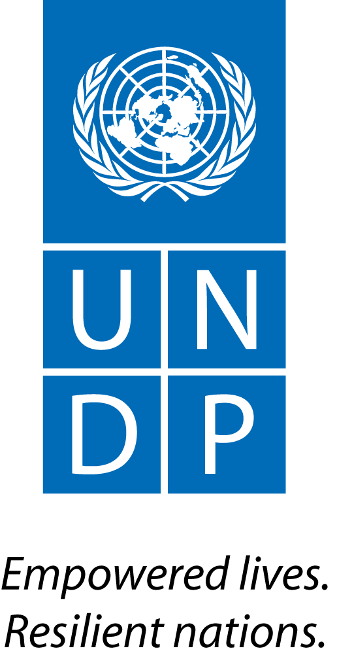 |  | Back to Office Report  Submitted by: Clea Paz Rivera  Title: BTOR mission to Colombia  Date submitted: May 5th, 2014
1. Practice area : BPPS
2. Mission period (incl. of travel days)
From : April 28th to: May 1st
3. Type of mission: Official |  |  | 4. Clients  UNDP Colombia CO  Ministry of Environment and Sustainable Development (MADS in Spanish)
5. Purpose of mission  The UN-REDD programme approved Colombia’s fund allocation request of US $4 million in June 2013 for supporting the implementation of Colombia’s R-PP. Colombia should have signed the project document until December 2013, and requested an extension unti February 28th. As of today the document has not been signed. In early April, MADS sent a revised version of the prodoc, including editorial changes and some substative changes, among them a revised composition of the project’s steering committee. The UN-Agencies compiled a response to this changes and requested a meeting with the Ministry on April 30th to discuss these changes. The purpose of the mission was:  - Participate in the meeting with MADS, to focuss in particular to discuss and agree on the revision of the composition of the steering committee  - Informally meet some REDD+ stakeholders in Colombia for coordination purposes |  |  | 6. Documents, materials, resources
7. Mission members  Clea Paz-Rivera, (all meetings conducted along with Sandra Aristizabal and/or Jimena Puyana from UNDP Colombia) |  |  | 8. Costs  US $1,880
9. Brief summary of the mission

9.a Findings.

- Meeting with GIZ (Rhena Hoffman, Eugenia Ponce, Ma Fernanda Ordoñez, Angélica XXX):
  - Based on the experience in Ecuador and the good coordination with UN-REDD there, Ms Hoffman expressed her willigness and commitment for good coordination with UN-REDD in supporting Colombia’s REDD+ National Process
  - They refered to an excellent relation with MADS and praised MADS efforts to coordinate with the multiple initiatives in Colombia
  - GIZ (around US $4 million program) will focuss on support to component 2 (National REDD strategy), although not strictly on all elements as per the R-PP, but based on the agreement between MADS and Germany, and elements of component 4 (safeguards). Under component 2, GIZ will support partial analysis of drivers of deforestation (to complete what has been done already in Santander only) intersectoral coordination, support to active participation from regional entities in the REDD+ process, a program for reducing emmisions in Colombia through pilot activities, and montitoring and evaluation of the readniess process. In component 4, and acknowledging that UN-REDD will focuss on designing the SIS, they will focuss on helping MADS to collect information for the SIS
  - GIZ is a member of the safeguards technical committee and recommended that UN-REDD joins
  - They have little information on REM, as this has been negotiated directely among Ministries
- Meeting with Daniel López (USAID):
  - While USAID at some point supported the national REDD+ platform (mesa REDD), due to limited coordination with the Government, they are now focussed on pilot projects in the Pacific region through the BioREDD project (2011-present): 8 pilot projects in 700000 has and 19 communities, directed to the voluntary carbon market. Very sofisticated MRV (radar and laser images with NASA’s support), loking into VCS certification and obtaining a “premium price” for “elite carbon”
  - Willing to collaborate with UN-REDD although there are no clear linkages at the moment, except with the technical information for Colombia´s MRV.
- Meeting with Inka Mattilla (UNDP Colombia Deputy Country Director)
  - General briefing on the purpose of the mission provided to Inka
  - She requested to make sure that the inception process includes a thorough revision of the results-framework with the RBM specialist from the regional center, to ensure a proper implementation, and highlighted the importance to link the REDD+ interventions with UNDP broader work in Colombia, in particular the support to the peace-building process
- Meeting with Norway Embassy in Colombia (Kirsti Andersen and Turid Johansen)
  - This was a courtesy visit, to explain the status of the UN-REDD Programme in the country and introduce UNDP’s RTA
  - For Norway’s Embassy in Colombia, as for UNDP, the main priority is the peace-building process in the country. For both, all interventions must contribute to the later. As the agreement for REDD early movers (REM) to be supported by Norway through the German cooperation and the UK support was negotiated directely by NICFI (Norways International Climate and Forest Initiative) from Oslo and MADS, this critical link was not taken into account.
  - Norway’s Embassy was under the assumption that REDD was going to be implemented in the Amazon (project-based approach) and had little knowledge of the national REDD+ process to be supported by UN-REDD. Once they heard the main elements to be supported, and as previously identified by the Norwegian Ambassador, the link between the peace process and REDD+ became evident and relevant. Several of the provinces of Norways’ supported “Alianzas territoriales por la paz” UNDP’s project are areas with high deforestation and REDD+ will only be achieve with an integral approach that considers the contribution to the peace process.
  - Norway’s Embassy has little or wanted to share little information of the REM initiative, its timeline and scope.
  - It would be beneficial both for Norway and UNDP to coordinate UNDP´s UN-REDD work with the Alianzas Territoriales project, and this coordination could open a new chanel for a future role for UNDP in implementing Norways bilateral support for REDD+
- Meeting with MADS
  - The Agency representatives (UNDP and UNEP) comfirmed the urgency to address the pending issues in the prodoc, and sign the document before the elections
  - Revision of the compiled comments byt the Agencies one by one, and clarification of all the points
  - Confirmed that the modification of the steering committee, removing IPs from it is a deal-breaker and needs to be reconsidered. UNDP offered a number of arguments (precedent of other project steering committees in the country, UN-REDD guidelines for SE) and support to make the case within the Ministry. As this is a political decision, the REDD+ technical team will consult with MADS climate change and forests directors on this change
  - Regarding to the linkages to Component 2, MADS clarified that they see FCPF, UN-REDD and GIZ all contributing to Component 2, under MADS leadership, and agreed on providing text to explicitly explain this in the prodoc.
  - Agreement on nexts steps, based on the inclusion of these changes in the prodoc.

9.b Results achieved (key outputs)

- Better understanding of the REDD+ stakeolders by the Regional Technical Advisor
- Improved collaboration with GIZ and an open communication channeled agreed upon
- Information on the UN-REDD Programme in Colombia provided to UNDP’s new Deputy Country Director
- Open a communication channel with Norway’s embassy for coordination with future REM activities
- All pending issues in the prodoc solved with the exeption of the composition of the steering committee pending confirmation from the directors
- Next steps towards signing the prodoc agreed

9.c Expected outcomes and impacts
- As a result of this mission and pending confirmation of the composition of the steering committee by MADS, it is expected that Colombia will sucessfully finish the development of the UN-REDD prodoc and sign it before the elections in May 25th, to initiate implementation activities afterwards.
10. Key counterparts
- UNDP CO
- MADS
- Key REDD stakeholders in Colombia (GIZ, USAID, Norway)
11. Follow up action matrix
Action to be taken | By whom |  |  | Expected completion date
Send revised prodoc including agreements reached on Wednesday | UNDP |  |  | Monday May 5th (done)
Consult with Director-level at MADS | MADS technical team |  |  | Friday May 9th
Send prodoc to PAC | Jimena Puyana |  |  | Monday May 12th
Breef NICFI on the findings of the mission and discuss further collaboration with REM | Clea |  |  | Week of May 5th
Request DoA from BPPS | Clea
Process signature of the prodoc | FAO, UNDP, UNEP, MADS |  |  | May 22nd
12. Distribution list
- UNDP CO: Jimena Puyana, Sandra Aristizábal, Inka Mattila
- UNDP REDD team in the regional center
- FAO and UNEP focal points for Colombia

