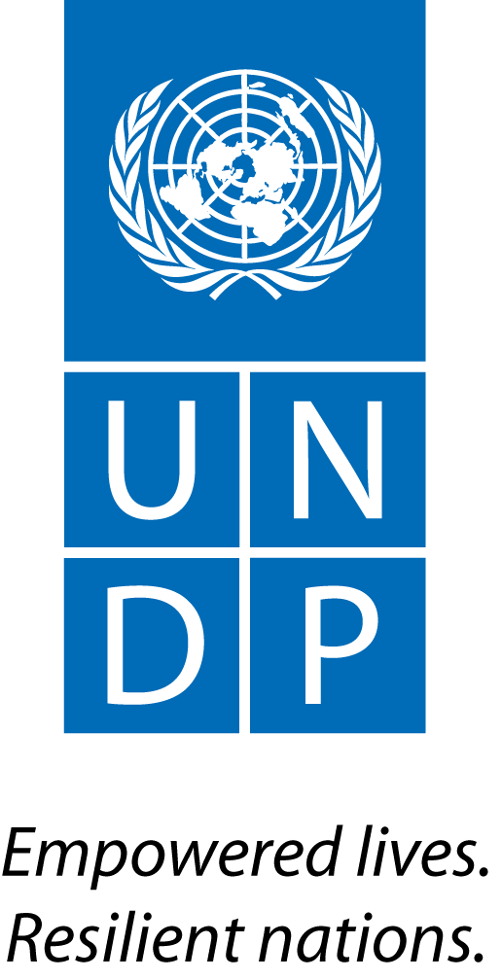 |  | Back to Office Report  Submitted by Ela Ionescu  Title Regional KM Specialist  Date submitted 31.06.2015
1. Practice area : UN-REDD
2. Mission period (incl. of travel days)
From : 22nd Feb to 25th Feb
3. Type of mission :  Scoping Mission to Addis |  | 4. Clients  Ethiopia REDD+ Team
5. Purpose of mission  Follow-up on South-South Exchanges Ethiopia/Korea and China |  | 6. Documents, materials, resources
7. Mission members  Elsie Attafauh-Senior Regional Advisor  Ela Ionescu, Regional KM Specialist |  | 8. Costs
9. Brief summary of the mission

Ethiopia has been in the REDD+ process since 2008. The FCPF grant agreement was signed in October 2012. The national process was officially launched by an inception workshop in January 2013, and effective implementation started in June 2013. Under the responsibility and supervision of the Ministry of Environment and Forests, the national REDD+ Secretariat coordinates REDD+ efforts as a tool towards green economy and carbon neutral development target, and implements readiness work with support from the FCPF, Norway and the UK. The national REDD+ process is part of a national development vision and strategy that is already strongly aligned with environmental and climate concerns. The Government of Ethiopia (GoE) has requested UN-REDD targeted support through UNDP and UNEP in order to enhance the national REDD+ readiness process, by strengthening capacities of national and regional authorities to drive and coordinate the development of the various REDD+ components, and to design a model for decentralised REDD+ under the UNFCCC Warsaw Framework. One of the objectives of TS was to organize a learning exchange with a country in A/P to provide a holistic view and look at an inspiring model on how to protect forests, how to successfully engage in bold reforestation process nation-wide, and how to stabilize high forest cover and position forest in a comprehensive vision of sustainable development. Korea has been the country of choice for the government and in the last minute an additional trip has been added–traveling to China to explore the bamboo sector.

Thus in the light of the above, a mission composed of Senior Regional Technical Advisor and KM Specialist traveled to Addis to conduct meetings with relevant stakeholders at Regional Service Center UNDP and with REDD+ team and Ministry of Environment respectively. The KM mission had three major objectives: 1) to support the organization of the South-South Exchange with Korea; 2) meet with South-south Unit UNDP to identify the areas of support be provided in the context of South-South partnership with Korea and 3) meet with REDD+ team to discuss other KM activities- knowledge products, communities of practices, etc.

9.a Findings
Knowledge Management :
- Meetings were held with State Minister of Enviroment, REDD focal point and Advisor to Minister, UNDP Ethiopia and other members of the delegation on which ocassion objectives and purpose of South-South Exchange were presented and KM methodology outlined to be well-equipped to capture key learnings. During discussions different avenues were presented and jointly explored on how to better integrate accumulated knowledge from Korea and China in Ethiopia’s forest action plans and forest sector strategy. Experiences were shared from other South-South Exchanges in the region that provided a solid framework for dialogue and positioned the trips in the context of South-south Learning. The Minister has explained his own expectations of the learning exchange- that the lessons learned from Korea counterparts need to be brought back and shared during the national workshop for the development of 5 year Forest Sector Development Plan and Forest Sector Action Plan. He has also added that the government has independently contacted China and INBAR to learn more on bamboo production and utilization and therefore he requested UNDP to provide any possible suport through UNDP China to ensure a successful trip. He has emphasized the excellent support UNDP has provided throughout the process and he expressed his wish that UNDP continues the suport Ethiopia in the forest sector beyond the South-South Exchange. He has also hoped that one of the primary learnings of the south-south exchange is how to better engage communities and farmers, exploring benefit sharing mechanisms and proper community participation. I have suggested that UN-REDD can provide examples/knowledge products which emphasize community engagement in other countries in Africa and success stories on stakeholder engagement. Finally he has expressedly requsted that the UN-REDD team review the TOR for both trips as well as the partnership framework with Korea (MOU) to ensure UNDP is well represented and will continue acting as a knowledge broker and partnership builder.
- Meeting with REDD+ Coordinator and Advisor to State Minister- and presented KM methodology, identification of roles and responsibilities of technical members of the team in terms of how to capture knowledge, what to search for in the discussions, how to conduct the final wrap up KM session and identify areas for cooperation for the longer term partnership agreement between Korea, Ethiopia and UNDP.
- A meeting took place with the South-South Exchange Unit, exploring the type of partnership to be developed following the exchange, and how to position UNDP role as partnership builder, knowledge broker, etc. A skype call was organized by South-South Unit with UNDP China and Partnership team to request support for China leg of the trip, actions were identified and UNDP China has commited to provide all needed support so that the trip is a success.
9.b Results achieved (key outputs)
- Following meetings with Deputy Minister of Enviroment, REDD+ team and other members of the delegation- the South-South Exchange has been better organized with concrete actions and outcomes
- Meetings with South-South Exchange Unit – leading to a better framework for the partnership between Korea and Ethiopia, identification of the form of institutional partnership to be put in place-MOU format agreed upon
- In coordination with REDD+ team, agreed and jointly developed the tools, templates and power point presentations on KM/lessons learned/best practices to be captured during the trip to Korea

9.c Expected outcomes and impacts
Knowledge products derived from South-South Exchange, partnership/MOU developed on specific KM activities between Ethiopia and Korea

- Key counterparts:
Addis Ababa : UNDP

11. Follow up action matrix
Action to be taken | By whom |  | Expected completion date
Send an email to government delegation with template for report, success indicators for knowledge tools to better capture lesson learned and power point presentation on KM/lessons learned | KM Specialist |  | 27th February
Continous follow-up with the delegation during the trip providing support on how to focus on bringing out lessons learned and how to prepare for the final Key Learnings Session | KM Specialist |  | 1st-10th March
Organize Final Wrap-Up session/agenda, editing presentation for the delegation and managing the session by skype from Nairobi under the leadership of Senior Regional Technical Advisor | KM specialist |  | 7th March
Edit the South-South Exchange report, develop a 4 pager on Key Lessons Learned and press release | KM specialist |  | April
With support from UNDP Ethiopia, Policy Center Seoul and South-south Exchange unit- develop MOU with identified areas of cooperation between Ethiopia and Korea with a focus on best practices and knowledge sharing in the context of a long term partnership
12. Distribution list:
UN-REDD global: Tim Clairs; Nairobi: Elsie Attafuah, Anne Martinusen,

