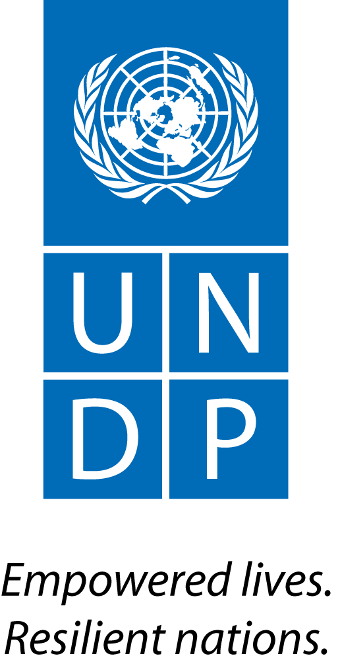 |  | Back to Office Report  Submitted by Anne Martinussen  Title Regional Stakeholder Engagement Specialist  Date submitted 14.04.2015
1. Practice area : UN-REDD
2. Mission period (incl. of travel days)
From : 16 March to 20th March 2015
3. Type of mission :  Technical support mission to Lusaka, Zambia |  | 4. Clients  UNDP Zambia, Zambia Department of Forestry, Zambian civil society
5. Purpose of mission  a) Discuss activities on civil society engagement in the implementation of the national REDD+ strategy;  b) Participate in a UN-REDD team retreat to discuss the national REDD+ strategy, with a specific focus on identifying appropriate entry points for stakeholder engagement in Zambia’s transition from REDD readiness to implementation. |  | 6. Documents, materials, resources  National REDD+ Strategy
7. Mission members  Anne Martinussen, Stakeholder Engagement Specialist and  Ela Ionescu, Regional KM Specialist (UNDP)  Thais Narsico, Associate Programme Officer (UNEP)  Philippe Crete, Forestry Officer (FAO) |  | 8. Costs
9. Brief summary of the mission
A joint UNDP, UNEP and FAO mission took place to the Republic of Zambia on 16th to 20th March 2015 to help assess and discuss national REDD progress. The team was comprised of global advisers and regional specialists, each with their own mission focus and mandate.
The UN-REDD programme was finalised officially on 31st December 2014 for Zambia. Zambia has developed a draft REDD+ National Strategy, anchored on widespread stakeholder consultations, communication and knowledge management at national and provincial levels. The Strategy provides the overall vision, measures and actions to address deforestation and forest degradation. It demonstrates the country’s global and national commitments to promote REDD+. The strategy provides the framework to facilitate stakeholder consultations, ensure buy-in of the strategy as well as consensus building on how to address drivers of deforestation. Given the significant progress made to date in Zambia’s implementation of the readiness programme, a UN-REDD team retreat took place from 17th to 20th March, 2015 to discuss the REDD+ strategy and how Zambia intends to transition from REDD preparation to implementation. The discussion focused on how the Government envisions the future support of UN-REDD in light of the overall transitional arrangements from readiness to implementation, noting the financial closure of the UN-REDD readiness phase by 30th June, 2015. It was equally focused on reviewing and planning for programme closure arrangements. Side meetings were also held with representatives from civil society to discuss and identify possible needs and activities for their continued participation in the implementation of the national REDD+ strategy and develop a work plan for the short-term support.
Thus, in light of the above the mission had two major objectives:
a) To meet with civil society to discuss activities and needs linked to engagement in the implementation of the national REDD+ strategy in Zambia and to develop a work plan for the next steps related to short-term support;
b) To participate in a UN-REDD team retreat from 17th to 20th March, 2015. The meeting seeks to discuss the REDD+ strategy and how Zambia intends to transition from REDD+ strategy to implementation. A specific focus was had on identifying appropriate entry points for stakeholder engagement work in Zambia’s transition from REDD readiness to implementation.
9.a Findings

- The UN-REDD retreat comprised high-level government officials from the Department of Forestry – where the UN-REDD Coordination unit currently resides, the UNDP country office and the global UN-REDD team. During the retreat participants agreed on a common direction and appropriate approach from REDD+ readiness to implementation and the UN-REDD support to Zambia post June 2015. There were information sharing sessions on private sector engagement, FREL/FRL, MRV, stakeholder engagement, knowledge management and programme evaluation. The government had the opportunity to discuss the draft REDD+ strategy, share the vision for the future support of UN-REDD in light of the overall transitional arrangements and identify areas requiring support from the UN-REDD programme. Participants agreed on a specific timeline for the programme closure arrangements including the end of term evaluation and end of programme reporting. Finally there were also discussions on possible future financial and technical support to Zambia in the transition phase between the readiness and implementation phase of REDD, it was agreed that a Targeted support proposal would be developed and a timeline including responsibilities and deadlines was made.
- The REDD+ Strategy for Zambia is anchored in widespread stakeholder consultations and participation, as well as communication and knowledge management at national and provincial levels. Discussions were had with civil society representatives on how they can be active participants in the national REDD+ process in the coming phase as well as on their immediate needs. Representatives from the Government and the UNDP country office were also attending the meeting. It was decided to develop a specific assignment to further strengthen the engagement of civil society in Zambia’s national REDD+ process. The main purpose of the task will be to assess the effectiveness, efficiency and impact as well as the quantity and quality of their participation in the REDD process since 2009 till now. The assessment will include recommendations and be followed by development of a strategy for the continued participation of civil society in the national REDD+ process in the investment and implementation phase. This strategy will be in line with Zambia’s national REDD+ strategy and focus on the specific priorities and needs of the civil society as well as the value added of their engagement. The final part of the task will be developing a system for improved internal organization of the civil society REDD+ platform, in collaboration with civil society themselves. There was joint agreement on that a national and an international assistant should be hired for the task, and that the consultancy should be undertaken and finalized before end July 2015.
It was agreed that the regional stakeholder engagement specialist will draft ToRs for the consultancies for the national and the international consultant. These will be shared with the Government of Zambia and the UNDP country office for input. It will afterwards be shared with the civil society for comments and input, before being advertised by the UNDP country office. If need be, for reasons linked to the financial closing of the programme in end June 2015, the recruitment may be done by the UNDP UN-REDD office in Geneva. This will be assessed with the relevant parties. The international and national consultant will receive direct technical supervision from the National REDD+ Coordinator and UNDP Environment Advisor, and overall guidance by the UNDP-Zambia Country Director, with technical support from the regional UN-REDD stakeholder engagement specialist.

9.b Results achieved (key outputs)
- Contribution to UN-REDD retreat discussions and development of a proposal for financial support to the Zambian REDD+ process in the transition phase from REDD readiness to implementation agreed upon;
- Needs assessment conducted and short-term priorities for support to civil society engagement in the national REDD+ process identified.

9.c Expected outcomes and impacts
- An improved civil society REDD+ platform in terms of credibility, legitimacy, accountability and internal governance, with enhanced abilities to advocate for effective change by July 2015.
- For the UN-REDD team and the Zambian Government partners as a whole it is expected that a Targeted Support proposal will be developed under the leadership of the Zambian Government and submitted to the UN-REDD Secretariat before the end of June 2015, in an attempt to secure funding for the transition phase from readiness to implementation.
- Key counterparts:
Zambia UNDP country office: Elsie Attafuah and Winnie Musonda
Zambia Government: Deuteronomy Kasaro and Davies Kashole
Civil society: Zambian Climate Change Network and CSO representative to the UN-REDD Policy Board

11. Follow up action matrix
Action to be taken | By whom |  | Expected completion date
Draft TOR and share with GoZ and UNDP partners, as well as CSO representatives for inout and comments | SE specialist |  | 15th April
Follow-up recruitment process of consultants | SE specialist |  | April/May
Provide technical support before, during and after consultancies, incl. participate in assessment workshop in Lusaka | SE specialist |  | May - July
Provide technical support on SE issues in the GoZ-led development process of a Targeted Support in the transition phase | SE specialist |  | May/June
12. Distribution list:
UN-REDD global: Tim Clairs, Josep Gari, Gaya Sriskanthan
Nairobi: Fabien Monteils, Elsie Attafuah, Ela Ionescu
Lusaka: UNDP Winnie Musonda

