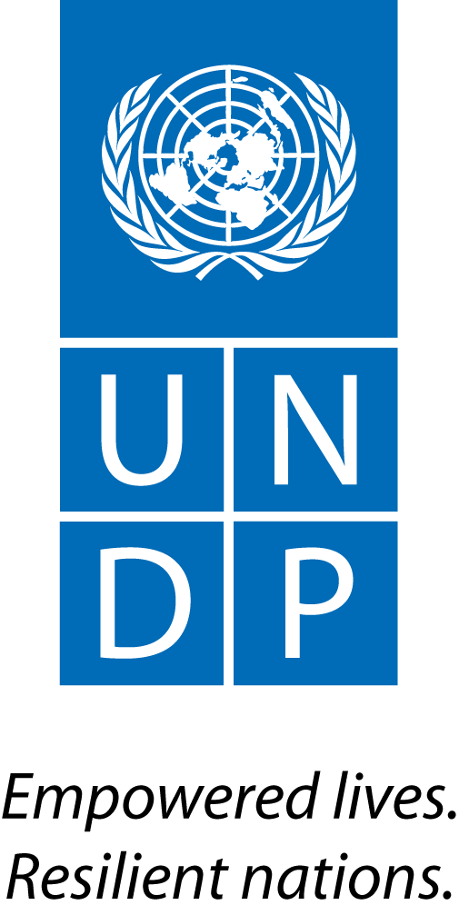 |  | Back to Office Report  Submitted by Anne Martinussen  Title Regional Stakeholder Engagement Specialist  Date submitted 14.04.2015
1. Practice area : UN-REDD
2. Mission period (incl. of travel days)
From : 23rd to 27th March 2015
3. Type of mission :  Technical support mission to Kampala, Uganda |  |  | 4. Clients  Government of Uganda through the UG-REDD+ Secretariat and the Inter-Ministerial Committee on Climate Change (CCPC), and UNDP Uganda
5. Purpose of mission  Joint mission |  |  | 6. Documents, materials, resources  National REDD+ Strategy
7. Mission members  Anne Martinussen, Regional Stakeholder Engagement Specialist and Fabien Monteils, Regional Technical Adviser (UNDP)  Daniel Pouakouyou, Regional Technical Adviser (UNEP)  Sergio Innocente, Technical Adviser (FAO)  Christopher James Warner, Senior Technical Specialist and  Lesya Verheijen, Operations Officer (FCPF) |  |  | 8. Costs
9. Brief summary of the mission
A joint mission to Uganda were conducted by UN-REDD and FCPF to Uganda in June 2014 to review REDD+ progress and scope the potential domains of UN-REDD support (via a National Programme, NP). Two major findings were noted: a) The country confronts a notable constrain in capacities to implement the existing REDD+ readiness finance, let alone a future UN-REDD national programme, and; b) Despite the current REDD+ readiness finance of circa US$ 5 million already mobilized by Uganda, a number of key work streams remain under funded or in need of specific support, which UN-REDD can provide.
The FCPF Grant Agreement for the REDD+ Readiness Grant (US$3,634,000) was signed in June 2013 and became effective in December 2013. The Closing Date is June 30, 2016. The grant disbursements are at 7.24 percent as of March 27, 2015.
Uganda’s UN-REDD National Programme was approved by the UN-REDD Programme 13th Policy Board in November 2014 in Arusha, Tanzania (US$1,800,000). It is expected to be signed by the GoU in April 2015; implementation will start thereafter and closing date is 31 January 2017. Uganda has also successfully mobilized 650,000 Euro from the ADC for work on national forest monitoring systems, safeguards and multiple benefits of REDD+ (approved in June 2013). In parallel, UNEP has provided a targeted support on safeguards and multiple benefits.
The UN-REDD NP focus on the following complimentary work streams: 1) Support to national strategy formulation through policy measures and multi-sectorial dialogue (UNEP); 2) NFMS with MRV functions, with design of a SIS (FAO); 3) Preparing REDD+ implementation through sub-national support through landscape approaches (UNEP), and; 4) Capacity-building support to manage REDD+ readiness (cross-cutting).

In light of the above, the UN-REDD team had the following objectives for the mission:
(i) Discuss and ensure a common understanding on the Programme's scope, objectives, activities, approach and expected impacts between the key governmental and UN stakeholders;
(ii) Refine and adopt the institutional and management arrangements to sustain the implementation of the programme (incl. roles and responsibilities of the key implementing parties);
(iii) Provide core stakeholders with an opportunity to raise challenges and opportunities regarding the REDD+ process; (iv) Review the national & international personnel and ToRs to support the Programme’s implementation;
(v) Review and confirm agreement over the draft Work Plan and Budget;
(vi) Further the coordination of UN-REDD with existing REDD+ fund streams (e.g. FCPF, Austrian Development Cooperation (ADC), and Government of Uganda)
9.a Findings
- Implementation of activities financed under the FCPF grant is significantly delayed, with only 15 months remaining until the FCPF grant closing date of June 30, 2016. Under the FCPF grant, procurement processes for most key consultancies are at advanced stages; however, only three consultancy contracts (out of the planned 10) have been signed to date. The mission received assurance from the MoWE Management that procurement processes will be fast tracked to allow completion of all activities by the grant closing date. The mission agreed that signing of contracts for (i) the critical contracts under FCPF, and (ii) additional UN-REDD supported REDD+ Secretariat staff provides the most important critical path activity.
- Synergies in the implementation of Uganda’s REDD+ agenda have been initiated, with an aligning of steering and implementation structures and with creation of a joint work plan; its implementation is anchored in the REDD+ Secretariat. Synergies between the World Bank, UN-REDD, and Austrian Development Cooperation (ADC) support to the REDD+ agenda were discussed and these will be utilized to coordinate and deliver on the overall objectives of REDD+ Readiness. A number of technical issues and recruitments were discussed and assessed with the view of avoiding overlap and replication of efforts and funding.
- The REDD+ process is steered by the Climate Change Policy Committee (CCPC) with additional members joining specifically for REDD+ - first meeting of this expanded CCPC took place in November 2014. First meeting of the National Technical Committee, which has a technical advisory function, took place in mid-March 2015. The three task forces, as described in the Assessment Note (SESA, Policy, and Reference Level) will be instituted at the next meeting of the Technical Committee, scheduled for early April 2015.
- The Government of Uganda requested if the FCPF might consider extension of the grant closing date. The Bank team recommended that such a request only be made once considerable progress in the FCPF grant implementation has been made. UN agencies confirmed that the UN-REDD implementation schedule will adapt to support the delivery of the REDD+ Strategy and would, if necessary and possible, support certain finalization aspects of the strategy after closing of the FCPF grant. Both agencies agreed that high delivery speed within the coming six months is critical, though insisted that the quality of the strategy should not be compromised as a result of time constraints.
- A Mid Term Progress Assessment is planned for November 2015; it will be delivered jointly with the UN-REDD Programme and coordinated with the Joint Water and Environment Sector Programme which covers ADC support to REDD+.
- For UNDP an urgent issue is to ensure the DOA is sent to the UNRC at the UNDP country office in Uganda so s/he can sign the NP Document (NPD), allowing for start-up of implementation. This procedure is not yet completed and is being followed up closely with Geneva by the responsible RTA.
9.b Results achieved (key outputs)
- Synergies between the World Bank, UN-REDD, and Austrian Development Cooperation (ADC) support to the REDD+ agenda were secured;
- A joint FCPF and UN-REDD “Aide Memoire” mission report was made;
- Dates for the next joint FCPF and UN-REDD mission was agreed upon;
- Support to the implementation of the three REDD+ initiatives was delivered and next steps, including a mid-term progress assessment in November 2014, was agreed upon.

9.c Expected outcomes and impacts
Enhanced progress and delivery of the NP initiative with a clear understanding between all partners and stakeholders of their roles and responsibilities.
- Key counterparts:
Uganda UNDP country office: Onesimus Muhwezi, Team Leader Energy & Environment and Daniel Omodo McMondo, Programme Analyst
Government of Uganda (National Forest Authority): Margaret Athieno, REDD+ National Focal Point and Xavier Mugumya, Coordinator Climate Change
FCPF: Christopher James Warner, Senior Technical Specialist and Lesya Verheijen, Operations Officer (FCPF)

11. Follow up action matrix
Action to be taken | By whom |  |  | Expected completion date
Develop ToRs for staff to support the national REDD+ Secretariat: International Chief Technical Adviser (CTA), National Consultant (NC), and Administrative and Financial Assistant (AFA) | Anne Martinussen UNDP Nairobi and Daniel Omodo McMondo UNDP Uganda |  |  | April 15, 2015
Send DOA to the UNRC at UNDP country office in Uganda | UN-REDD Geneva / Fabien Monteils UNDP Nairobi |  |  | April 25, 2015
Signature of NPD | UNDP Uganda CO UNRC |  |  | April 25, 2015
Launch of the UN REDD Programme | REDD+ Secretariat and UNDP CO Uganda |  |  | April 30, 2015
Develop ToRs for UN-REDD REDD+ University | Anne Martinussen UNDP Nairobi and Daniel Omodo McMondo UNDP Uganda |  |  | April 30, 2015
Develop ToRs for self-selection of CSO representative to national structures | Anne Martinussen UNDP Nairobi and Nicholas Soikan FCPF |  |  | April 30, 2015
Recruitment of CTA, NC and AFA | UNDP Uganda |  |  | June 30, 2015
Next joint FCPF UN-REDD mission, with focus of kick-starting work of CTA and consultants | FCPF, UN-REDD and GoU |  |  | July 26 – August 1, 2015
12. Distribution list:
UN-REDD Global: Tim Clairs and Josep Gari
UN-REDD Nairobi: Fabien Monteils and Elsie Attafuah
UNDP Uganda: Onesimus Muhwezi and Daniel Omodo McMondo

