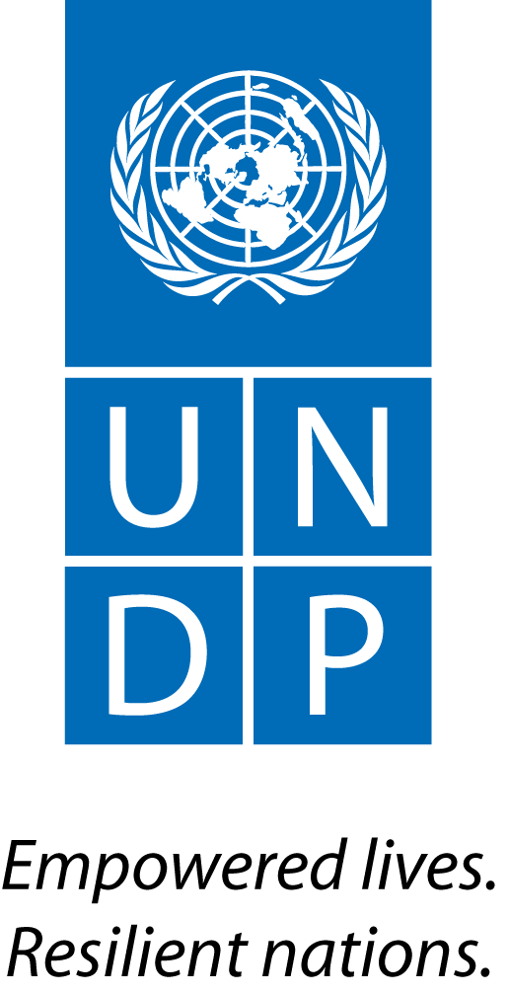 |  |  |  |  |  |  |  | Back to Office Report  Submitted by Tina Sølvberg  Titles Governance Programme Officer  Date submitted 22 September 2015
 |  | Group/Unit  BPPS / UN-REDD, UNDP REDD+ team | Tel No.  +47 926 29 992
 | Approved Mission Itinerary: |  |  |  |  |  |  | List of Annexes:
 |  | (From) Inclusive Travel Dates (To) |  |  |  |  | Key counterpart (s) in Bangkok:
 | 27/7/15 |  |  | 1/8/15 |  | Country counterparts from AP region and UN-REDD colleagues
Purpose/Objective of Mission:
Participate and observe a AP regional workshop led by regional and global UN-REDD colleagues with the view on sharing lessons learned from some countries that could feed into other countries work on developing national REDD+ strategies as well as map country demand for further support. (workshop prepared and led by BKK-based colleagues)
Brief Summary of the Mission
Ove

a.Findings
- Good/ relevant/ concrete examples from the panel, in particular Brazil, although outside the requested themes/ parameters of , especially on real time monitoring of loggers as a particular PaM related to law enforcement
- Countries were really requesting clear/ concrete guidance from UN-REDD on HOW to plan/ best prepare/ what to include and consider in their process to develop national REDD+ strategies as opposed to non-prescriptive “dialogues”
- 3 key points observed as repeated/ asked for by countries in relation to workshop discussions and presentation:
- Clarity on REDD+ finance needed
- Requesting clear guidance on NS process

b.Results achieved
- See forthcoming meeting report to be prepared by regional centre/ Heang – but all in all a well-organized and useful event hosted by BKK-colleagues tweaking out key/ sticky points in national strategies.

 |  | Follow up Actions Matrix
Action to be taken | By whom | Expected completion date
Myanmar’s interest in ICA | Tina/ Thao with TB and Celina | Continuously, in particular Q3-Q4
Discuss further how to best accommodate countries’ clear demand for concrete and clear guidance on national strategy development rather than “loose guidance” and keep referring to country context (so, only referring back to the country on how to best solve different challenges/ obstacles/ arrive at solutions) | Jointly | Continuously

Distribution list;
- UNDP UN-REDD BPPS mailing list / posting on UN-REDD workspace

