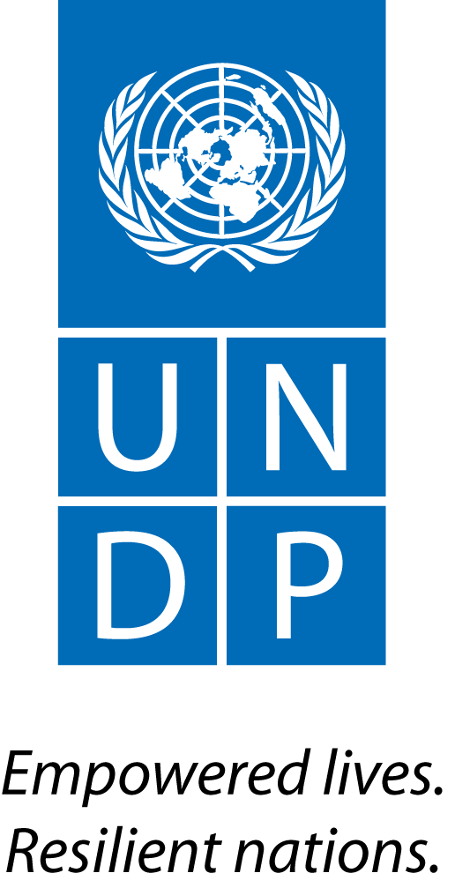 |  |  |  |  |  |  |  | Back to Office Report  Submitted by Tina Sølvberg  Titles Governance Programme Officer  Date submitted 1 September 2015
 |  | Group/Unit  BPPS / UN-REDD, UNDP REDD+ team | Tel No.  +47 926 29 992
 | Approved Mission Itinerary: |  |  |  |  |  |  | List of Annexes:
 |  | (From) Inclusive Travel Dates (To) |  |  |  |  | Key counterpart (s) in Kuala Lumpur:  31/8-1/9: Global Programme on Anti-Corruption/ GAIN network
 | 29/8/15 |  |  | 5/9/15 |  | 2-4/9: International Anti-Corruption Conference (led by Transparency International)
 | Purpose/Objective of Mission: (specify the type of work which has/had to be accomplished - not acceptable to write “see attached”) Participate (as a speaker and a discussant) in the UNDP-led GAIN 2-day meeting, and to participate and observe general trends/ examples/ lessons learnt within global anti-corruption work
Brief Summary of the Mission
Ove

a.Findings
-Throughout the “internal” GAIN meeting there were good and concrete examples of AC work and results at output/ outcome level – such as “open government” but not directly relevant to REDD+ work.
- GAIN meeting was also a meeting looking at its future role/ mandate with a mid-term review on the table and no ear-marked funding from UNDP core funding as previously – so some of the discussions stood out as too internal for me
- Surprising that both GAIN meeting and IACC focused on the importance of AC rather than results achieved, concrete results and what works/ does not work
- Good/ interesting panel discussion on technology and also film making/ documentary as a way to put sensitive information on the table and create global awareness
- IACC has a very wide agenda, and although good for network we should more strategically assess our participation the next time around and even consider making more visible contributions if we do (such as plenary or parallel track presentations or a side-event prior to the conference itself)

b.Results achieved
- Raised awareness building of UN-REDD’s/ UNDP’s REDD+ Anti-Corruption work (led by Estelle Fach) to date with specific examples
- Networking with relevant governance focal points within UNDP and also donor focal points (SIDA, Norad and US State Dept)

 |  | Follow up Actions Matrix
Action to be taken | By whom | Expected completion date
Follow up with governance focal points in relevant COs – through RTAs - as an additional resource in our work be it ICAs, CRA, gender, PGA or other (e.g. Sudan, Costa Rica, Ethiopia etc.) | Global colleagues | Continuously
To determine before possible next participation how to get more out of our participation (presentation, side-meeting/ side event back to back etc) | Global colleagues/ jointly | By next year (next IACC to take place in Panama next year – date tbc)
Share GAIN and IACC meeting reports with colleagues once available | Tina | Mid-October

Distribution list;
- UNDP UN-REDD Global team / posting on UN-REDD workspace

