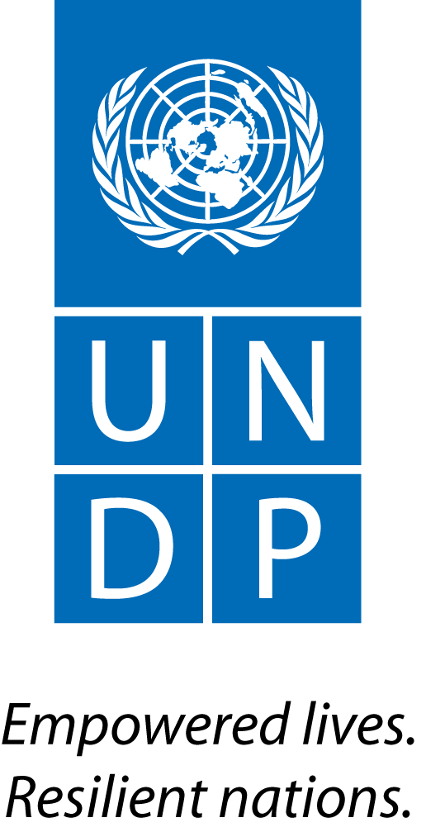 | Back to Office Report  Submitted by: Pierre Yves GUEDEZ,  Title: RTA  Date submitted: 10 Dec 2016
1. Practice area : REDD+

2. Mission period (incl. of travel days): 6-10 Dec 2016

3. Type of mission : Annual UNDP-FCPF follow-up mission | 4. Clients: NIMOS, SBB, Unique,
5. Purpose of mission  - Follow-up of the implementation of the UNDP-FCFP project in Suriname;  - Presentation of REDD+ with Council of Ministers;  - Participate to the meeting on drivers of deforestation  - Initial discussion on responses to mid term review recommendations | 6. Documents, materials, resources  - Detailed agenda of the mission
7. Mission members: Guedez Pierre | 8. Costs: FCPF
9. Brief summary of the mission
- Dec 7th: a presentation on REDD+ and progresses in REDD readiness in Suriname was delivered to the Council of Ministers by CTA, UNDP CO, NIMOS and SBB.
- Dec 8th: the consultancy UNIQUE presented the results of its analisis on drivers of deforestation in a national workshop, and working groups discussed on specific issues and follow-up actions. Discussions with the PMU and NIMOS about work with REDD Assistants and on engagement with indigenous people and marroons communities. Meeting with Unique consultancy to provide feed-back on their work and agree on requirements until closure of their tasks.
- Dec 9th: discussion with i) UNIQUE for the finalisation of the study on DDFDB+, ii) SBB and NIMOS on project management and strategic looking forward for REDD+ in Suriname and on AWP2017
9.a Findings
Since my last mission in nov 2015, elections took place in May 2016 and a new government team has been put in place. The bureau of Land Rights has been dismantled. A new Office of Human Rights has been created, under Police and Ministry of Justice. The responsibility of negotiating with inidgenous and tribal people on land rights has been given to the Ministry of Justice, the Ministry of Regional Affairs and the Ministry of Physical Planning, Land and Forest management. The responsibility related to Environment has been transferred to the Cabinet of the President. A new national developtment strategy 2017-21 has been prepared and should be released within a week. The Parliament will lead consultations with CSO, private sector, local authorities, etc on this document before official approval. Once this strategy is released, an analysis will be realized to assess how the different priorities of this new stragegy might affect Surinamese forests.
With regards to the UNDP FCPF project, the PMU has been strenghened; a Chief Technical Advisor has been recruited in August 2016; several UNDP missions took place to provide assistance on planning, technical issues, strategic orientation and political discussions; a new interim project coordinator has been named in Dic 2016. The implementation and delivery of the project has improved. The mid term review of the UNDP-FCPF project has been realized in Nov 2016, and the recommendations on management responses for this review have been discussed during the present mission. Besides, an audit of UNDP Suriname has been realized.
Since end 2015, there are some uncertainties regarding the futur of SBB. Besides, several contracts related to the NFMS unit are ending in the next 3 months together with the ACTO project that was financing them. NIMOS and SBB are looking for a solution to ensure this unit is maintain, whether within SBB or another location, in order to maintain the competencies on board to build up the SFMS, the FREL and latter on the REDD+ technical annex of the upcoming BUR.
The Council of Ministers welcomed the presentation on REDD+. The idea of organiznig a longer and more in depth presentation in january has been raised. This upcoming presentation and discussion could potentially be focused on explaining how international climate finance could potentially contribute to co-finance the new national development strategy, and stress the importance for Suriname to make significant progresses on issues if indigenous rights as a precondition to access this type finance. The Ministry of Justice could potentially be a champion in supporting this stream of work. Several ministers have requested bilateral meetings to discuss REDD+.
Several technical discussion on REDD took place with PMU, NIMOS and SBB, to discuss amongst other about the DDFDB+ analisis, the prioritization of PAMs, the SESA process and the ESMF. It has been agreed that a first SESA will take place based on the draft of prioritized PAMs is available. It would serve as training for staff of NIMOS and other potentially entities, as well as one of the input to finalize the prioritisation of PAMs. And that a second SESA will be realized in a much more participative and detailed manner, based on the finalized list of prioritized PAMs. Both work will be led by the National REDD+ strategy consultants as part of their Terms of Reference.The idea of “REDD projects” has also been extensively discussed: issues of ownership of the ERs, carbon rights, attribution, safeguards, consistancy with PAMs prioritized in the NS-AP, social expectations, etc. Given that CI is elaborating a Funding Porposal to the GCF on forests and community, NIMOS will approach CI and seek information on this FP to understand if is somehow related to the upcoming national REDD+ strategy and how, in order to ensure that all the efforts initiatied by CI with GCF, and by NIMOS and SBB in the context of the Warsaw Framework, will be complementary and coordinated. Main options to improve engagement of indigenous and tribal people in the project have been analyzed and should be dicussed in the coming days with REDD+ assistants, as well as indigenous and tribal people representatives.

The process and conditions for requesting a no cost extension have been discussed; and well as the policy of UNDP regarding cost recovery.
9.b Results achieved (key outputs)
- The report on DDFDB+ will be finalized by end 2016 and will be used as the basis for the elaboration of the NS-AP.
- The presentation on REDD+ was delivered to the Council of Ministers.
- The importance for Suriname to progress on the issue of indigenous rights during the remaining period of implementation of the FCPF project has been enfasis, as a precondition to access international climate funds such as REDD+, from the GCF and other sources. This barrier could potentially become a very strong asset in the futur if high level commintments and tangible progresses materialize.
The uncertainties regarding the timing and process for the SESA have been clarified.
10. Key counterparts
NIMOS (Cedric, Tanya), SBB (Rene, Sarah, Priscilla, Sara), PMU (Namil), UNDP Country Office and CTA, UNIQUE consultancy.

11. Follow up action matrix
Actions to be taken | By whom | Expected completion date
- Screen new national development strategy, to assess its potential impact on forests, and identify potential REDD+ policy and measures aligned with the strategy | PMU, NIMOS, SBB | As soon as national development strategy is released
- Assess support requested by UNDP REDD team for delvlerables included in the AWP2017 | Thomas | End Dec
- Provide costs of UNDP REDD staff (Jen, Danae, Estelle, Arturo, Pierre) for providing TA to support FCPF project | Tim / Dina | Within 1 week
- Validate process for requesting no cost extension with Tim | Pierre | Within 1 week
- Share Ecuador’s decree on REDD | Pierre | Within 1 week
- Ask for a copy of the concept note of CI to GCF and initiate discussion with CI to understand their views and ensure that they will contribute to Suriname’s objectives and national vision for REDD. | Cedric | Within 1 week
- Ensure synergies btw UNDP projects related to REDD, such as CCCD and the upcoming GEF Mining. | Bryan, Alexandra, Pierre | Jan 2017
- Adjust text of DDFDB+ studies when needed and provide comments to UNIQUE for finalization of the DDFDB+ report. With special focus on analisis of indirect drivers, and future infrastructures as well as issues of gender, land right and forest governance. | PMU | Within a week
- Provide comments to draft mid-term review document | All, for consolidation by Anu | 14 Dec
- Prepare the 3 hours meeting with council of Ministers, scheduled tentatively in January 2017, which could be focused on opportunities for Suriname to access international climate finance to co-finance its new national development plan, and corresponding requirements and conditions such as indigenous rights related safeguards. | PMU | Before Jan 2017.

