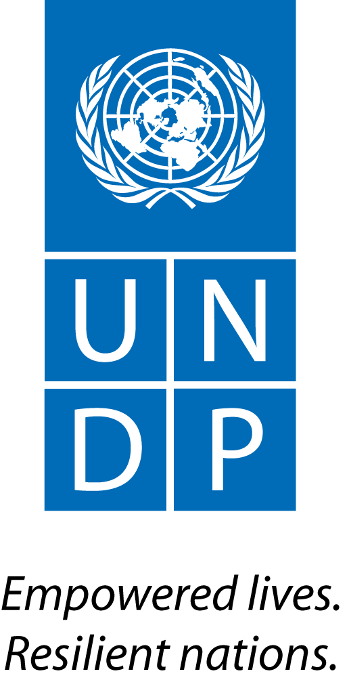 |  | Back to Office Report  Submitted by Anne Martinussen  Title Regional Stakeholder Engagement Specialist  Date submitted 14.04.2015
1. Practice area : UN-REDD
2. Mission period (incl. of travel days)
From : 17-21 February 2015
3. Type of mission :  Technical support mission to Kinshasa, the Democratic Republic of Congo (DRC) |  | 4. Clients  UNDP DRC, SGP DRC, Government of DRC, DRC civil society
5. Purpose of mission  Support and facilitate the finalization as well as the validation of the CBR+ Country Plan for DRC in a National Steering Committee meeting for SGP and CBR+ |  | 6. Documents, materials, resources  Draft Country Plan for CBR+ for DRC Congo  National REDD+ Strategy
7. Mission members  Anne Martinussen, Stakeholder Engagement Specialist |  | 8. Costs
9. Brief summary of the mission
The program "Community Based REDD+ (CBR+)" is a partnership between the UN-REDD Programme and the Small Grants Programme (SGP) of the Global Environment Facility (GEF) to financially support the initiatives of local communities and indigenous peoples to engage in preparedness activities of REDD+, and developing experiences, lessons learned and recommendations at the local level in order to contribute to REDD+ national processes. DRC is one of the six pilot countries for designing and implementing CBR+.
The development of the mandatory Country Plan for CBR+ in DRC started in March 2014 and have been through the following steps: a) assessment of existing documentation, exchanges and development of a first draft of the plan; b) broad consultation with stakeholders and beneficiaries, with special focus on local communities and indigenous peoples (IPs); and c) revisions based on consultations and final inputs from the SGP and UN-REDD teams in DRC and at global level. The final remaining step was to be achieved during this mission; d) Finalization and validation of the CBR+ country plan for DRC at a meeting of the National Steering Committee (NSC) for SGP and CBR+.
Thus, in light of the above the mission had two major objectives:
• Support and facilitate the finalization of the CBR+ Country Plan for DRC in the SGP CBR+ NCS;
• Facilitate the validation of the CBR+ Country Plan for DRC in the SGP CBR+ NCS.
9.a Findings
Preparatory meetings were held with the SGP coordinator and the recruited NGO CODELT the day before the NSC meeting and revisions of the Plan was done.
The CBR+ Country Plan for DRC has been developed over a long period of time and extensive consultations has been undertaken with all relevant stakeholders. Broad consultations had been undertaken at community level with local communities and IPs by a recruited national NGO (CODELT), and a revised final draft version of the plan had been sent to a number of experts in the field and in UNDP and SGP, as well as the members of the NSC. The discussions linked to finalization of the Plan at the NSC meeting were therefore focused on a few outstanding issues, which were resolved jointly. There was further agreement to validate the Plan with a few last revisions.
The National Steering Committee (NSC) for SGP and CBR+ includes representatives from the Government of DRC through Ministère de l'Environnement, Conservation de la Nature et Tourisme (MECNT) and Coordination Nationale REDD+ (CNREDD+), from civil society and IPs, from research and private sector, and from UNDP and SGP. During the meeting the following presentations were made: of the CBR+ Country Plan for DRC by CODELT; of the monitoring and reporting cycle as well as the format for applications by the SGP coordinator; and on the possible types of CBR+ projects and criteria for assessment of relevance by the regional SE specialist.
Discussions were had on the Plan and the various documents presented, before all was approved and validated by the NSC. The representatives from civil society requested an additional two-week consultation period for the civil society platform for REDD+, which was granted. The next steps were also discussed and agreed upon: these include advertising the Call for Proposals with a 3-month timeframe for submission of proposals; finding an NGO which will be responsible for capacity building of local communities and IP who are interested in submitting proposals; and agreeing on a next NSC meeting in June where a first batch of proposals will assessed and selected.
Due to the fact that a time-consuming joint FCPF / UN-REDD mission was taking place at the same time as this mission, there was limited contact with the UNDP country office team in Kinshasa.
9.b Results achieved (key outputs)
- CBR+ Country Plan for DRC finalized and validated;
- Agreement on and support to the initiative from relevant key stakeholders in DRC secured.

9.c Expected outcomes and impacts
Launching the Call for CBR+ proposals in DRC by end March, hence ensuring that the official milestone of launch before the 14th UN-REDD Policy Board meeting in mid-May is met. This may lead to strengthened and continued Policy Board support to the global pilot initiative.
- Key counterparts:
DRC UNDP country office: Team leader Etienne de Souza, Technical advisers Leslie Ouarzazi and Idesbald Chinamula Vuningoma
DRC Government: Gilbert Kilola (MECNT) and Théophile Nsuela (CNREDD+)
DRC SGP office: National Coordinator Célestin Kabeya
Civil society: CSO and IP representative to the SGP CBR+ NSC, and the NGOs CODELT and GTCR

11. Follow up action matrix
Action to be taken | By whom |  | Expected completion date
Incorporating NSC meeting comments in the CBR+ Country Plan for DRC | CODELT and SE specialist |  | 23 Feb 2015
Sending out final draft of Plan to CSOs | SGP coordinator |  | 24 Feb 2015
Drafting ToRs for Call for Proposals | SGP coordinator and SE specialist |  | 10 March
Incorporating final comments from CSOs to the Plan | CODELT |  | 10 March 2015
Advertising Call for Proposals | SGP coordinator |  | 25 March 2015
Including note in UN-REDD Newsletter on Call for proposals | NY-based SE advisers |  | Early April 2015
12. Distribution list:
UN-REDD global: Tim Clairs, Josep Gari, Nina Kantcheva and Dearbhla Keegan
Nairobi: Elsie Attafuah
UNDP DRC: Etienne de Souza, Leslie Ouarzazi and Idesbald Chinamula Vuningoma

