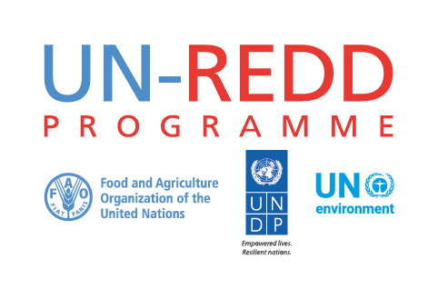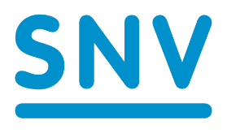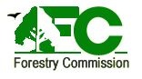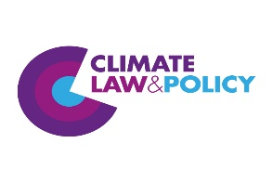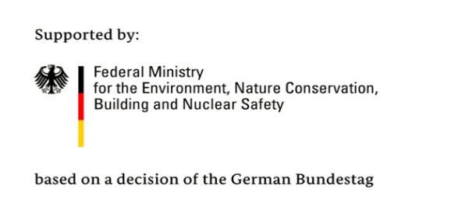

Concept Note: Africa Region South-South Knowledge Exchange on Country Approaches to REDD+ Safeguards and Safeguards Information Systems
(Ghana Forestry Commission, SNV/CLP & UN-REDD)
- Concept Rationale & Overview
Developing countries intending to participate in Reducing Emissions from Deforestation and forest Degradation (REDD+) under the United Nations Framework Convention on Climate Change (UNFCCC) are expected, as agreed by the Parties at COP 16 in Cancun, Mexico to address and respect a set of seven (environmental, social and governance-related) safeguards in the implementation of REDD+ actions (Decision 1/CP 16). In addition, Decision 12/CP17 states that countries should have in place a safeguards information system (SIS) providing information on how all the ‘Cancun safeguards’ are addressed and respected. This requirement was re-affirmed in the Warsaw Framework for REDD+ (‘The REDD+ rulebook’) which indicated that a SIS was one of four key design elements for national REDD+ readiness. The Warsaw Framework also requires countries to submit a Summary of Information on how all the Cancun Safeguards have been addressed and respected.
Developing countries, which intend to participate in REDD+, are currently at varying stages of REDD+ readiness in attempting to meet these safeguards requirements. Additionally, many of the countries also receive financial support from the World Bank’s Forest Carbon Partnership Facility (FCPF), as well as other bilateral and multilateral donors, each with their own safeguards requirements. In addition to existing safeguards requirements for the first (readiness) and second (implementation) phases of REDD+, the Green Climate Fund (GCF) has recently issued further safeguards requirements as part of a pilot programme for the third phase of REDD+ - payments for results. In response to the challenge of meeting multiple safeguards requirements, countries have been adopting different safeguards approaches depending on their national REDD+ strategy, their primary sources of funding, and their capacities.
The different approaches to meeting international safeguards requirements for REDD+ have generated a wealth of experience for countries. In the spirit of South-South cooperation and learning, a coordinated knowledge exchange on the different approaches to meeting safeguard international requirements (including development of a SIS) is proposed as an opportunity for REDD+ countries in the Africa region to share these experiences and lessons learned to date and to discuss common challenges, issues and potential solutions. This event directly responds to the priority recently identified by African countries, and the explicit request for more exchange on the ‘safeguards-financing nexus’, during the Regional UN-REDD South-South Knowledge Exchange on ‘Navigating the Transition from REDD+ Readiness to Implementation’ held in Nairobi, September 2017.
The event is jointly organised by the Ghana Forestry Commission (FC), SNV and the UN-REDD Programme. It would take the form of a workshop, spread over 2 days, hosted by Ghana (in Accra). It is expected that the event would be attended by key national level stakeholders and experts involved in developing and implementing these strategies in various REDD+ countries in Africa as well as representatives from Latin America (Peru) and South-east Asia (Vietnam). As such, this Africa regional knowledge exchange on safeguards would follow on from, and build on, a similar event co-organised by SNV and UN-REDD for the Asia-Pacific region in Hanoi, October 2017.
The UN-REDD Programme supports several countries throughout the Africa region to develop and establish their safeguards approaches and SIS. Meanwhile with funding from the International Climate Initiative, SNV also provides support in this regard to Ghana, Peru and Vietnam.

- Objective
Knowledge and capacity of African REDD+ countries on safeguards enhanced through the sharing of experiences and lessons learned to date on meeting international safeguard requirements for REDD+, particularly the design and development of a SIS.

- Proposed format
The proposed approach for this 2-day workshop would be, following an introduction session (session 1), to split it into thematic sessions. For sessions 2 and 3, initial framing presentations will be made by the event organisers in plenary (session introduction, recap of UNFCCC requirements, global/regional progress overview). This will be followed by 1-2 illustrative example country presentations around the theme. Finally, participants will be split into breakout groups (4-5 groups, maximum 10 participants per group) in a roundtable format and discuss the theme questions. Session 4, on safeguards requirements for results-based payments will include expert and country example presentations and panel discussions.
Suggested sessions:
Session 1: Introduction
- Welcome by country host - Ghana Forestry Commission
- Event needs, objective and concept introduction
- Country introductions (very brief – 2 mins each)
- REDD+ safeguards requirements overview (UNFCCC; GCF; FCPF)

Session 2: How to address and respect the Cancun safeguards
- Introductory presentation: specific UNFCCC requirements on addressing and respecting safeguards, overview global experience and approaches
- Illustrative country presentations (1-2): Countries that have clarified the Cancun safeguards in their national contexts, carried out environmental/social benefit-risk assessments, conducted assessments of existing policies, laws and regulations (PLRs) and the institutional capacities to implement them, or have otherwise made substantive progress on implementing a country approach to safeguards.
- Group discussions:
- Purpose, methods and results of benefits/risks assessments in REDD+
- Purpose, methods and results of national interpretation of the Cancun safeguards
- Purpose, methods and results of identifying, assessing and strengthening safeguards-relevant PLRs (i.e. how to address safeguards?)
- Purpose, methods and results of identifying, assessing and strengthening institutional capacities to implement safeguards-relevant PLRs (i.e. how to respect safeguards?)
- Contributions of FCPF (and other initiatives’) safeguards procedures to addressing/respecting Cancun

Session 3: How to develop a safeguards information system

- Introductory presentation: UNFCCC requirements on SIS; global experience, approaches and progress to date on meeting these requirements
- Country presentations (1-2): Countries that have made substantial progress in designing their SIS
- Group discussions:
- Aligning the SIS to national REDD+ strategies and action plans (PaMs)
- SIS and national forest monitoring system (NFMS) linkages
- Information needs, availability and structure
- Institutional arrangements (and operational costs) for SIS
- ICT solutions for managing and disseminating safeguards information (databases, web platforms and portals)
- How different donor safeguards requirements can contribute to the SIS
- Financing SIS capital outlay and operational running costs

Session 4: How to access payments for results with safeguards information
- Introductory presentations: UNFCCC requirements and global experience, approaches and progress to date; GCF pilot programme safeguard requirements; FCPF safeguard requirements
- Country presentation (1-2): Any country that has started on drafting a first summary of information and/or negotiating an Emission Reduction Payment Agreement
- Panel discussion/plenary
- Wrap-up

Cross-cutting theme: Ensuring effective stakeholder engagement
- Engaging government – institutional arrangements and capacity development for cross-sectoral engagement
- Engaging civil society – capacity development for constituency representation and managing expectations

- Participants
The regional learning event will be hosted by Ghana Forestry Commission (FC). Technical support for organising the event is provided by SNV and Climate, Law and Policy (CLP) and UN-REDD Programme.
As a South-South learning event, the participation of delegations of key individuals (2-3) working on REDD+ safeguards approaches and SIS design from Africa REDD+ countries would be financially supported by IKI and UN-REDD. In order that the event generates useful/high quality dialogue and discussions, participation is limited to key representatives that are actively leading the work on REDD+ safeguards in their respective countries. Country delegations participating that are currently tentatively confirmed (budget available) are:

- Cote d’Ivoire
- DR Congo
- Ethiopia
- Ghana
- Liberia
- Madagascar
- Nigeria
- Republic of Congo
- Uganda
- Zambia
- Vietnam
- Peru

There may be some slight modification of this list depending on availability, practical considerations (e.g. travel restrictions) or co-financing (e.g. from countries using FCPF funds to attend).
In addition, it is expected that the event would be attended by experts from UN-REDD global and regional headquarters to assist with facilitation. The invitation will also be extended to FCPF, GCF and NICFI participants as key resource persons. However, for a productive event the number of participants should be limited to around 50-60 participants overall e.g. Ghana (5), other countries 2-3 participants (26-32); UN-REDD global/regional (3); FCPF global/regional (2)*; SNV (4); CLP (2); FCPF global/regional (3)*; GCF (2)*; NICFI (2)*.

- Outputs
Potential outputs (tbc) would have joint intellectual property and may include:
- Regional info brief capturing state of the art understanding of challenges and emerging solutions for meeting REDD+ safeguards requirements in the Africa region (complementing that produced for the Asia-Pacific event in October 2017.
- Blog/newsletter article(s)
- Real time social media feeds during the event

