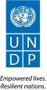 |  | Back to Office Report  Submitted by: Marco CHIU  Title: UN-REDD RTA  Date submitted: May 12th 2016
1. Practice area : BPPS / UN-REDD
2. Mission period (incl. of travel days)
From: 2 to 7 May, 2016
3. Type of mission: Support to finalize prodoc for the implementation of the JDI´s Phase II first disbursement. |  | 4. Clients  MINAM / UNDP CO
5. Purpose of mission  - Appraisal of Norway´s comments to first PRODOC draft  - Discuss a Theory of Change (ToC) for the project  - Finalize a second draft of the PRODOC for JDI´s Phase II implementation (first disbursement) |  | 6. Documents, materials, resources  - Project´s Theory of Change  - Summary of project´s results framework
7. Mission members  James LESLIE and Marco CHIU (UNDP). |  | 8. Costs  UN-REDD / GCP
9. Brief summary of the mission
Peru is a partner country of the UN-REDD Programme since 2011. Since 2012 the country has been engaged with the Programme on the design and execution of two “targeted support” (TS) projects. Peru is currently developing a NP.
In September 2014 the Governments of Peru, Norway, and Germany signed the Joint Declaration of Intent (JDI). The JDI is a cooperation initiative for the reduction of greenhouse gas emissions resulting from deforestation and forest degradation (REDD+) and to promote sustainable development in Peru. Together with the National Strategy on Forests and Climate Change (ENBCC in Spanish), which is considered as the umbrella national policy that guides activities to address CC challenges related to forests, the JDI is consider a key instrument on Peru´s forest and CC agenda.
The purpose of the JDI is: a) to contribute to significant reductions in GHG emissions from deforestation and forest degradation in Peru; b) to contribute to the achievement of the target of zero net emissions from land use change and forestry in Peru by 2021 and the national target of reducing deforestation by 50% by 2017 and additional reductions thereafter; and c) in the context of a) and b) to contribute to the sustainable development of Peru’s agricultural, forestry, and mining sectors.
JDI´s implementation is planned to take place in three phases: preparation, transformation, and contributions to verified emission reductions. The first two phases consist of a set of milestones (presented as deliverables) which will allow Peru to access REDD+ results based payments (third phase). The implementation of the JDI contemplate the definition of a financial instrument, which involves two stages: development of an interim mechanism and a final mechanism. At present, a number of activities are being implemented as part of the interim phase. In this context, the signatory parties of the JDI have agreed to invite UNDP and IDB to act as interim administrators of JDI´s phase II financial resources in close coordination with MINAM. In the meantime, MINAM continues developing the design of the final financial mechanism for future implementation of JDI´s financial resources, as well as other finance related to forests and climate change.
As part of JDI´s Phase II implementation, UNDP has been invited to administer a first disbursement of aprox USD 6,136,000 (depending on the NOK exchange rate to USD). In this context, UNDP in close collaboration with MINAM and Norway is currently working towards launching the Project: Paving the way for the full implementation of the JDI “transformation” phase (reducing GHG emissions from deforestation and forest degradation and promoting sustainable development in a planned, participatory, and decentralized manner), expected to start in June 2016 and end in December 2017. The present mission was intended to finalize the Projects´ PRODOC. The mission consisted in working sessions with MINAM representatives to assess and address Norway´s and other partners comments provided in an earlier version of the PRODOC.
9.a Findings
- Comments provided by Norway re the first prodoc draft were in general looking for more country context, consistency with the JDI´s objectives, and alignment to NICFI´s M&E language.
- Prior to this mission a call took place with MINAM and Norway in order to clarify comments. This call was an opportunity for MINAM to offer more context on the country and processes related to the project (land titling, forest zoning, and forest landscape planning). To a great extent the call was useful to address many comments.
- Similarly, at the beginning of the mission a call took place with NICFI´s M&E experts, with whom comments on the results framework were analyzed.
- Following the two calls the full project document was assessed in order to attend Norway´s comments, as well as to complete all sections indicated in the new UNDP´s prodoc template.
- The project ended up structured to pursue five outcomes and six outputs, as follows:
  - OUTCOME 1: Government of Peru has planned the implementation of JDI´s phase II, and initiated its efficient execution under a participatory and transparent approach with engagement of the main stakeholders. This outcome encompasses the activities/outcomes related to planning the full implementation of JDI´s phase II (including activities that will be implemented by MINAM with support from UNDP and IDB in the near future), and an analysis of the impacts of the drivers of deforestation in the Peruvian Amazon
  - Output 1.1: Main stakeholders have participated in the development of a plan for the full implementation of phase II of the JDI, under a transparent approach
  - Output 1.2: Impacts of deforestation drivers in the Peruvian Amazon assessed through a transparent and inclusive multi stakeholder process, involving all relevant ministries as well as civil society and indigenous and local communities.
  - OUTCOME 2: Increased zoning and forest landscape planning at the national level (outcome 5 of the ENBCC). This outcome encompasses part of the activities/outcomes related to the initial implementation of JDI´s Phase II.
  - Output 2.1: Improved regularization of indigenous community lands (issuing of land title) in San Martin and Ucayali regions.
  - Output 2.2: Forest covered land without zoning category reduced in San Martin and Ucayali regions.
  - OUTCOME 3: Forests value increased, to make them more competitive against activities that cause deforestation and forest degradation (outcome 2 of the ENBCC). This outcome includes one output. However, in order to complete the deliverables under the JDI, additional outputs may be added at later stages, such as other incentive systems beyond direct cash transfers (DCTs).
  - Output 3.1: Increased indigenous community land under payment for conservation performance in Amazonas, San Martin, Pasco, Madre de Dios, and Ucayali regions.
  - OUTCOME 4: Reduced Illegal/informal activities that cause deforestation and forest degradation (outcome 3 of the ENBCC). This outcome includes one output. However, in order to complete the deliverables under the JDI, additional outputs may be added at later stages, such as the promotion of low-carbon agriculture, the implementation of NAMAs, among others.
  - Output 4.1: Control of land use change strengthened in areas with forestry capability and areas for protection purposes in the Peruvian Amazon.
  - OUTCOME 5: Increased area, production, and investments on sustainable, competitive, and climate smart agriculture, that facilitates the conservation of forests in the Peruvian Amazon (outcome 1 of the ENBCC). This outcome is a place holder for the future integration of other actions considered in JDI´s Phase II implementation, which will be part of a second disbursement and will contribute to outcome 1 of the ENBCC. It is expected that JDI´s Phase II Implementation Plan (to be developed under Output 1.1) includes actions that encompass support to a public-private coalition with multinational companies committed to ambitious zero deforestation policies, the design and implementation of NAMA for sustainable production of cocoa, coffee, biofuels, agrofuels/agroindustry, and cattle ranching, and improved management of landscapes to avoid new conversion of forest to agriculture.
- In accordance with an expected future funding disbursement, UNDP will accompany efforts to meet Outcome 5, taking advantage of linkages with initiatives in the framework of the UNDP Green Commodities Programme, the UN-REDD Programme, and the GEF-funded Sustainable Productive Landscapes project. MINAM has already requested UNDP to administer up to $US 13 million, additional to this first disbursement ($US aprox 6,136,000), in the context of JDI´s Phase II implementation. The results framework described above is already developed in a way that facilitates the integration of future JDI´s Phase II activities/outputs.
- MINAM has requested UNDP to lead the implementation of OUTCOME 1 in addition to the “funds administration” role that will have for the execution of the entire project. Leading the implementation of outcome 1 will entail technical backstopping as well as direct implementation of activities leading towards outputs 1.1 and 1.2. This situation has opened the door for discussing a DPC modality. At the moment, a budget placeholder has been inserted in the project. UNDP needs to define the type of support and allocation of staff time that will be dedicated to this outcome and the project in general.
- The implementation of this project poses some challenges for UNDP:
  - Due to the general time-frame indicated in the JDI there is a sense of urgency in MINAM and Norway to implement the project and accomplish the expected results. This situation lead to an expected project time-frame that will require to execute all activities in around 18 months.
  - Given the nature of activities (in particular those related to forest zoning, forest landscape planning, and IP´s land titling) the first SESP suggests that the project is of high risk. A specific plan to address those risks will be necessary. UNDP will need to pay particular attention to those activities, as other related experiences in the country have been difficult to implement on the ground and have taken more time than expected.
  - The up-coming presidential elections will lead towards a change in the executive cabinet. It is expected that new political leaders will be on board at early stages of implementation of the project. Even if there is an effective buy-in of the project by the new authorities, changes in the cabinet might lead to some delays.
- MINAM and Norway are committed to do whatever is necessary to sign the prodoc in early June and start implementation shortly after.

9.b Results achieved (key outputs)
- Project design rationale agreed: It was agreed that the general structure of the project will be designed so it over all attends the 5 outcomes of Peru´s ENBCC. JDI´s deliverables have been connected to relevant ENBCC´s outcomes, and consequently project´s outcomes have been aligned also to attend simultaneously JDI´s deliverables and ENBCC outcomes.
- New prodoc draft completed. A new version of the project document has been finilized and submitted on time to Norway, right before working sessions between the two governments intended to agree on final details of the document.
- NP implementation modalities discussed: UNDP will use NIM to execute this project. Outcome´s 1 activities will be lead by UNDP (particular details to be stated in a LOA), whereas all the rest will be lead by MINAM. UNDP will administer the resources of the entire project and will have specific technical responsibilities in Outcome 1 and will offer backstoping for the general execution of the project under a DPC scheme.

9.c Expected outcomes and impacts
As a result of this mission and related follow up, it is expected that MINAM and Norway will be able to sign the project document and initiate its implementation shortly after.
10. Key counterparts
MINAM.
11. Follow up action matrix
Action to be taken | By whom |  | Expected completion date
- Revise and define final details with Norway. | MINAM and UNDP CO |  | May 13th 2016
- Develop final version of the prodoc | MINAM, UNDP CO and UNDP RSCLAC |  | May 27th 2016
- Up-date Project SESP | UNDP CO with support from UNDP RSCLAC and UNDP global |  | May 23rd 2016
- Define and agree on figures for DPC | UNDP and MINAM |  | May 27th 2016
- Develop an “Indigenous Peoples Plan” for risk management | UNDP CO with support from UNDP RSCLAC and UNDP Global |  | May 25th
- Conduct L-PAC | UNDP CO |  | May 25th 2016
- Facilitate signatures | MINAM supported by UNDP |  | June 3rd 2016
12. Distribution list
Tim, Josep, Arturo, Clea, Mirey, Fernando, James, Dina, PY, Kim, Jen, Wahida, Beth, Yolanda, Berta, Bruno, Andrew, Jorge A, Matilde, Lyes, Helen, Carla

Annex 1: Draft Project´s ToC
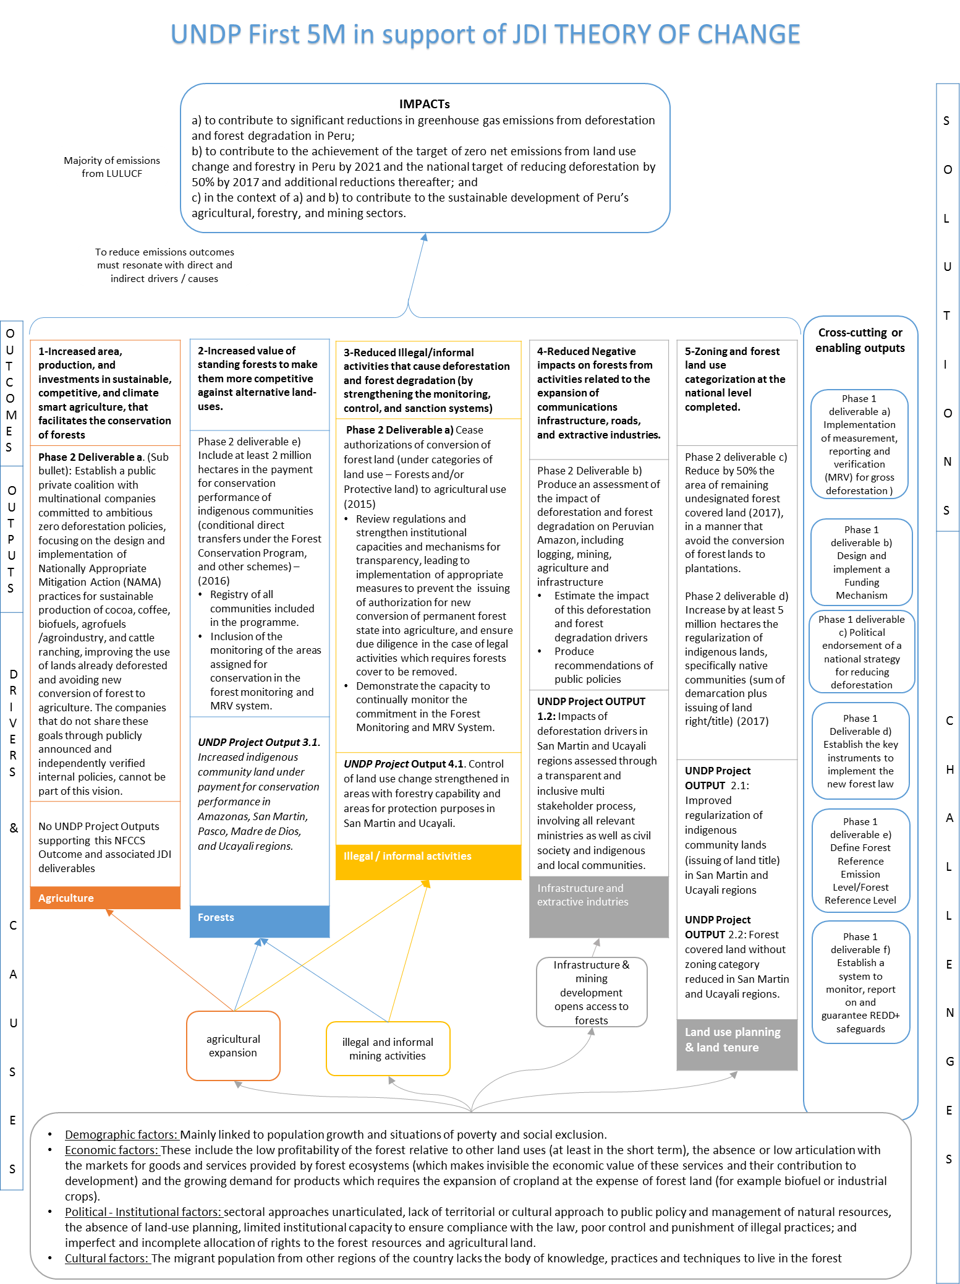

Annex 2: New Results Framework Structure
Project Title: Support to the implementation of the JDI “transformation” phase (reducing GHG emissions from deforestation and forest degradation and promoting sustainable development in a planned, participatory, and decentralized manner)
New Results Framework structure, according to Project´s ToC
CORRESPONDING ENBCC OUTCOME | Project´s Outcomes and Outputs
All | OUTCOME 1: Government of Peru has planned the implementation of JDI´s phase II, and initiated its efficient execution under a participatory and transparent approach with engagement of the main stakeholders
All | Output 1.1: Main stakeholders have participated in the development of a plan for the full implementation of phase II of the JDI, under a transparent approach
OUTCOME 4 : Negative impacts on forests reduced, from activities related to the expansion of communications infrastructure, roads, and extractive industries. | Output 1.2: Impacts of deforestation drivers in the Peruvian Amazon assessed through a transparent and inclusive multi stakeholder process, involving all relevant ministries as well as civil society and indigenous and local communities.
OUTCOME 5: Forest zoning and forest landscape planning at the national level. | OUTCOME 2: Increased zoning and forest landscape planning at the national level.
 | Output 2.1: Improved regularization of indigenous community lands (issuing of land title) in San Martin and Ucayali regions.
 | Output 2.2: Forest covered land without zoning category reduced in San Martin and Ucayali regions.
OUTCOME 2: Forests value increased (through SMF and other actions), to make them more competitive against activities that cause deforestation and forest degradation. | OUTCOME 3: Forests value increased, to make them more competitive against activities that cause deforestation and forest degradation.
 | Output 3.1: Increased indigenous community land under payment for conservation performance in Amazonas, San Martin, Pasco, Madre de Dios, and Ucayali regions.
OUTCOME 3: Illegal/informal activities that cause deforestation and forest degradation reduced (by strengthening the monitoring, control, and sanction systems). | OUTCOME 4: Reduced Illegal/informal activities that cause deforestation and forest degradation (outcome 3 of the ENBCC).
 | Output 4.1: Control of land use change strengthened in areas with forestry capability and areas for protection purposes in the Peruvian Amazon.
OUTCOME 1: Increased area, production, and investments in sustainable, competitive, and climate smart agriculture that facilitates the conservation of forests. | OUTCOME 5: Increased area, production, and investments on sustainable, competitive, and climate smart agriculture, that facilitates the conservation of forests in the Peruvian Amazon.

