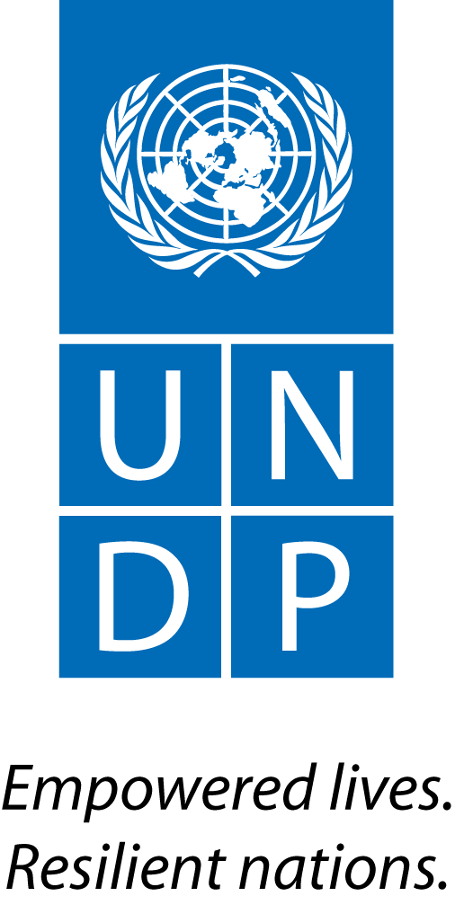 |  | Back to Office Report  Submitted by: Berta PESTI, Marco CHIU  Title: UN-REDD Technical advisor and RTA  Date submitted: April 22nd 2015
1. Practice area : BPPS / UN-REDD
2. Mission period (incl. of travel days)
From: 9 to 15 April, 2015
3. Type of mission: Work with MINAM to support the design of an “interim” financial arrangement to enable Peru-Norway/Germany DoI funds transfers, and support design of the “final” arrangement. |  | 4. Clients  MINAM, MEF (Ministry of Economy and Finance)
5. Purpose of mission  - Assess and analyze with MINAM and partners particularities of different options for the design of interim financial arrangements  - Observe experiences on the design of interim financial arrangements from other countries engaged on bilateral RBPs mechanisms  - Analyze elements to be considered for the final design of the financial arrangement of Peru´s “National Fund of Forests and Climate Change” (NFFCC) |  | 6. Documents, materials, resources  - Agenda of the mission
7. Mission members  Berta PESTI, Marco CHIU (UNDP) |  | 8. Costs  Global Programme
9. Brief summary of the mission
Peru is a partner country of the UN-REDD Programme since 2011. Since 2012 the country has been engaged with the Programme on the design and execution of two “targeted support” (TS) projects. Among others, the second TS includes activities to support the design of a financial mechanism to channel CC-forestry resources. Those activities started to be implemented since mid-2014.

On September 23rd 2014 the governments of Peru, Norway, and Germany signed a “Declaration of Intent” (DoI) aim at financing activities in Peru in the context of RBPs. The declaration states as objectives: (1) to contribute to significant reduction of GHG emissions from DD in Peru; (2) to contribute to the achievement of the target of zero net emissions from land use change and forestry in Peru by 2021; and (3) contribute to the sustainable development of Peru´s agricultural, forestry, and mining sectors. The DoI envisages implementation of activities in three phases: preparation, transformation, and contributions to verified emission reductions. The aim is to enter in phase III by 2017. It´s been agreed by the three governments that the execution of phases I and II will entail an investment of USD 50 million (10 and 40 for phases I and II respectively).

Follow-up of the DoI included a first mission from Norway in January 2015. Norway´s mission assessed the progresses on the milestones of phase I, including the design of the financial arrangement. A suggestion presented by Norway to Peru was to consider defining an interim financial mechanism to mobilize the resources in the short term, considering that Norway will need to execute a full due-diligence process to the institutions engaged in the financial mechanism proposed by Peru. In Peru´s proposal, it is envisioned to have one or more Peruvian institutions running the mechanism. Norway has suggested to consider an interim mechanism on the basis of the time it will require to perform the due diligence process, given that there is no past experiences with such institutions executing Norwegian funds. In this context, and adding on the support UNDP is providing to Peru on the design of the financial arrangement, this mission took place to analyze possibilities for the interim design, as well as to progress on defining elements to be considered for the final design. Participants included delegates from MINAM, MEF, KfW, IDB, CIAM (Inter-regional Amazon Council), and legal consultants.

9.a Findings
- The draft REDD+ Strategy in Peru is progressing in what is being called “National Strategy of Forests and Climate Change” (NSFCC). Within this NSFCC is contemplated to include a “REDD+ Action Plan” (which scope is still under consideration by MINAM). The scope of the NSFCC goes beyond REDD+, as it includes also adaptation and competitiveness objectives. The level of detail of this NSFCC creates a challenge, as it is not possible yet to identify activities to be funded by the NSFCC. Finalizing the NSFCC is one of the DoI´s Phase I milestones.
- The question of the possibility to use a “fund” or create a “trust account” is still open for the final design of Peru´s financial arrangement. Regarding a Fund, it seems unlikely that the Ministry of Finance (MEF) would allow the creation of a new public Fund, but the idea of using an existing Fund, namely FONAM was re-visited. This fund is currently being used by the German cooperation (KfW) to channel down some resources from bi-lateral agreements (Peru-Germany).
- Previous MINAM´s idea of capitalizing a trust account using NICFI´s resources is being cancelled, as per doubts presented by Norway in its first mission, on the capacity they might have to do it. Nevertheless, opening up a trust account seems to be MINAM´s favorite option. Further consultations will be done by MINAM on this matter.
- To help assessing the optimal proposal a key element that needs to be clarified is the legal framework that applies to ODA resources in Peru. A presentation on ODA management (re who allocates funding to “public” or “private” purposes) will be prepared before the meeting with the Norwegian delegation as part of the second mission in the context of the DoI (week of April 20th 2015).
- Following one of Norway´s suggestions for the interim financial arrangement (engage with an International Financial Institution – IFI, as those accredited to GEF) MINAM is planning to handle discussion with: KfW, Inter-American Development Bank (IDB), WWf, and UNDP to assess to what extent it is feasible to engage with one of those entities as fiduciary of the interin arrangement. KfW and BID have participated actively during the sessions of this mission.
- In this context, analysis of funding flows, agreements, and accountability issues of the possible interim arrangement were started during this mission:
  - UNDP: completed a draft resource-flow diagram, – ready to be used during the meetings with the Norwegian delegation after finalizing some details to be discussed with the CO.
  - IDB: same – pending some clarifications from IDB
  - WWF: to be done
  - KfW: to be done
Interviews with the 4 entities will follow this mission by MINAM´s consultants.
- UNDP´s support for the design of the NFFCC has included the main elements proposed by Peru. One of those elements is to have a national entity acting as the main host of the NFFCC (whether it is a fund or a trust account), in what is being called the “Peruvian modality”. Norway has suggested Peru to also consider other options, such as “sector support” and working through an “IFI”. A discussion on the different long term arrangements is expected to take place as part of the second follow-up dialogues between Peru and Norway/Germany:
- Peruvian modality
- Sector support
- FIF
Basic information is available on b. and c. – maybe sufficient to make a decision during Norway´s mission.
- In order to clarify some details of the Peruvian modality, and possibly to take some decisions for the final design, ti will be important to:
- Describe the basic differences between “funds”, “trust accounts”, and “comisión de confianza”
- Define the basic structure for grant based allocation under “trust account” and “FIF” (funding flows, agreements, and accountabilities) to be refined further during and after discussions with Norway.
- Other important issues that need to be clarified include:
- the fate of ER under the DoI (to be clarified with Norway), and
- the links b/w the SIS and the fund´s project cycle management arrangements, particularly in reltion to social and environmental safeguards/criteria, and M&E.
- From the legal perspective, clarifying the following two elements will allow further advancement for the final design:
- To what extent the “private” nature of the trust account may or may not be acceptable to Norway
- The accountability gap with the trust account modality – i.e. the fact that the trustee will not be accountable beyond the fiduciary function.
- Regarding other UN-REDD work areas in Peru, CO informed that the funds for TS2 implementation have been transferred to the country. CO is working with MINAM to start implementation (particularly recruiting staff).
- Jorge Saenz, Coordinator of the FCPF Project (which implementation started in March 2015) was assigned to act as the Government Focal Point to follow up on the REDD+ Country Needs Assessment. Coordination between the UN-REDD Program and Jorge Saenz will initiate with a view of finalizing the exercise no later than October 2015.
- UN agencies (like UNODC) have reached the RRs in Peru to request information on the engagement of the UN-REDD Programme in Peru. To help attending those requests an informal UNDAF infotmative meeting was planned as part of this mission. Information was presented to the group, including generalities of the UN-REDD Programme (governance, participant countries, modalities of implementation), as well as the current activities undergoing in Peru (CNA, TS).

9.b Results achieved (key outputs)
- Experiences from other countries shared: Vietnam, Guyana, and Indonesia´s experiences on the design of a financial arrangement in the context of RBPs have been shared. Those experiences have been taken into account to start the assessment of options for the interim financial arrangement design, as well as for the final design.
- Interim design initiated: Based on the discussions taken during the mission, initial drafts of an interim design have been initiated, as well as the key elements that needs a decision identified.

9.c Expected outcomes and impacts
As a result of this mission and related follow up, it is expected that critical decisions of the NFFCC architecture will be taken, both for the interim and final design.
10. Key counterparts
MINAM, MEF and UNDP CO.
11. Follow up action matrix
Action to be taken | By whom |  | Expected completion date
- Undertake a first talk with Peru´s CNA focal point and define next steps. | UNDP RSCLAC supported by UNDP CO and FAO, UNEP |  | April 16th 2015
- Prepare ppt on the modalities for the final design of the NFFCC (Peruvian modality, sector support, IFI) | MINAM consultants (supported by UNDP CO and Berta if needed) |  | April 20th 2015
- Prepare a ppt to describe the basic differences between “funds”, “trust accounts”, and “comisión de confianza” | MINAM consultants (supported by UNDP CO and Berta if needed) |  | April 20th 2015
- Follow up on the work plan for the design of Peru´s NFFCC | UNDP CO supported by UNDP RSCLAC |  | Next months
12. Distribution list
Tim, Josep, Arturo, Clea, Mirey, Fernando, James, Dave, Dina, PY, Kim, Berta, Bruno, Andrew, Jorge A, Matilde, Lyes

Annex 1: Mission Agenda

Sesión Técnica para el Diseño del Mecanismo Financiero para el Acuerdo de Pagos por Resultados de la DCI Perú-Noruega-Alemania
Av. Dos de Mayo 1565 Piso 5 – San Isidro

Viernes 10-Martes 14 Abril, 2015

 |  | Viernes 10 Abril
8:30 - 8:40 | Sesión de Presentación  - PNCB, UN-REDD, SERFOR, MEF, CIAM
8:40 – 9:00 | Contexto del actual proceso de diseño de un mecanismo financiero, Gustavo Suárez de Freitas, PNCB
9:00 – 10:00 | Análisis de procesos de negociación de acuerdos de pagos por resultados de Noruega con países tropicales (Guayana, Vietnam, Indonesia), Berta Pesti, UN-REDD
10:00 – 11:00 | Análisis de modalidades operacionales y características de los arreglos financieros institucionales, Berta Pesti, UN-REDD
11:00 – 11:30 | Coffee Break
11:30 – 12:15 | Requerimientos de la CMNUCC y del Fondo Verde del Clima sobre diseño financiero, Marco Chiu, UN-REDD
12:15 – 13:00 | Marco normativo sobre ODA / OECD, Berta Pesti, UN-REDD
13:00 – 14:30 | Almuerzo
14:30 – 15:30 | Modalidades de transferencia entre sectores de acuerdo al marco normativo nacional, Representante MEF
15:30 – 16:30 | Manejo de los fondos ODA, de acuerdo al marco legal peruano, Por definir
16:30 – 18:00 | Arreglos internos y proceso de transferencia a entidades financieras nacionales, Berta Pesti, UN-REDD

 |  | Lunes 13 Abril
8:30 - 9:00 | Portafolio potencial de proyectos a financiar, Patricia Luna, PNCB
9:00 – 10:00 | Tipos de instrumentos financieros y no financieros propuestos, Jorge Torres, PNCB
10:00 – 11:00 | Propuestas de Mecanismos Financieros Interino y Definitivo, Jorge Torres, PNCB
11:00 – 11:30 | Coffee Break
11:30 – 13:00 | Marco normativo para propuestas de mecanismos financieros, Rolando Castellares, PNCB
13:00 – 14:30 | Almuerzo
14:30 – 16:00 | Estudio de caso de diligencia debida realizado por Noruega, Berta Pesti, UN-REDD
16:00 – 17:30 | Implicancias jurídicas de los arreglos financieros, Berta Pesti, UN-REDD
16:30 – 18:00 | Definición de Próximos Pasos

 |  | Martes 14 Abril
8:30 - 17:00 | Sesión interna de trabajo para análisis de opciones a presentar a misión noruega, Rolando Castellares, Berta Pesti, Marco Chiu, Jorge Torres

