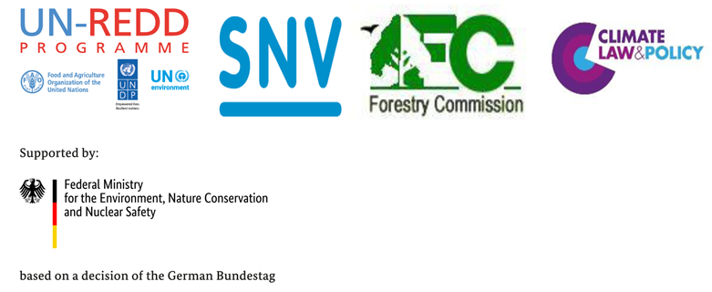
Africa Regional South-South Knowledge Exchange on REDD+ Safeguards and Safeguards Information Systems
Accra, Ghana; 12-13th June, 2018
Agenda
Day 1
08.00-08.30 | Registration | FC/SNV
Session 1: Introduction
Objective: To ensure participants have a good understanding of the UNFCCC, FCPF and GCF safeguards requirements and to identify some of the key challenges in trying to meet these requirements through a single country led process
08.30 -08.45 | Opening remarks and welcome | Roslyn Adjei (FC)
08.45 – 09.00 | Event Introduction, objective(s) and outputs | Richard Rastall/Reuben Ottou (SNV)
09.00 - 10.00 | Country Introductions | Representatives of participating countries
10.00 – 10.20 | UNFCCC Safeguards Requirements & Global and Regional Overview - Progress in meeting UNFCCC Safeguards Requirements (incl. 5 mins Q&A) | Steve Swan (UN Environment/UN-REDD)
10.20 – 10.40 | Coffee
10.40-11.00 | FCPF: Accessing Results-based Finance from FCPF - Safeguards Requirements and Approaches and Progress in Africa (incl. Q&A) | (FCPF)
11.00 – 11.20 | GCF: REDD+ Readiness, Implementation and Results Based Payments Pilot Programme and Safeguards (incl. Q&A) | Leonardo Paat & Moon Herrick (Green Climate Fund)
11.20 -12.15 | Expert Panel Discussion: Key challenges for African countries in trying to meet multiple safeguards frameworks for REDD+ | Representatives from selected countries
12.15 – 13.30 | Lunch
Session 2: How to address and respect the Cancun Safeguards
Objective: Review experiences and lessons learned in ensuring REDD+ activities are carried out in consistency with Cancun safeguards
13.30-13.45 | Framework presentation: Key considerations and elements in country-led approaches | Sebastien Korwin (Climate Law and Policy)
 | Theme 1: Environmental and social benefit/risk assessments of REDD+ actions
13.45 – 14.00 | Country Presentation: Environmental and social benefit/risk assessment of REDD+ actions | Name, Position, Country
14.00 – 14.45 | Group work on environmental and social benefit/risk assessments of REDD+ actions | All
14.45 – 15.15 | Sharing from group work (standard re-cap from group participant) | All
15.15 – 15.30 | Coffee
Parallel Thematic Discussions
 | Theme 2: Identifying, assessing and strengthening legal and institutional frameworks to develop an effective safeguard management framework
15.30 – 15.45 | Country Presentation: Identifying, assessing and strengthening legal and institutional frameworks | Name, Position, Country
15.45 – 16.30 | Group work on Identifying, assessing and strengthening legal and institutional frameworks | All
16.30 –17.15 | Sharing from group work (Morning TV chat show interview) | All
17.15 – 17.30 | Concluding Remarks | SNV/UN-REDD
18.00 – 21.00 | Reception Dinner | All
Day 2
08.00- 08.30 | Registration | FC/SNV
08.30 – 08.40 | Opening remarks – recap of key points from Day 1; overview of Day 2 | SNV/UN-REDD
Session 3: How to develop a Safeguards Information System
Objective: Review experiences and lessons learned in developing a Safeguards Information System
08.40 – 09.00 | Framework presentation: Key considerations and global lessons learnt (SIS) | Steve Swan (UN Environment/UN-REDD)
09.00 – 09.15 | Country Presentation 1: SIS process, challenges, opportunities and lessons | Name, Position, Country
09.15 – 09.30 | Country Presentation 2: SIS process, challenges, opportunities and lessons | Name, Position, Ghana
- – 10.15 | Group work on sharing steps in SIS design:  - processes  - stakeholder engagement  - challenges | All
10.15 – 10.30 | Sharing from group work (standard re-cap from group participant) | All
10.30 – 10.45 | Coffee | All
10.45 – 11.00 | SIS Country Presentation 3: SIS process, challenges, opportunities and lessons | Name, Position, Country
11.00 -11.15 | SIS Country Presentation 4: SIS process, challenges, opportunities and lessons | Name, Position, Country
11.30 – 11.45 | Country Presentation: experiences and lessons learnt
11.45 – 12.30 | Group work on synthesising collective SIS design:  - lessons learnt  - take home messages  - outlook for SIS operations  - determining functions and institutional arrangements for the SIS | All
12.30 – 13.00 | Sharing from group work and plenary discussion | All
13.00 - 14.00 | Lunch
Session 4: How to access Results-based payments with safeguards information
Objective: Review experiences and lessons learned in preparing safeguards information for accessing results-based payments
14.00 – 14.30 | Framework presentation: Key considerations and global lessons learnt/progress on preparing safeguards information for accessing results-based payments (incl. Q&A) | Steve Swan (UN Environment/UN-REDD)
14.30 – 14.45 | Country Presentation: Preparing Viet Nam’s Summary of Information – Approach and Lessons Learned | Le Ha Phuong (Safeguards Officer, Viet Nam REDD+ Office)
14.45 – 15.30 | Panel Discussion | Representatives of selected countries
15.30 – 15.45 | Coffee
Session 5: Stocktaking of experiences and lessons learned
Objective: Examine and analyse country’s experiences, reflections on lessons learned, key take-home messages from the event and next steps.
16.00 - 16.45 | Panel Discussion: Reflections and Next Steps | Representatives of selected countries
16.45 – 17.10 | Countries’ Take Home Messages | All Countries
17.10 – 17.20 | Evaluation survey | All
17.20 – 17.30 | Closing remarks | UN-REDD, SNV & FC

